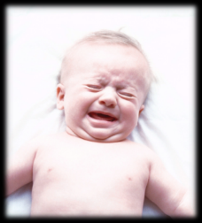 **QUICK FACTS** 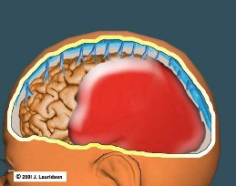

**Abusive Head Trauma (AHT) and Shaken Baby Syndrome (SHS)**

* Abusive Head Trauma often occurs at the age of peak crying
* **Crying** is the most common trigger for Shaken Babies

|  |  |
| --- | --- |
| **Injuries caused by shaking include:**   * + Bleeding within the brain   + Swelling of brain tissue   + Bleeding in the retina   + Rib fractures   + Arm or leg long bone fractures | **What doesn’t cause AHT?**   * + Bouncing a child on a knee   + Tossing a child in the air   + Short falls off furniture   + Falls down stairs   + Sudden car stops   + Running with child |
| **Signs and Symptoms of possible AHT:**   * + Vomiting   + Difficulty breathing   + Decreased appetite   + Trouble sleeping   + Irritability   + Lethargy   + Convulsions/seizures   + Change in level of awareness   + Inability to vocalize   + Trouble sucking or swallowing | **Long Term Effects of AHT:**   * + Severe brain damage   + Learning disabilities   + Permanent blindness   + Hearing impairment   + Paralysis   + Impaired motor skills   + Loss of cognitive skills   + Cerebral palsy   + Seizures   + Behavior problems   + Death |
| **Perpetrator Statistics:**   * + 70% of perpetrators are men   + Father of victim or mother’s boyfriend   + Caregivers, stepparents, grandparents   + No other common ties   + Most have no history of violence | **Victim Statistics:**   * + Usually less than 1 year old   + Majority are younger than 6 months   + More males than females   + No accurate statistics   + Est 1,200-1,400 injured or killed each year |

For more information, please visit the webpage for the **National Center on Shaken Baby Syndrome** at <http://dontshake.org>