**HOME & ENVIRONMENTAL HAZARD**

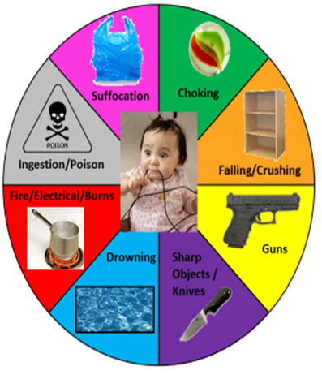

**HOME & ENVIRONMENTAL HAZARD ONLINE RESOURCES**

**Safe Kids –** [**http://www.safekids.org**](http://www.safekids.org) **-** Safe Kids Worldwide is a global organization dedicated to preventing injuries in children, the number one killer of kids in the United States. Around the world, a child dies from an unintentional injury every 30 seconds. And millions of children are injured in ways that can affect them for a lifetime. This website includes information, articles, discussion, and safety tips for children of all ages. “Keeping kids safe is a global issue that directly affects all of us.”

**American Academy of Pediatrics –** [**http://www.aap.org**](http://www.aap.org) **-** The American Academy of Pediatrics (AAP) and its member pediatricians dedicate their efforts and resources to the health, safety and well-being of all infants, children, adolescents and young adults. The website has an abundance of information, articles and resources for parents and practitioners.

* **Healthychildren.org -** <http://www.healthychildren.org/English/Pages/default.aspx>
  + This website is partnered with pediatricians and parents and includes information about child development / Ages & Stages, Healthy Living, Child Safety and Prevention, Family life, Health issues, etc.
* **Injury, Violence, and Poison Prevention** - <http://www2.aap.org/sections/ipp/>
  + Try this link for updated information on child safety in the home, in the car, and everywhere.

**Center for Disease Control -** <http://www.cdc.gov/parents/infants/safety.html> - This website has an abundance of information from the CDC with this link focusing on helpful in the home safety tips for parents of infants and toddlers.

**KidsHealth -** <http://KidsHealth.org> – “for Parents” – First Aid and Safety – many resources on Household and environmental safety for infants and toddlers, as well as information for older kids including internet security, food safety, teen job safety, and Printable Safety Guides. Click the link below for Household Safety Checklists - <http://kidshealth.org/parent/firstaid_safe/home/household_checklist.html#cat150>

**We Make It Safer** – <http://wemakeitsafer.com> – Includes a searchable database for recalled products and checking a products safety information. As well as information from other consumers and links to easily order safe products and food. MakeItSafer's mission is to dramatically reduce the number of product-related injuries, illnesses and deaths that occur each year worldwide.

**Recalls.gov –** <http://www.recalls.gov> – This government website seeks to provide better service in alerting the American people to unsafe, hazardous, or defective products, six federal agencies with vastly different jurisdictions have joined together to create this website as a “one stop shop” for US Government recalls. This partnership includes US Department of Agriculture (USDA), US Food and Drug Administration (FDA), US Coast Guard, National Highway Transportation Safety Administration (NHTSA), Consumer Products Safety Commission (CPSC), and the United States Environmental Protection Agency (EPA).