
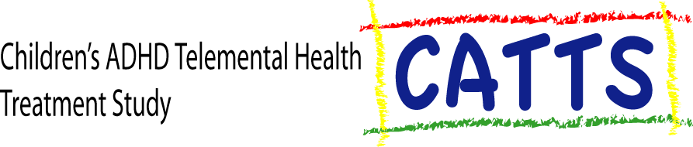

Dear Parent/Guardian:

We have a study that might be helpful to your child. The Telemental Health (TMH) Service at Seattle Children’s Hospital (SCH) has been treating children for 9 years through videoconferencing --- that is, over the TV. Since 2001, we have treated over 900 children with 3000 appointments. Now, we are conducting a study to determine how well TMH works. Our project is called the Children’s ADHD Telemental Health Treatment Study (CATTS). CATTS will determine how much TMH helps children 5.5 to 12 years old with Attention-deficit Hyperactivity Disorder (ADHD). The sessions are free of charge to families.

Eligible children receive an evaluation at the local TMH clinic (Longview, Olympia, Everett, Wenatchee, Richland, or Boardman OR). Then, they are assigned to one of two treatments: 1) Group A, or the Intervention Group, receives 6-sessions with a telepsychiatrist to find the right medication treatment for your child followed by in-person parent behavioral training at the clinic with a local therapist; or 2) Group B, or the Consultation Group, receives a consultation with a telepsychiatrist who makes recommendations to your doctor for ongoing treatment. Your doctor also becomes part of the study because we ask to review his/her records of your child’s treatment during the time you are in the study. These sessions are free to families. But, families have to pay for any medication that is prescribed.

Families in both study groups complete assessments at 5 times during the project. Families receive $35 for each assessment, plus a bonus payment for completing all assessments (total payment of $245).

If you want your child to be evaluated for our CATTS project, please bring the attached letter and form to your child’s doctor. The letter explains the study and your doctor’s role in the study. Then, your doctor can FAX us the NARF form to officially refer your child to the study. We will call you about your child’s participation in the project. You may also give your doctor the website for the study: http://www.tv4adhd.org

Other Information:
If you have questions or want to discuss the study further, please call the CATTS Study Line at 1-(800)-997-4017.

Sincerely,
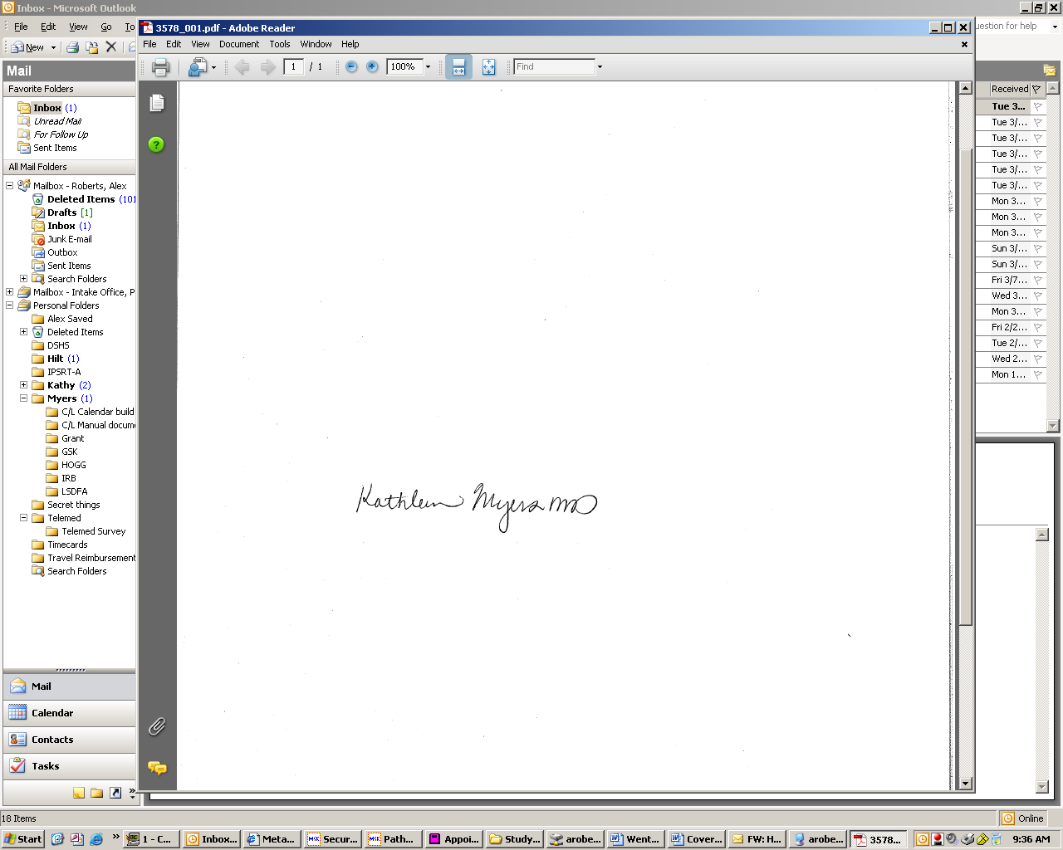
Kathleen Myers, MD, MPH, MS
Director, Telemental Health Service
Principal Investigator, Children’s ADHD Telemental Health Treatment Study (CATTS)
Seattle Children's Hospital
Kathleen.myers@seattlechildrens.org
(206) 9871663

