The Youth Political Web Sphere and its Potential Role in Rebooting Youth Political Engagement

Christine Lee

University of Washington

Department of Communication

Honors Thesis

Although participation in traditional politics such as voting has declined among all age groups since the 1970s, the decline is most prominent among current youth (18-25 years old). Some may attribute this disengagement simply to the tendencies of young people, but this claim is inaccurate as today’s youth is more significantly disengaged than the youth of previous generations (CIRCLE, 2002). This decline reveals what many call the youth political engagement crisis.
Youth political engagement is an important area of study because of the current lack thereof. Although youth are civically engaged and volunteer in record numbers, are more likely to have volunteered in the past year than any other generational group (CIRCLE, 2002), and, between the years of 1998-2000, more than 73% of students have volunteered at least once (Panetta Institute, 2000), many young people are simply not engaged in traditional politics such as voting, campaigning, etc. Additionally, a study from the Harvard Institute of Politics reveals this divide between traditional and nontraditional forms of political engagement, as 85% of youth prefer volunteering to traditional politics as a way of addressing important community issues. As a study from Greenberg Quinlan Rosner Research (2003) noted, only 32 percent of 18-25 year olds voted in the 2000 presidential election. This is a clear decrease from the 40.8 percent of the 18-25 year olds who voted in the 1984 presidential election and from the 36.2 percent of 18-25 year olds in the 1988 presidential election. In fact, a survey from the Center for Information and Research on Civic Learning and Engagement found that “57% of all young adults are completely disengaged from political and civic life”(CIRCLE, 2002). Putnam states that “voting is by a substantial margin the most common form of political activity, and it embodies the most fundamental democratic principle of equality”(Putnam, 2000, p. 35). Given that voting is a fundamental aspect of democracy, low youth voter turnout is troublesome. Also particularly problematic is the possibility that the current youth will carry their political apathy and disengagement into “adulthood” and continue a lifelong pattern of avoiding traditional politics.
A step towards a potential solution to the youth political engagement crisis may lie within the Internet. The Internet is a potent vehicle for communicating to the youth because, among numerous other reasons, youth view the Internet as a highly valuable source of political information (Delli Carpini, 2002) and youth media use styles complement the inherent characteristics of the Internet and new media (Graber 2001a).
However, it is unlikely that traditional political websites such as election campaign sites personalize and direct messages to the youth. If this is the case, the potential for the Internet to influence youth political engagement appears to be vastly underused. Of course, there are youth-oriented political websites that attempt to attract and encourage traditional and non-traditional youth political engagement. What are some characteristics of these websites that may help attract and engage youth and in what ways are they distinct from the mainstream political sites? What roles do youth political sites play as their own entity and also as part of/relating to the online political mainstream?

Literature Review

The Youth Political Engagement Crisis
Participation in traditional politics such as voting has declined among all generational groups since the 1970s, yet the decline is most pronounced among current youth (18-25 years old). Greenberg (2003) noted that only 32 percent of 18-25 year olds voted in the 2000 presidential election. This is a clear decrease from the 40.8 percent of the 18-25 year olds who voted in the 1984 presidential election and from the 36.2 percent of 18-25 year olds who voted in the 1988 presidential election. Also, the youth political engagement crisis is not limited to voting. According to a survey from the Center for Information and Research on Civic Learning and Engagement, “57% of all young adults are completely disengaged from political and civic life”(CIRCLE, 2002).
There are numerous studies on the reasons for the decline in traditional political engagement among youth. As the survey from CIRCLE (2002) revealed, almost half of all young adults believe that voting is unimportant. Similarly, only 53% of youth believe that traditional forms of politics such as government and voting address their interests and concerns. Halstead (1999) states that currently youth show signs of further disengagement in traditional democratic politics:
[Young adults are] more likely to describe [themselves] as having a negative attitude toward America, and as placing little importance on citizenship and national identity, than its predecessors. And [young adults] exhibit a more materialistic and individualistic streak than did their parents at a similar age. Moreover, there is a general decline in social trust among the young, whether that is trust in their fellow citizens, in established institutions, or in elected officials. These tendencies are, of course, related: heightened individualism and materialism, as Alexis de Tocqueville pointed out, tend to isolate people from one another, weakening the communal bonds that give meaning and force to notions of national identity and the common good. (Halstead, 1999, para. 8)
Bucy (2003), citing a National Association of Secretaries of State study, gave five reasons for why young adults are not engaged in traditional politics like voting. (1) Parents, as displayed by the overall decline in voting among all age groups, are not voting and thus, parental influence on youth regarding voting has also declined, (2) there is very little youth-oriented political communication from politicians, (3) aspects of the political process such as voter registration and absentee votes can be confusing or simply unknown to youth, (4) youth believe their interests and those of politicians are incompatible and that politicians are motivated by selfish reasons (such as money), and (5) many young adults view the process as flawed and thus, do not want to take any part in it.
Putnam (2000) identifies another more societal and complex explanation for the deterioration of civic engagement among all age groups: television and the loss of social capital. Bennett (1998), conversely, emphasizes the rise of lifestyle politics and an increasingly individualistic culture as reasons for the disconnect between people and government, yet he believes that political engagement is in a state of moving away and transitioning from old institutional forms rather than in decline.

The Internet as a Tool for Encouraging Youth Political Engagement
Before this study examines the Internet’s potential role in encouraging youth political engagement, it must first examine why the Internet is such a potent vehicle for communicating to the youth in the first place. Delli Carpini (2002) noted that a vast majority of young citizens (18-25 years old) view the Internet as not only a useful source of political information in general, but as the most useful source of political/issue information among communication processes including newspapers, television news, and radio, etc. Youth, because they are more likely to welcome such technologies, are also much more likely to have access to and use the Internet than any other generational group. This attraction to technologies such as the Internet likely exists because of the media use style of young adults (Graber, 2001a). Regarding general media use, Graber described youth as more visually oriented, seeking diversity of information, inclined to actively “shaping their information menu”(Graber, 2001a, p. 437), cherishing interactivity, and as niche viewers. Sparks (2001) identifies, among other things, the communication model of the Internet as interactive, notes that the Internet was created for the purpose of exchanging information, and recognizes that the structure of the Internet facilitates distribution and organization (shaping) of information. The inherent characteristics of the Internet and new media as a whole (such as speed and sheer volume of information, accessibility, asynchronocity, high level of interactivity) are consistent with Graber’s claims about the media use styles of young people.
Delli Carpini (2002) suggested that the use of the Internet for increasing youth political involvement could be categorized among the various actors. That is, the implications for the Internet and youth political engagement can be studied from the categories/perspectives of “political elites,” “engaged citizens,” “interested but inactive citizens,” and “neither engaged nor clearly motivated citizens.” Additionally, he noted that the category of “neither engaged nor clearly motivated citizens” is the most difficult and under-developed component for the capabilities of the Internet to engage youth. Delli Carpini (2000) also warned of three “complicating factors” for the study of the Internet’s potential on youth political engagement:
- The Internet and new media change and evolve at great speed, and it is crucial that we pay attention to both the current utility of new media and potential future utility.
- New media may possibly create new manifestations of political engagement that can go unnoticed under our “traditional indicators” of engagement.
- The new media environment may possibly have detrimental repercussions (such as further societal fragmentation, consumerist politics, information overload, etc.) on civic health as a whole.
These “complicating factors,” among others, must be kept in mind and addressed throughout such studies.

Methods
This study, done with the University of Washington’s Center for Communication and Civic Engagement (CCCE), first identified 25 prominent youth-oriented websites through an assortment of techniques including the use of search engines such as Google™ and through scholarly resources (Center for Social Media, 2004). The 25 websites selected for the study are listed below:

1. Rock the Vote
2. Youth Noise
3. Arsalyn
4. Youth Vote
5. Millennial Politics
6. Freedom's Answer
7. Pop and Politics
8. Generation Vote
9. New Millennium Young Voter’s Project
10. CIRCLE
11. Institute of Politics (Harvard University)
12. Youth in Action
13. WWE Vote (Smackdown Your Vote)
14. Third Millennium
15. Democracy Matters
16. Youth Leadership Initiative
17. College Republican National Committee
18. Republican Youth Majority
19. Young Democrats of America
20. College Democrats of America
21. Kids Voting USA
22. Student Voices
23. YouthVoice.net
24. NAACP Youth & College Empowerment Program
25. National Coalition Black Youth Vote
The study then investigated this 2002 Youth Political Web Sphere, an archival collection of the 25 youth-oriented political websites, and identified discourse, content, and features that appeal to youth. The study also examined the 2002 U.S. Electoral Web Sphere, an archival collection of the 2002 U.S. congressional and gubernatorial election campaign websites, for any existence of such youth-friendly content and features and whether these campaign sites possess the characteristics that appeal to young people. Both spheres were analyzed using similar coding schemes that predominantly focused on issue content (existence of discourse with youth appeal) and website features.
Additionally, the same 25 sites from the 2002 Youth Political Web Sphere were personally archived for 2004 using a website archiving computer program called Teleport Pro™. The 2004 Youth Political Web Sphere was then analyzed using a coding scheme nearly identical to the scheme used for the 2002 Youth Political Web sphere.

Data and Discussion
Issue Discussion: 2002 Youth Political Web Sphere vs. 2002 U.S. Electoral Web Sphere
Regarding issue discussion (Fig. 1), the data show that both the 2002 Youth Political Web Sphere and the 2002 U.S. Electoral Web Sphere present the traditional “staple” election issues in fairly similar numbers. Education is present on 87.5% of the youth sites and 80.9% of the candidate sites, and economy/jobs is present on 62.5% of the youth sites and 57.4% of the candidate sites. Other staple issues such as health care (62.5% of youth sites vs. 75.2% of candidate sites), taxes (50% of youth sites vs. 59.7% of candidate sites), and national security/terrorism (50% of youth sites vs. 61.8% of candidate sites) are also represented somewhat equally in both spheres.
However, there are numerous issues that are heavily favored by one sphere and not the other. For example, issues such as crime/violence (75% of youth sites vs. 30.5% of candidate sites), gun control (50% of youth sites vs. 31% of candidate sites), abortion (50% of youth sites vs. 28.9% of candidate sites), minority rights/recognition (62.5% of youth sites vs. 19.4% of candidate sites), politics/government changes (75% of youth sites vs. 18.8% of candidate sites), and gay rights (50% of youth sites vs. 6.2% of candidate sites) are present in a significantly larger percentage of youth sites than in the electoral sites. Similarly, issues such as Social Security are more prevalent in the U.S. Electoral Web Sphere than in the Youth Political Web Sphere (25% of youth sites vs. 55% of candidate sites). However, one possible explanation for these differences is that some of these abovementioned issues are of a highly divisive and controversial nature (for example, abortion and gay rights). Candidates tend to exclude such issues from their campaign discourse in order to appeal to the broadest base of voters possible, whereas youth political websites have more freedom to discuss these issues in detail and at length.
In general, a higher percentage of the Youth Web Sphere covers a broader spectrum of issues, providing diversity of information that appeal to youth, while the Electoral Web Sphere tends to focus on the six or seven “staple” election issues.
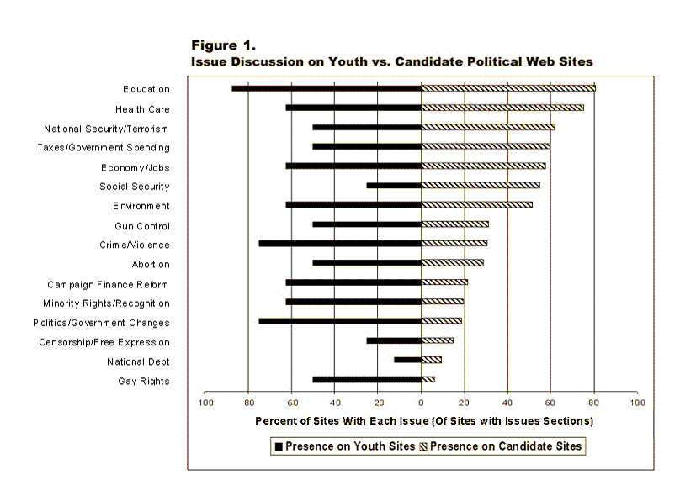
*Courtesy of the CCCE

Features: 2002 Youth Political Web Sphere vs. 2002 U.S. Electoral Web Sphere
The data for website features (Fig. 2) reveals that the Youth Web Sphere possesses more of the characteristics that complement the media use styles of young people than the Electoral Web Sphere. Features such as email signup (65% of youth sites vs. 35% of candidate sites), multimedia (25% of youth sites vs. 8% of candidate sites), and features facilitating local community involvement for youth (youth participation) (55% of youth sites vs. 9.7% of candidate sites) are found more frequently in the Youth Political Web Sphere. In fact, even the features that are not exactly common in the Youth Political Web Sphere are still used by the youth sites more often than by the electoral sites. Such features include message board/blog (15.8% of youth sites vs. 5.1% of candidate sites), interactive polls (15% of youth sites vs. 5% of candidate sites), and website login (15.8% of youth sites vs. 0.2% of candidate sites).
The presence of such features reveals the Youth Web Sphere’s youth appeal (as opposed to the Electoral Web Sphere’s lack thereof). Because youth are more visually oriented, features such as enhanced multimedia and photos can pull and hold interest. Message boards/blogs, interactive polls, and website login emphasize interactivity, another characteristic of youth media use style. And features like news/press release sections and email signup appeal to youth because they are quick yet useful sources of information (that they can access on their time and at their leisure).
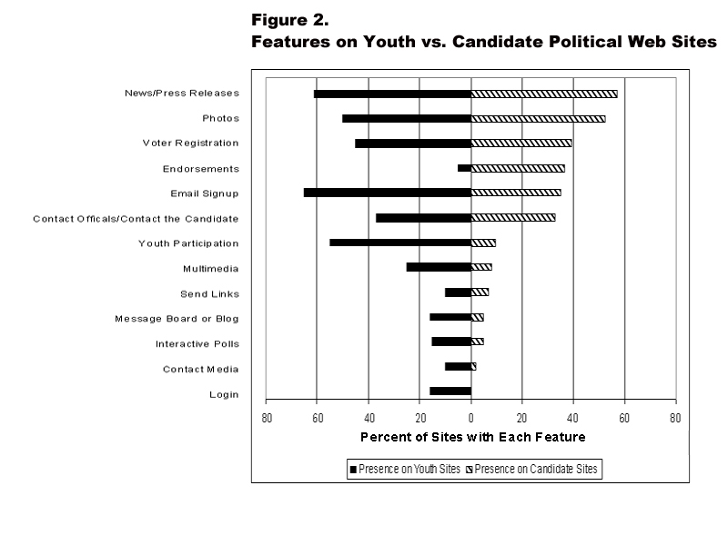
*Courtesy of the CCCE

Issue Discussion: 2002 Youth Political Web Sphere vs. 2004 Youth Political Web Sphere
In most cases, there is more presence of issues in the 2004 Youth Political Web Sphere compared to the 2002 Youth Political Web Sphere. This is most noticeable with the issues of education (100% in 2004 vs. 75% in 2002), health care (85.7% in 2004 vs. 50% in 2002), economy/jobs (71.4% in 2004 vs. 50% in 2002), minority rights/recognition (71.4% in 2004 vs. 50% in 2002), and Social Security (42.9% in 2004 vs. 25% in 2002). In fact, most issues are found more frequently in 2004 than in 2002 with the exception of national security/terrorism (42.9% in 2004 vs. 50% in 2002), gun control (42.9% in 2004 vs. 50% in 2002), campaign finance reform (28.5% in 2004 vs. 62.5% in 2002), and politics/government changes (57.1% in 2004 vs. 62.5% in 2002). Overall, the 2004 Youth Political Web Sphere appears to have diversified its issues discourse over the past two years.
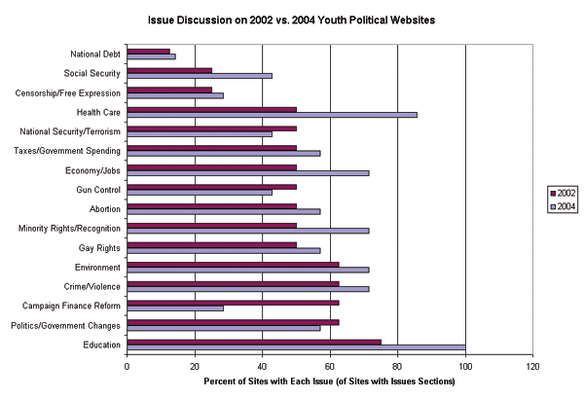

Features: 2002 Youth Political Web Sphere vs. 2004 Youth Political Web Sphere
The presence of features in the 2004 Youth Political Web Sphere follows a similar pattern to the presence of issues mentioned above. In most cases, there is increased use of features in the 2004 sphere compared to the 2002 sphere. For example, voter registration (52.6% in 2004 vs. 45% in 2002), endorsements (21% in 2004 vs. 5% in 2002), contact media (21% in 2004 vs. 10% in 2002), login (31.6% in 2004 vs. 15.8% in 2002), message board/blog (31.6% in 2004 vs. 15.8% in 2002), multimedia (36.8% in 2004 vs. 25% in 2002), photos (84.2% in 2004 vs. 50% in 2002), news/press releases (73.7% in 2004 vs. 61.1% in 2002), and email signup (78.9% in 2004 vs. 65% in 2002) increased their presence in the 2004 Youth Political Web Sphere. In fact, only the contact officials feature (31.6% in 2004 vs. 36.8% in 2002) decreased in presence at all. The 2004 Youth Political Web Sphere has overall enhanced and increased the presence of these youth-friendly features.
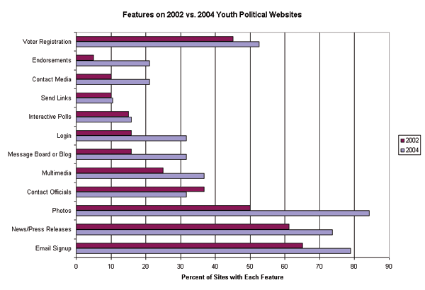
Connections from Youth to Candidate Political Web Spheres, 2002 vs. 2004
The connections from youth sites to the mainstream electoral sites remain fairly static from 2002 to 2004. The major exception to this is the facilitation of local youth political action (youth participation) that increased from 55% in 2002 to 78.9% in 2004. Otherwise, there are only rather small increases in the presence of onsite election information (31.6 % in 2004 vs. 25% in 2002) and voter registration links (52.6% in 2004 vs. 45% in 2002). Links to outside political information was present in 84.2% of both the 2002 and 2004 youth spheres.
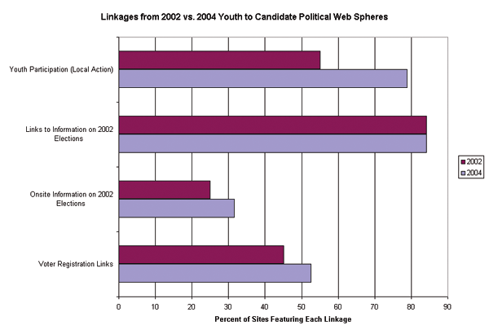
A point of interest regarding the Youth Political Web Sphere (2002 and 2004) is its heavy use of links to outside, more traditional mainstream political sites such as Project Vote Smart and the League of Women Voters as a (oftentimes main) source for political/campaign information, rather than using original, on-site campaign information. A significant percentage of sites (84.2%) from the 2002 Youth Political Web Sphere used this method of linking to political information, and as mentioned above, the percentage remained static in the 2004 Youth Political Web Sphere. This trend reveals the tendency for many youth political websites to act as “portals” to the mainstream political world, attracting young people to their sites with youth-oriented, personalized messages and then sending the visitors out into the political mainstream. Although the numbers show a small increase in the presence of unique on-site campaign information in the 2004 Youth Political Web Sphere that may indicate a small possible shift towards a more inclusive, independent source of youth-oriented political communication, it is much more likely that the Youth Political Web Sphere will continue to play a role of a political portal.
However, these portals can only really be effective for enhancing youth engagement in traditional political forms not only if the youth websites themselves appeal to youth, but also if the destination sites also appeal to youth interests and sensibilities. If the destination sites (mainstream political sites) do not possess some youth appeal in terms of issues, features, etc., the Youth Political Web Sphere becomes isolated and fails to connect young people to the mainstream political world.

References

Bennett, W. L. (1998). The uncivic culture: communication, identity, and the rise of
lifestyle politics. PS: Political Science & Politics, 31, 740-741. Retrieved October 8, 2003, from Expanded Academic Index.
Bucy, E. (2003). The political (dis)engagement of Generation Y. Retrieved October 8,
2003, from Georgetown University, Communication, Culture, and Technology Program website: http://cct.georgetown.edu/apsa/papers/Bucy.pdf
Delli Carpini, M. (2002). Gen.com: youth, civic engagement, and the new information
environment. Political Communication, 17 (4), 341-349. Retrieved October 8, 2003, from Expanded Academic Index.
Graber, D. (2001a). Adapting political news to the needs of twenty-first century
Americans. In W. L. Bennett & R. M. Entman (Eds.), Mediated politics: Communication in the future of democracy (pp.433-452). Cambridge: Cambridge University Press.
Graber, D. (2001b). Processing politics: Learning from television in the Internet age.
Chicago: University of Chicago Press.
Greenberg, A. (2003). New generation, new politics: as Generation Y steps into the
polling booths, how will political life change? The American Prospect, 14, A3-A6. Retrieved October 25, 2003, from Expanded Academic Index.
Halstead, T. (1999). Politics for Generation X: Today's young adults may be the most
politically disengaged in American history. The author explains why, and puts forth a new political agenda that just might galvanize his generation. The Atlantic Monthly, 284 (2), 33-34, 36-42. Retrieved October 8, 2003, from Expanded Academic Index.
Montgomery, K., Gottlieb-Robles, B., & Larson, G. (2004). Youth as E-Citizens: Engaging the Digital Generation. Retrieved April 2004, from the Center for Social Media
website: http://www.centerforsocialmedia.org/ecitizens/youthreport.pdf.
Panetta Institute survey summary. (2000). Retrieved October 25, 2003, from the Panetta Institute website: http://www.panettainstitute.org/poll-memo.html.
Putnam, R. (2000). Bowling alone: The collapse and revival of American community.
New York: Simon & Schuster.
Sparks, C. (2001). The Internet and the global public sphere. In W.L. Bennett & R.M.
Entman (Eds.), Mediated Politics: Communication in the Future of Democracy (pp. 75-95). Cambridge: Cambridge University Press.
CIRCLE national youth survey. (2002). Retrieved October 25, 2003, from the Center for
Information and Research on Civic Learning and Engagement website: http://www.civicyouth.org/research/products/national_youth_survey.htm.

