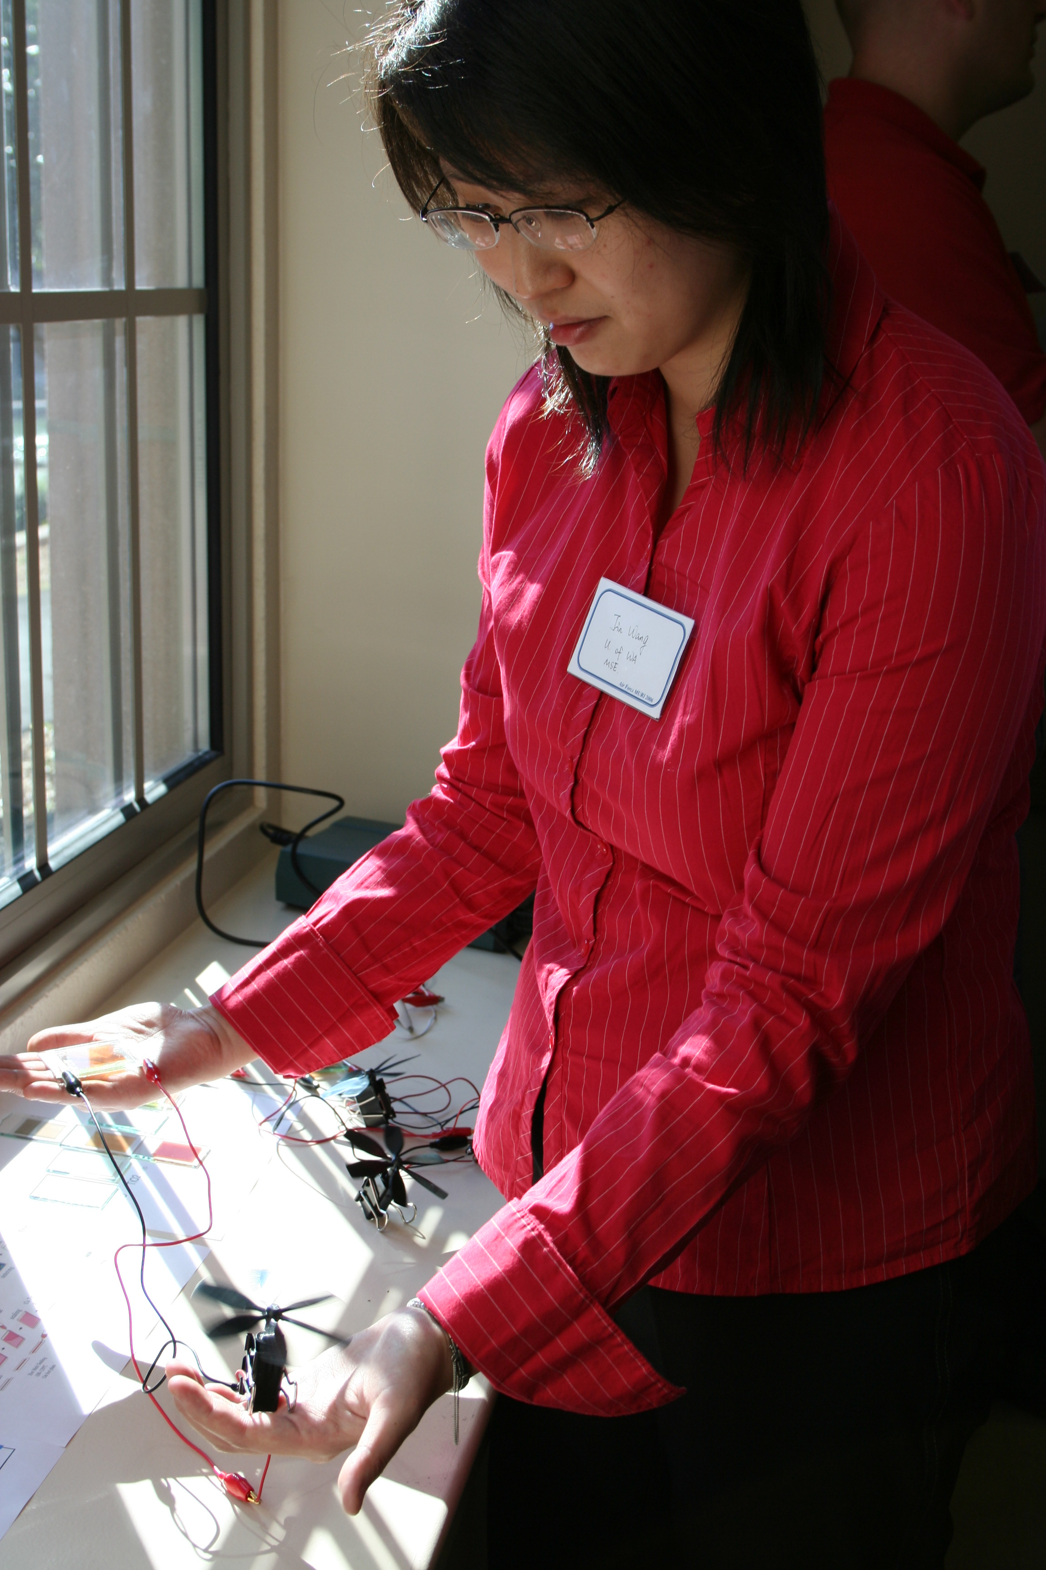
ARLINGTON, Va. – Jin Wang, a material sciences and engineering department second-year doctorate student at the University of Washington, holds a model engine in her left hand being powered by the solar energy collectors held in her right hand. The “Bio-inspired Design of Dye-Sensitized Solar Cells” was on display recently at the Air Force Office of Scientific Research MURI kickoff at the University of Washington. (Air Force photo by William Sharp).

