Example #1

Inspired and assisted by Cesar Chavez, Washington farm workers began to organize in the early 1970’s. They formalized their union through the United Farm Workers of Washington State in 1986, but still suffered from low wages, high unemployment, substandard conditions, and unsavory recruitment practices. A meeting with Governor Booth Gardener in 1987 did not yield any substantive changes. In 1988 workers began picketing the Chateau Ste. Michelle winery in Woodinville, and by the early 1990s the United Farm Workers launched a full organizing and corporate campaign. They sought a union contract and an end to the abuses that farm workers were facing on the job. The first union contract was reached in 1995 for farm workers in Washington State. Today the UFW in Washington State, headquartered in Sunnyside, continues to organize and appeal for farm worker rights and dignity.
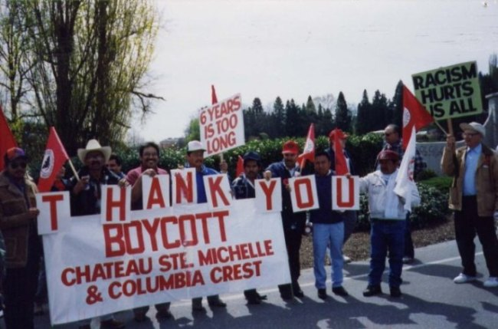

Source: United Farm Workers of Washington State History Project http://depts.washington.edu/pcls/ufw/photographs.htm

Example #2

In 1854-1855 Washington’s governor Isaac Stevens conducted treaty negotiations with Native Peoples around Puget Sound that secured, among other things, the right for Indians to fish “in their usual and accustomed grounds... in common with all the citizens of the Territory.” However, over the following century, as non-Indians poured into western Washington, Native people found every aspect of their fishing activities increasingly limited. By the mid-20th century, numerous state regulations severely limited fishing as a livelihood for western Washington Indians.
In the 1950s some western Washington Indians began asserting that the 1854-55 treaties created a special legal relationship to the United States that superceded state authority. In the face of arrests and violence, some Native people protested by staging “fish-ins.” “Fish-ins” defied state laws in a variety of ways. For example, though the state had banned the use of nets, which was many Natives’ preferred method, Native people openly fished with nets and risked arrest. Particularly dramatic were the protests on the Nisqually River which drew national media attention when actor Marlon Brando joined in the protests and was arrested along with the others. The western Washington Indians’ protests were meant to demonstrate that the century old treaty fishing rights were still applicable. In 1974, the protests paid off when federal Judge George Boldt sided with the Indian protesters.

Written by Nathan Roberts, Department of History, University of Washington

Example #3

The open housing campaign in Seattle began inconspicuously in the 1950s with the efforts of the NAACP, the Urban League and the Jewish Anti-Defamation League to assist Blacks, Asians, and other people of color who wanted housing outside of the Central District.
Even though residential covenants were outlawed by the 1948 Supreme Court ruling in Shelley v. Kramer, resistance by White homeowners and realtors prevented the majority of Black Seattlites from leaving the Central District. In 1960, nearly 80% of the city’s 26,901 Black residents lived in four of the 110 census tracts.
On July 1, 1963, Reverend Mance Jackson and Reverend Samuel McKinney led a march protesting the city government’s delay of passing a citywide open housing ordinance. Thirty-five young people from the Central District Youth club left the march and staged Seattle’s first sit-in, occupying the mayor’s office for nearly twenty-four hours.
: Taylor, Q. (1994). The forging of a Black community: Seattle’s Central District from 1870 through the Civil Rights Era. Seattle: University of Washington Press.
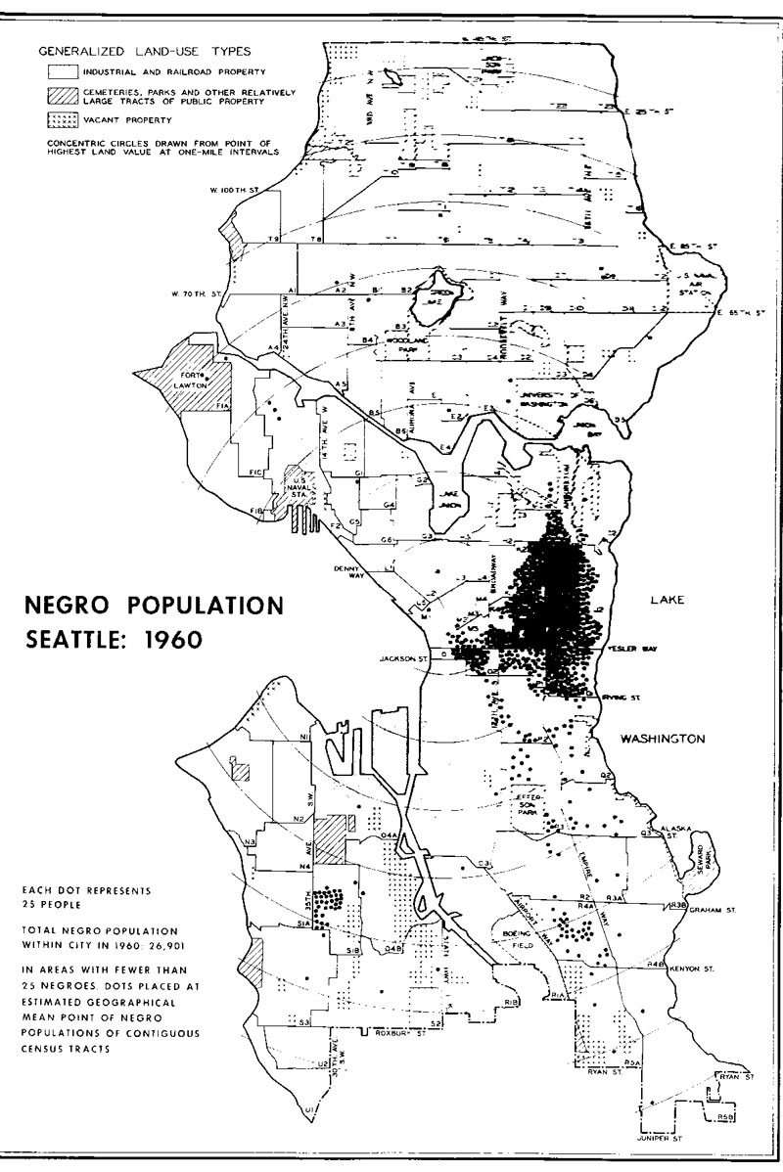
Example #4

In Depression-era Seattle, Filipinos found work through the contract system, in which a middle man would connect the worker with a job...for a fee. Many men saw this as corrupt and unnecessary. Once they found jobs through this system, Filipino workers were sent to Alaskan canneries or Yakima Valley farms. On the job, the men noticed that there was a dual labor system; Filipino workers were hired only for the least desirable jobs. Facing discrimination in the canneries, they were treated as inferior employees. Due to these persecutions, some workers decided it was time to organize. The men were faced with prejudice and hostility, yet many men were determined to protect themselves through organization.
“From the pool halls and dance halls, men talked about the benefits of organization, realizing that they needed a union to protect the rights of cannery and farm workers. In 1933 the Cannery Workers’ and Farm Labors’ Union Local 18257, the first Filipino-led union in the United States, organized in the Pacific Northwest. Based in Seattle, it was organized by "Alaskeros" who worked in the Alaska salmon canneries each summer and in agricultural regions of Washington, Oregon, and California in the other seasons. Shortly after the union was launched the battle began; facing accusations of communism and the possibility of deportment or murder, union leaders persevered and succeeded in changing many unfair conditions of Filipino labor.”
-Micah Ellison, “The Local 7/Local 37 Story: Filipino-American Cannery Unionism in Seattle, 1940-1959.”
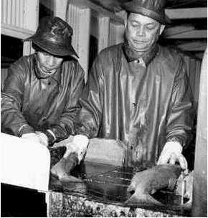

Source:The ILWU Story: Six Decades of Militant Unionism http://www.ilwu19.com/history/the_ilwu_story/the_marine_division.htm
Example 5

On May 1, 2006, thousands of people marched through downtown Seattle to agitate for immigrant’s rights. Labeled a “Day without Immigrants,” workers boycotted their jobs, and marched instead. Carrying American flags and signs with slogans such as, “We Are America," "Immigrant Values are Family Values," and " "U.S. needs our labor, we need our dignity," marchers attempted to draw attention to the contribution that immigrant laborers make to the U.S. economy and society. The march was in response to proposed changes in immigration law that would crack down on illegal immigration, potentially deporting thousands of people.

