CIS 201c: A Course Portfolio
John Staneff, Instructor, Pierce College, WA

Abstract: CIS 201c at Pierce College is used to develop this course portfolio. Included are experiences having taught the course, now 4 times. Discussion and interaction with other members of the Disciplinary Commons regarding this course helped lead to an introspective analysis of the course as it has been taught. Support materials and sample assignments are presented. Conclusions about the course, how it is taught, and useful changes foreseen are presented.

Introduction and Background

Computer Information Systems 201 (CIS 201c) is taught at Pierce College, Washington’s Ft. Steilacoom campus as part of the Associate of Applied Science in Programming Degree. It is considered an integral component in the University Transfer program that allows community college students to transfer to 4-year schools. And, by articulation agreement, it is accepted at par for the University of Washington’s Tacoma campus in lieu of CS-142. CIS 201c follows, mainly, the curriculum put forward in the Association for Computing Machinery (ACM) guidelines for Computer Science I (CS-I).

Construction of this Course Portfolio occurred during an academic year-long Disciplinary Commons wherein faculty members from several community college and 4-year schools in the south and western Puget Sound area cooperated to analyze one course taught at each of the schools represented. By far, the CS-I course was the most popular course selected. Most of the analysis for any specific course was introspective, that is the faculty who teaches it did the analysis. Each course selected was also observed by other members of the commons, and all materials prepared were examined by at least two other members.

Anticipated readers of this document include fellow faculty at Pierce College (including those based at the Ft. Steilacoom and Puyallup campuses, as well as off-campus faculty), fellows in the Disciplinary Commons, and their peers at their own institutions, other interested faculty in the Puget Sound region, as well as any who may simply be curious at what they have uncovered as they searched the web. Making this document freely available on the web serves the dual purpose of “publishing” the results of analysis as well as seeding future thought and planning for similar course portfolios.

Computer Science is an evolving discipline, having sometimes reached plateaus from which the discipline emerges when new technologies overturn previous assumptions. Computer Information Systems at Pierce College is generally not “full-blown” Computer Science, but in the case of 201c, it is. Because 201 plays that role for Pierce, and because it is a University Transfer program course, it must meet (or exceed) specifications for what is taught that are largely set by others. It is currently the case that 201 uses the Java programming language as its target language instantiation of Computer Science concepts. By studying Java and its use of Classes, the course takes a student who has some basic knowledge of computer programming and develops a foundation of understanding in the Object-Oriented paradigm.

Pierce College’s AAS Programming degree has several sub-tracts a student may choose from to complete degree requirements. University Transfer program is one such tract, and currently includes CIS 201c, CIS 202c, and an elective. (CIS 202c is the follow-on course, CS-II, and is generally considered as CS 143 at local 4-year schools.) Other tracts are available to the student, and the total degree requirements are such that it is likely a student will have completed at least two separate sub-tracts prior to graduation (the student will then select which of them the degree is “for”). (It is also possible for a student at Pierce to earn more than one concurrent Associates degree.)

Prerequisite to CIS 201c is CIS 122, Introduction to Structured Programming. By convention in recent years, CIS 122 has served to introduce problem solving techniques to students, to provide the fundamentals of programming logic constructs and primitive data types, to introduce the concept of “problem space partitioning”, as well as to jump start the student by using various versions of the BASIC programming language. Problem space partitioning may be better known to most as decomposing the problem into smaller and smaller pieces so that eventually a piece is small enough to be solved. It is therefore expected that a student entering CIS 201c is prepared in some basic way to begin the more difficult task of dealing with Java and objects.

(CIS 122 also has prerequisites, including CIS 121 and Math 98. Math 98 is essentially equivalent to pre-college algebra. CIS 121 is an introductory survey course of the CIS field.)

Pierce’s course catalog lists CIS 201c with this description:

“An introduction to computer science using a high level language, problem solving and programming techniques; syntax and semantics through arrays, text files, programming practice (ACM CSI).”

These are the enumerated course outcomes for CIS 201c:

1. Apply the syntax and semantics of the chosen computer language to create and modify programs using loops, selections, nested structures, and arrays of basic data types.
2. Predict the output of programs involving nested selection, looping constructs, and arrays.
3. Apply basic algorithm design tools to the program design process.
4. Evaluate code with respect to its maintainability.
5. Identify and apply basic debugging strategies.
6. Identify and apply object-oriented design, coding terms, and concepts.
7. Create and modify programs using multiple classes, arrays of classes, constructors, polymorphism, and inheritance.
8. Demonstrate the correct use of programming environment software features, including debugging tools, editor features, and help options.
9. Incorporate within programs comments and other techniques that enhance clarity and maintainability.

Outcomes are approved by the college’s committees (Cluster and Class) appointed to monitor and control the curriculum.

Winter Quarter 2006 is the fourth time I have taught CIS 210c, and it is the third time I have used materials stemming from a project begun in Winter Quarter 2005 when Pierce, Olympic College, and UW Tacoma jointly taught the class via Instructional Television (ITV). That class was a pilot, and its future is uncertain, however, the materials covered in the ITV project combine to form a course that meets the course outcomes at Pierce College as well as at UW/T. This is important considering that university transfer is a critical goal of CIS 201c.

Delivering three quarters of nearly identical material delivered to similar sets of students provides an ability to compare student progress in material with respect to their peers (earlier or after). It also affords an opportunity to measure class progress to determine if it is too fast or too slow paced. Since previous students have succeeded in this course, and the materials are similar (or identical), it can be reasonably expected that current students will succeed. It is also helpful that a base of frequently asked questions (e.g., a knowledge base about the course and assignments) is built, casually, and provides a good basis for helping students who may be floundering.

Importantly, repeating the materials with only minor updating where necessary allows me to focus on instruction rather than a continual process of course development. Of necessity certain assignments must change from offering to offering, so as to keep students from copying the work of their predecessors. Such changes also help keep a spark of interest going in the course, both for me as the instructor and for the students who sense that what they are working on is “new”. While updating is minor, it is continual, thus helping keep the course from staying too long on a plateau as the field evolves beyond.

What follows summarizes the efforts spent analyzing CIS 201c. Changes to the course may at first appear to be limited by the Articulation Agreement with UW/T, but changes to how the course is taught are not. As a result, much of the focus of this Course Portfolio is targeted toward classroom success and student learning.

Several items referred to in the text may be found in the appendix. The chart below shows the relationship of this course to the entire CIS Programming program at Pierce College.

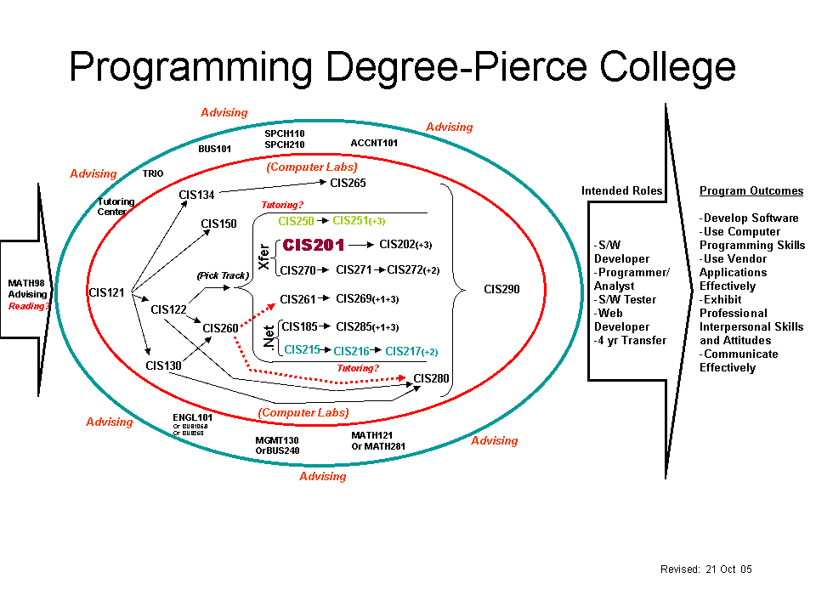
Course Design

Key to successful teaching is the teaching philosophy governing class presentation and student guidance. Implementing a philosophy, however, is subject to the vagaries of such meddling things as the current student mix, changes in the underlying technology, whether I have had enough sleep lately, external time pressures, and probably the phase of the moon. The computer scientist will recognize most of these as “soft science” issues and blatantly try to ignore them. The classroom teacher realizes, however reluctantly, that these so-called “soft issues” are essential to good delivery, and certainly to good reception.

Some of the difficulty can be programmed out by means of programming in things that seem to make presentation of ideas “automatic”. While little can be done to turn a didactic and crusty old fart into a “silver tongued devil”, at least the rough edges can be battered down somewhat.

This section of the Course Portfolio seeks to deliver the teaching philosophy and to show how the delivery of materials is structured.

My teaching philosophy is an evolving one. My background in industry (over 35 years in most phases of IT and product development involving software) leads me quite strongly toward helping students who demonstrate the root skills and talents. It cautions me to not overly encourage those who do not so demonstrate because for those students, continuing in a poorly-matched discipline may be a serious error.

Ah, but who am I to make such judgments? Fair question, and it deserves fair treatment. Surprisingly, I do see the validity in teaching this discipline to those who should never practice it. Conversely I also see the downside in such students holding back an entire class as they discover what they do not like about CS-I. Sometimes the greatest lesson a student learns is through failure. A student who previously anticipated a career programming computers, and who discovers it is much too tedious for their taste, and who performs well below the class average, may learn the most valuable lesson: find another field.

I am a firm believer in teaching students to look at computer applications through problem-solving eyes. I have learned to avoid the “urge to code” and find that a thorough examination of the problem-space made prior to any coding greatly reduces the effort required in coding and in “debugging”.

Nearly as much, I am a believer in the idea that anyone can code; coding is the easy part. So, apart from teaching the various constructs, and ensuring that students can actually apply them, computer language syntax and semantics are not much of an issue.

Problems are not solved by “bit-twiddling”. They are solved by partitioning and resolved by abstraction. It is imperative that students learn the basic techniques of divide-and-conquer, that they learn to recognize classes of problems and abstract particular instances into general cases.

Our world has evolved significantly in the time that computers have been readily available, and the field of programming has evolved to perhaps even greater extent. Today’s computer programmer has specialized in narrow ‘market segments’. Today we can teach the basics, and how to decompose problems and structure software, but we must also teach students what resources are available and how to make good use of them.

One aspect of programming that students seem to have a difficult time with is that when one programs, one is not reciting from a list of memorized answers. Programming is by no means an exercise solved by rote memorization. To succeed in programming a programmer must be capable of performing independent, and fairly complex, problem solving. Many times the answer is simply just not available anywhere else. In my cynical and jaded view of the world, this equates to an automatic skepticism of younger students. Students who have just managed to escape high school and who have no preconceived notion that college is different, may quickly become flustered by a course where there are very few, if any, memorized answers. Older students, those returning to school after a time away, seem to have an easier time recognizing that they have to solve the problems themselves and that memorization is not key.

But there are exceptions, and sometimes they surprise me. Sometimes even pleasantly.

One set of students has proved to be somewhat ill-prepared above all others. The Running Start student (high school student taking courses at the community college for dual credit, both in high school and at the college) is still firmly affixed in the mold of answering all questions by rote. Several of these students baulk at the demands of highly organized computer programming. In most cases they simply are not ready for it. (And some are, including at least one of the brighter students I’ve had the pleasure to teach.)

My basic approach with a class is to begin with lecture, work into in-class lecture-based demonstrations, and evolve toward largely in-class project programming assignments. Learning by doing is important; having the computer constantly barking at you to “get it right” is a lesson best learned with an experienced programmer available to help you see what the computer is complaining about. Because CS-I introduces so much new material, and does so at the start (where else could it?), this class is heavily oriented toward lecture in the first several sessions. Some students find that difficult. Surprisingly there have been relatively few dropouts from this class.

One difficulty in this class, for the younger student, is that it meets only twice a week, and the meeting period is much longer than the normal 1 hour class.

In more basic programming classes, such as CIS 122, I tend to use ordinary mathematical equations and formulations for problem sets, specifically because they are readily proved. In CIS 201c, there is a bit more focus on “business-like” problem sets. Solutions are less provable, approaches are more varied, and that certain liberty to design the program bubbles-up when students compare their solutions to the problems.

Unfortunately for students, however, Java (and CS in general) is not simply a “pick and choose” opportunity, but a highly structured and mathematically precise discipline. Students quickly learn that they either “get it” or they don’t. Object-Oriented thinking involves considerable abstraction, and it is something many students never do well. When I start seeing a student who just struggles with the basic concepts, I also struggle to try to find the appropriate time and way to intrude so as to provide assistance, advice, a source for tutoring, or such-like.

Reflecting that in my philosophy is the basic assumption that this class is not teaching the Java language, it is teaching computer science. Students who only enrolled so they could learn Java will most certainly get more than they bargained for.

In essence, then my teaching philosophy requires that I do whatever I can to help a student learn, but to also recognize when a student is incapable of learning. Both have happened, and I’m sure both will again.

I cannot change the student such that the student becomes more pliable, more receptive to learning, more creative, more able to document work performed, and etc. I can recognize what the student is capable of doing, what the student illustrates willingness to do, and maybe help guide that student. Often guidance is in the form of “here, let me show you a trick”. Rarely does a student respond well to “That’s’ wrong. You lose 10 points.”

Course materials are delivered via lecture and in-class example. (In-class exercises and exams serve to reinforce those materials.) The nature of the materials is such that they are structured in a by-class segment manner. The class is presumed to be a twice-weekly, 2 hour and 10 minute session. It is therefore possible to monitor progress by means of ticking off the number of segments delivered.

Shown in the attached syllabus is the general outline of how the class progresses. Each day’s segment is given in a rough headline; details to be supplied in-class. The syllabus grants that I reserve the right to change it at any time, and that reflects an important piece: how quickly we progress through the material is a function of how quickly students get bored with it and exhibit the need to move on. Some students proceed at the “standard’ pace, others move quickly and need additional materials to keep them going. Some students feel that the standard pace is too fast and require considerable time for detail learning. When an entire class illustrates a common need, then the class is appropriately adjusted. Of the three classes taught from the current materials, each condition has been met. There is concern on my part that the materials delivered are therefore somewhat dissimilar, but the course is designed so that even the slowest class will meet the course objectives.

Two texts are required for this class. They are “Data Abstraction and Problem Solving with Java Walls and Mirrors” and “Barron's How to Prepare for the AP Computer Science Advanced Placement Examination Java Version”. Some criticism has been levied against use of the “Walls and Mirrors,” in that it appears to be “more advanced” than the typical CS-I course. That criticism has been counter-balanced by the use of the other book because it brings in the more basic parts of instruction, such as statement structure, how and when to use specific statements in the language, and so on.

Given that the focus is on Computer Science rather than on Java, it means that the student may struggle to learn the meaning and use of basic language constructs, if that student has not met the previous programming language requisite. Some students are allowed into the class by instructor’s permission, and others by advisor’s request. . (A previous instructor was adamant about not wanting students to have had previous programming experience; a feeling I most certainly do not share.)

Many students ask if another, simpler, book might be available to help them learn Java. I generally do not offer suggestions, but I have seen books like “Java for Dummies” and suchlike on student’s desks. My general feeling is that books like that distract the student by focusing on the language rather than the concept. Some students need the more concrete example having found abstractions too difficult.

When the course was taught as ITV, “Lewis and Loftus, Java Software Solutions” was used as the text, and it may again. When used it was the sole text. For reasons having to do with student’s finances, I may require “Lewis and Loftus, Java Software Solutions” for the course, and suggest “Barron's Advanced Placement” as a useful companion. Such a switch may prove “popular” but it must also be able to cover the bases with respect to the material covered and assignments, etc. Clearly it will require a review of required reading.

Because some students have not taken the prerequisite programming course, I make certain materials available for downloading. I do not maintain a course web site, but do keep files on a shared drive. The shared drive is available in the class/lab, as well as in the various computer labs at Pierce. Some of these are fairly basic: how to do successful homework assignments; program structure charts; and etc. Some are more complex, dealing with problem solving techniques. For students who have taken my CIS 122 course, they have already been exposed to these materials. Others, and especially those taking 201 as their first programming class, may find them to be useful.

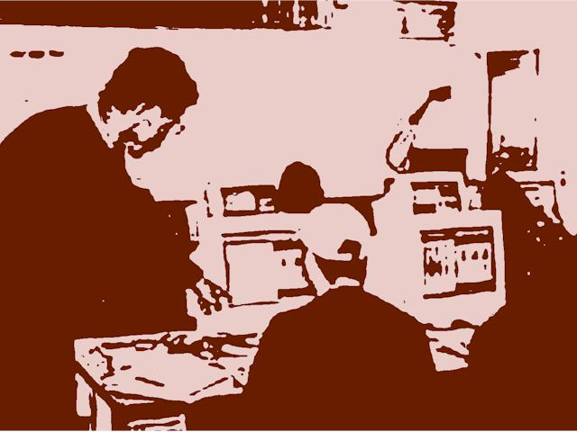
Enactment

Students of CIS 201c experience a variety of teaching methods generally oriented toward student learning. A typical course begins in a fairly didactic way with lecture consuming much of the period. As students complete reading assignments, they are exposed to in-class use of computers and the Java language programming environment. Continuing through the course, the quantity of lecture diminishes and the amount of time spent working on in-class examples increases. Toward the end of the course, much in-class lab time is oriented toward a specific multi-session (over several days of class) programming experience. The class has several assigned homework assignments, of increasing difficulty. There are 3 exams scheduled, the final and two intermediate exams.

Those students who have not had prior programming experience (e.g., did not take CIS 122) may be at a disadvantage since the course does not focus on the language so much as it focuses on the objects one uses to write programs using the language. Also, there is little direct instructional focus on “problem solving” since that is well-covered in CIS 122. Therefore, those who gain entrance by “permission” have a more difficult experience than others.

Borland’s J-Builder is used as the class programming environment. While free to students, and available on all machines in the on-campus labs, there are several versions of this product installed (different versions on different machines), making use somewhat difficult. As well, it is slightly out-of-date (e.g., Scanner is not yet built-in). Due to Borland’s intention to sell off its IDE business, it is unlikely we will continue to use J-Builder in future classes.

Of the seven programming assignments, I have included assignment number 3 in the appendix of this Course Portfolio. (It will, of course, be significantly different “next time”, since this exposure may serve to forewarn students. ) Assignment 3 is a transitional point where the work begins to get harder and the time a student takes to complete it grows.

Observation shows that only two students have flagged by this point. One was “rescued” by personal attention (coaching), the other continued but never fully recovered (even though receiving attention from both another student and myself). Most students seem to take the increasing challenge in stride, and to show a sense of accomplishment in the work done.

It should be noted that I do not visit the contents of the assignments before assigning them, and rarely go over them once they are due. Generally I do not like to discuss their contents while they are outstanding … in sum, I do not like to discuss assignments in lecture. There is, however, the (rare) situation where a class is struggling with the work, and in such instance I do sometimes tackle a bit of the assignment for explanation / illustration in class. I generally do not do the hardest parts, but may cover something like a menu or an input utility, or some-such that is needed, but is relatively minor to the assignment. (Interestingly, even when it’s done in class, some students still “get it wrong’ in their completed homework, and other students may not realize that only a portion of the whole problem was worked on in class.)

Assignment 3 has several parts, the first is shown here;

- Payroll

John, Mary, Tom, Peter and Paul have banded together in their quest to provide the ultimate burger for all their very best customers. In order for the JMTPP Burger Joint, better known as The Jumping Tea Pot Burger Emporium, to work, they have decided to hire YOU to produce a payroll program for them.

The payroll program takes as input an employee ID number, a positive integer. That number will correspond to a file in the current directory. For example, information about employee #15 will be in a file named 015-hours.txt, and information about employee #2 will be in a file named 002-hours.txt. Notice that leading zeros are significant in the file name: the file is 002-hours.txt, not 2-hours.txt. Your program will be run one time for each employee. Each time it is run it will write a "simulated paycheck" for the employee to the standard output stream. The "paycheck" will consist of three lines:

- output line 1: the current date
- output line 2: the payment line of the form "Pay to the order of <name>: $amount"
- output line 3: a memo line: "Memo: employee #<employee number> for the period <date1> through <date2>"

Information in the input file for each employee takes the following form:

- line 1 contains the following items
o the first date of this pay period int the form mm/dd/yy
o the employee's first and last name (first name separated from last name by white space)
o hourly wage rate (a floating-point number)
o the number of dependents (a non-negative integer)
o the dollar amount of pre-tax retirement deduction (an integer dollar amount)
- lines 2 through 6 each contain a single floating point number containing the number of hours worked on days 1 through 5, respectively

Tax is computed on the basis of the following rules:

- gross pay for the week is paid at the employee's wage rate for the first 40 hours, and at 1.5 times the wage rate for any additional hours
- medical deduction is $100 for the employee, plus $50 for each dependent
- taxable income is gross pay less the retirement deduction, less medical deduction, except that this number cannot be less than 0
- tax is computed on taxable income at the rate of 18%, less 2% for each dependent, but cannot be less than 0%
- the paycheck amount is taxable income less tax, but cannot be less than 0

There are three sample data files in the assignment directory. Note however, that your program must work for any valid data file in your application's current directory. (That is, we should be able to add a new data file for a new employee, and your program must work for that new employee as long as the data file is formatted properly.)

Here is sample output for employee #2:

Please enter an employee ID: 2
01/18/05
Pay to the order of Tom K Smith: $327.60
Memo: employee #2 for the period 01/03/05 through 01/07/05

You must complete this problem without using any IF statements!
This application will be named Payroll.java

In order to be successful for this part of the full assignment, the student must be able to use the Scanner class, to open a Scanner on an input file, to be able to parse data from that file using a second Scanner class, and to perform the usual kinds of calculations one expects in a payroll application.

Most students find this to be a challenge, but are up to the task. Some students discover at this assignment that they have not been paying attention: they have no clue how to proceed. The hardest part for many students seems to be the requirement to not use any IF statements.

Students also struggle, immensely, with the problem of obtaining a name that may be one, two, or three tokens in length. Worse, there are numeric fields following the name. It is critically important that students learn to use inverse logic to solve this problem. Many do not, and eventually hand in an assignment that may be custom tailored to the specific input files (wrong answer, of course!). As before, even when this problem of inverse logic is worked in class, a fair number of students fail to recognize it as being helpful to them in this problem.

Class Observation

During development of this course portfolio, several members of the Portfolio Commons team observed one another doing instruction. In addition to observing Richard Hoagland and he me, I also asked Ms Chris Martin of Pierce College to observe this course. Brian Martin (no relation to Chris) from Pierce College’s Digital Design program also visited the class and had a comment to offer.

Because I am still in the tenure process, the class is also observed by my tenure committee, and via end-of-quarter student evaluations. In effect, then, this is a well-observed class.

Importantly, some observations are more critical than others. I value all observations, but will focus on those that seem to somehow suggest a change is needed. Why? Primarily because these observations reflect how some learning is NOT happening. Those that reflect learning are nice to have, nice to point to, nice to remind me of the good job I do, but don’t much encourage improvement.

Brian’s observation was simple: “tell ‘em what your going to do, tell ‘em while you’re doing it, and tell ‘em what you did when it’s over.” That’s the Army’s way, and it works for them, so do it!

Observations from the tenure committee have been glowing. Typically they say that they observe me having an intense desire to teach students, and that the students seem to appreciate that. Mostly they say that I have a solid background in the subject, am an authority in the classroom, and practice a “soft Socratic” method of instruction.

One tenure committee member asks a different question: “If you’re so good, why do we have high dropout rates, why do we have declining enrollments?” Hard questions, and questions that are not necessarily realistic for this course. In one specific instance, a student who had simultaneously enrolled here and in a prerequisite programming course opted to drop this one and focus on the more fundamental one. Good choice. In other circumstances I have seen students who had not taken the prerequisite finally decide to drop. The broader question of declining enrollment may be better addressed in an appropriate forum. This class is unlikely to be the primary factor in declining enrollment, especially when this class is so poorly attended. The declines appear in the beginning courses first, and filter throughout the program. CS-I is a 3rd course in our sequence, and is most probably not a determining factor for a student deciding against Computer Science.

Students vary in their take on the class, and that may vary at different times throughout the quarter. See the End Note for more specific information.

Chris took some time to evaluate a sample hour of lecture. Her evaluation was oriented toward the way the material is presented. Her background leads her to considering such things in a 4-quadrant perspective: Why, What, How, and If. Each quadrant has specific things that occur during instruction, and during learning. (This is documented elsewhere as a “4Mat” model.)

In her analysis, she determined that most of what I do comes from the What quadrant, none from the If quadrant, and a bare minimum from the Why and How quadrants. This is not unexpected, considering that the What quadrant is frequently called the “expert’s quadrant”. Her comments here include “Provide information to students”, “Write on board during lecture”, “Demonstration problem by instructor”, and “Problem solving by instructor.” These are certainly fair observations. For the Why quadrant, her sole comment was “Some Socratic questioning”, and for the How quadrant, her sole comment was “Lecture with demonstration.”

To some extent, this observation of teaching style matches fairly well the placement of the lecture in the course. In other similar observations (charts pasted on my office walls testify), I have been seen solidly in the What quadrant, mixed between Why and What, crossed between If and What, and heavily into the How quadrant. Each reflects a different place in the natural progress of a course: a single observation is insufficient to determine any specific bias, unless of course all show the same bias. So, this is a fair observation.

Richard’s observation was of a technical nature: handwriting, font size on the display, clarity of voice, and suchlike. The observation has two specific parts: a play-by-play of what happened, and a set of impressions. The impressions are certainly more useful.

He noted that students did not interrupt with questions as he would have expected them to. He was also surprised that I accept assignments late. He has firm due dates and expects work at those times. While I prefer work done on time, I do accept late work.

He was also somewhat unhappy with the long class period (his classes are just 50 minutes each). In his view the students were beginning to fade as the class wore on. He suggested small groups and/or lab exercises to break up the period.

Richard ended his observation stating it was clear I know the material and do bring in real-world experiences to the classroom for discussion.

One final observation should be mentioned: a fellow faculty member who is a part-time faculty from another discipline but who had previously spent 30 years teaching in another community college in this state was shocked and appalled that Pierce does not monitor students while they provide their classroom evaluations at the end of the quarter. In his view this allows students to “gang up” by discussing their ideas before writing their comments. Sharing this view helps me somewhat when the students’ comments seem “too similar”.

To summarize the observations: these focus on the “negative” because focusing on the positive is not useful if I am looking for ways to improve subject delivery. Many of the comments are reactive to the essential tension in this course: a semester’s worth of material crammed into a quarter with a “governing body” watching to see that the material is sufficiently covered, and that is willing to discard the Articulation Agreement if the material is not. Too much, too fast, and students too ill-prepared lead toward a course that is hard. The talented and the determined get through; attrition is high; and, the retention rate to the next course is not high. Arrgh!

A final note: Yes, looking at good things can help to see what does work, and perhaps how to leverage that. Unfortunately much of the “good stuff” is vague and difficult to actually use. People seem to be more able to critique than to compliment.


Assessment of Student Work

Some questions arise when assessing student work, some obvious, and some underlying. Here are a handful of these questions, and an earnest attempt to answer them in a meaningful manner (e.g., not too flip!).

Importantly, one must consider the first question (and maybe all of them) as having a rather mundane answer: “Because that’s the way it’s always been done”. This is both true to a large degree, and insufficient. As the insufficiency is explored, possible meaning arises, as does, possibly, an hither-to unseen emergent goal.

I. Why do you grade the way you do?

Work products include description, program structure charts, decision tables or other documentation, program code, and evidence of test. A working program is the first important work product, but it is insufficient. All phases of the program development process must be in evidence to demonstrate a proficiency in programming and an understanding of the basic principles involved. Test data must be shown to have been examined and the program proved against it.

My many years of industry experience illustrate that failure is common, no matter that it is "not an option". All too often a program has been written that only works for the most common case, and crashes whenever "wrong" data is supplied. Crashes that cause long production runs to be restarted cannot be long tolerated. Poor documentation leads to poor maintenance and production failures. I've seen a lot of that, and want to instill avoidance of it in my students.

But, that's not answering the question. The specifics of how an individual problem is graded are vague, even as I do the grading. Saying that I grade "viscerally" may be accurate, if "politically incorrect". If I don't know how I'm going to grade until I see the work, how can I let a student know the criteria for getting a good grade? Why am I unscientific about how I grade? Is it unfair to other students? One thing that is clear, however, is a strong reliance on how I graded this specific problem in a previous class: the hardest grading is the first time a problem is graded. In effect, I build an ad hoc rubric for each problem, when it’s initially graded.

Still, I look at some student work and think "This is crap”. I look at other student work and think "this is okay". Sometimes I'm impressed favorably. Why? Because the ideas expressed in how to solve the work are good.

I have noted that I will make more red marks on a better paper than on a poor one. Why? Because the red marks are intended to guide the student toward a better, more thoughtful, solution. The absence of red marks typically indicates very poor work. How does one make comments about what's simply not there?

II. What does your commentary on student work convey to students?

I want it to convey: "this works, here is a better way you could do it". Sometimes I want it to convey "neat idea, good job". Sometimes I just want it to convey: "good work", especially when a struggling student has finally done something half-way decent.

What it really says can be taken critically. Any student who takes criticism poorly can be overwhelmed by some of my comments. Here's an example from student "BS": "Shows not yet understanding the concept of looking for the inverse". What does that mean? Is it a signal to "BS"' that s/he is stupid? Or, is it a signal that s/he missed an obvious approach? Or, is it just a tickler to think "beyond the box"? In the event, it is a signal that there's an obvious approach that was missed: look at the problem backwards to find the proper solution. We have to have an open mind to find solutions, things are not always forward-looking.

That's a problem for new programmers. They want a "concrete sequential" world and do not tolerate well the abstractions and randomness that programming requires. They have not learned to keep multiple pads of paper (or edit sessions, or ...) at the ready to jot down, revise, augment, etc., as the ideas occur to them.

Some comments are related to the solutions itself. For example when the ChangeMaker.java program is US-centric, the comment might be something like "What happened to the 1/2 dollar coin, or the dollar coin?" This is mind-broadening. This is detail-oriented. It upsets people. Why? Because they do not want to think in that mindless detail quagmire of bits and bytes that is computer programming. If we don't use 1/2 dollar coins, or dollar coins, then why should the ChangeMaker.java program even be aware of them? The answer is not obvious to them: provide for it, and, keep a zero-on-hand balance. That's not a typical way of thinking.

So, some of these comments are oriented toward getting students to start thinking critically.

Then there's the case where a student is not given sufficient information to solve the problem. In the case of student "MR" this comment: "Good, you found the calendar and date software" was offered in response to successful research. Prior to this assignment s/he was just plodding along. Something in this assignment gave incentive to start looking. In the event, the comment rewards the effort and encourages more. This student did do more, and did well as the course progressed. Lesson: there is reward in effort expended.

III. What does it say about who you are and what you value as a teacher?

It says “I have a specific viewpoint and will share it with you whether or not you like it!”

I don't mince my words: "All the dead code serves to clutter up the program and make reading it confusing..." This shouts: "Clean this up!" Another: "Tight code needs a wee bit more white space to make it readable ...” This shouts: "I'm being subtle here! Clean this stuff up!!!"

What I'm telling the student is a foretaste of the workplace. Workplaces that do not do code reviews (peer or otherwise) may tend to fail. You have to review the code. Unless you do, you get poor product. Poor product leads to faulty deliveries to customers, and that leads (eventually) to business failure. Review the code! So, if your code is going to be reviewed, then you have to make it presentable.

I do not believe that your code is great just because you wrote it. Unless you're me, on a great day, your code sucks. So learn, fix it, and get over it!

What does it say about what I value as a teacher? I value the bright student who takes what's said, fixes things, and does me one better. That's good. I do not value the space-taker / time-waster who sits quietly in class and steadfastly refuses to do what s/he's told. How many examples can I start with a decision table, a program structure chart, a write-up of what's to be done, then code, then TEST, TEST, TEST? How many students can continue to sit back, do little to nothing, then jump into code and wonder at the end of the exercise why it doesn’t work?

Okay, I really dislike students who after 8 to 9 weeks are still unable to figure out how to split the program into separate methods, and who haven't a clue about how to use different classes. And, it really upsets me off when a student sits in class, does not turn in assignments, does poorly on exams, and never, ever, raises a hand in class for help, calls or emails, or makes an appointment.

IV. Grading rationale for the assignments that we are grading in common ....

This is easier: my first rationale is "did they do the work?" Secondly, "is it complete, does it work properly?" Thirdly, "is it hopeless, or does it show promise?"

Mostly I give one point for each major piece of the assignment. So a typical assignment represents from 4 to 6 points. Those are hard-won points, of course, but you can see from the grading that students are covering the bases and earning points. I frequently knock off 1/2 point, 1/4 point, 1/3 point, etc., as seems appropriate. Largely these are not determined via some generalized rubric.

Why no standardized rubric? Ah! This is programming, and there are multitudinous ways that an assignment can be correctly completed. So, I do not have a checklist of "did this, did that, should have done that, etc." I have an "open mind" about did the work succeed? If so, then I don't much care about style.

Style is an issue. The broader issue: code that is pleasant-to-look-at is art. But before we do style, we must do substance. Form does follow function, eh? Students learn by seeing good code what it should look like. Students have a serious problem, at first, figuring out the basic idea of indenting, using white-space, and such-like. But they learn over time.

Results

Interestingly, one unexpected benefit of doing this course portfolio project has been the revamping of one of the prerequisite courses to CIS201c. The CIS122 course, Structured Programming Methodology, has received a significant amount of remodeling, all due to the experiences found here.

Why that course and not this one? That course is a Pierce College course without significant impact to the University Transfer program. Hence it can be adjusted without much outside attention needed. And, as such, it can be “played with” to see what works before making significant similar adjustments to CIS201c.

Not unexpectedly, one significant result has been the increased rapport with the other members of the Disciplinary Commons. As we each worked our own Course Portfolio, we were editing and revising based on input from others who taught the same courses. Collectively our insight to the process of teaching the material, and to the students we teach grew.

Our continued interaction, our new-found voice when talking to and with the local university, our openness and cooperation, and our presentation of our work efforts, as a group, all represent an expectable outcome. But it is expectable ONLY if we each worked toward it, and we did!

Or, as Lee Shulman says, we have begun to put an end to our pedagogical solitude.


Analysis

It is easy to just grab the existing course materials and jump right into teaching the course one more time! It will be much harder to teach this course when it requires revisiting all lesson plans and adjusting for changes that are clearly needed.

One important “Take Away” from this process: enforce the requisites and don’t allow students in without them.

Another: place some time limit on the requisite courses. Students who wait too long (3 years or more) before taking the next class tend to do more poorly.

Another: partition the lesson plans so that it’s not all didactic lecture. Intermix some lab work, a break or two, engage students, and etc. In effect, more stringent partitioning of the material into “units” that can be sequenced along with labs to ensure better delivery, and better use of time.

Another: include more effective, and well-placed, group interaction. This is probably best placed near the end of the course, after students have passed by the watershed assignment.

Appendix:

Included here are support materials for the course. These are encapsulated here and would ordinarily be stand-alone documents

- syllabus including course assignment schedule
- sample assignment (#3?)
- how to succeed
- program structure charts

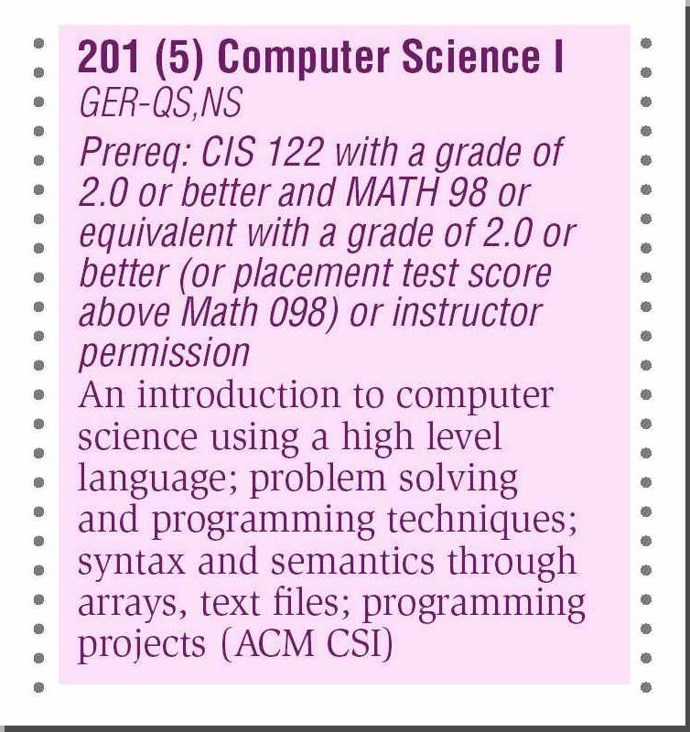
Syllabus Including Schedule:

 | CIS 201 – Introduction to Computer Science I (Java)

Class Title | Introduction to Computer Science I (Java) |  | Instructor | John Staneff
Quarter | WN 2006 |  | E-mail | <email addr here>
Inclusive Dates | 04-Jan-2006 – 15-Mar-2006 + final
Class Days / Time | #1090 MW 2:50 – 5:00 |  | Office Location | O-108

Textbook:
- “Barron's How to Prepare for the AP Computer Science Advanced Placement Examination Java Version” 2nd Edition ,Teukolsky
- “Data Abstraction and Problem Solving with Java Walls and Mirrors” Updated Edition

References & Materials
Students should have appropriate media to transport work (pen drive, CD-R, floppy disk, etc.). In addition, students are required to have a copy of the text. Additional sources for required and/or recommended reading may be found on the network drive or the Internet.

Course Description: CIS 201 is Computer Science I. This quarter the Java programming language will be emphasized. The primary goal of the class is to cover Computer Science I concepts, especially problem solving involving control structures and object oriented programming. However, some features of the Java programming language will also be covered.

Prerequisites
For CIS 201, the equivalent of a 2.0 or better in MATH 98 or higher and CIS 122 are prerequisites. Furthermore, students should be able to type at least 35 words per minute and have at least a 12th grade reading ability (in English).

Course Conduct, Requirements, and Grading
The course will be conducted as a lecture/lab combination. It is the student’s responsibility to attend each lecture and be responsible for the material that is presented during each lecture. Students are expected to complete at least 10 hours of course work/study per week outside of class. Plagiarism and/or cheating will not be tolerated and may result in automatic course failure.

Grading will be based on:
- Seven programming assignments (total 50%)
- Two midterm exams (total 25%)
- Final exam (total 15%)
- The remaining 10% of the grade will be based on class participation

Grading: 3.5 – 4.0 = A (90% and higher), 2.5-3.4 = B (80%-89%), 1.5–2.4 = C (70-79%), 0.7-1.4 = D (62%-69%), else F.

Disability/Special Needs
If you are a student with a disability and want to discuss or request support services, please contact the Disability Support Services (DSS) as soon as possible. Accommodations for qualified students are handled through this office.
Fort Steilacoom: (253) 964-6526 or 964-6527, Room 300K in the Cascade Building
Puyallup: (253) 840-8443, Room A115-F in the Administration Building

Class Participation: This is a fairly intense course. It is the student’s responsibility to actively participate in the course, and be responsible for all material described in the syllabus. If you are going to drop this course, you must formally withdraw. If you just stop doing coursework, you will receive a failing grade on your permanent record.

You will not be given an Incomplete as a grade…so, don’t ask.
Academic Integrity: Cheating and plagiarism will not be tolerated. All work must be your own.
At the instructor’s discretion, a 20% penalty per week may be assessed for late work.

Project Guidelines
Students will not receive credit for projects that fail to compile. A successful project must meet the requirements of all four of the following categories:

Category | Requirements
Maintainability: | Follows standards for naming conventions, indentations, spaces, blank lines, modularity, clarity, reusability, and documentation. Also includes other documentation such as a report that explains the concepts used and the choices made when solving the problem(s).
Logic: | Logic is efficient and correctly uses techniques appropriate for the chapter.
User-interface: | The user interface has a professional appearance, which is easy to understand and use. All visible controls are functional. Labels and tab order are used appropriately and all spelling is correct.
Assignment topic: | All requirements for the particular assignment are included, logical, accurate, and functional.

The Instructor may modify this syllabus at any time.

This schedule is approximate to what is covered per class period…

 | Day | Topic |  | Reading / Activity | Due / Assigned
1 |  |  | Intro / First Java program | WM – Ch 1
2 |  |  | Data and Expressions | AP -- Ch 1
3 |  |  | Data and Expressions |  | A1 due
4 |  |  | Using Classes and Objects | AP – Ch 2, 6
5 |  |  | Conditionals and Loops |  | A2 due
6 |  |  | Conditionals and Loops
7 |  |  | Conditionals and Loops
8 |  |  | Conditionals and Loops
9 |  |  | Conditionals and Loops |  | A3 due | MT 1
10 |  |  | Iteration, Examples, Decomposition
11 |  |  | Iteration, Examples, Decomposition |  | A4 due
12 |  |  | Object-Oriented Design | AP – Ch 3
13 |  |  | Object-Oriented Design
14 |  |  | Object-Oriented Design | AP – Ch 4 | A5 due
15 |  |  | Object-Oriented Design
16 |  |  | Object-Oriented Design |  |  | MT 2
17 |  |  | Arrays and Collections | WM – Ch 3 | A6 due
18 |  |  | Arrays and Collections
19 |  |  | Arrays and Collections
20 |  |  | Collections / Applets / Review | WM Ch 4 | A7 due

Course Assignment #3, in its entirety:

Assignment

CIS 201c, WN/SP/FL 200X

Assignment #3

Assigned dd/MMM, dd/MMM at start of class

- Payroll

John, Mary, Tom, Peter and Paul have banded together in their quest to provide the ultimate burger for all their very best customers. In order for the JMTPP Burger Joint, better known as The Jumping Tea Pot Burger Emporium, to work, they have decided to hire YOU to produce a payroll program for them.

The payroll program takes as input an employee ID number, a positive integer. That number will correspond to a file in the current directory. For example, information about employee #15 will be in a file named 015-hours.txt, and information about employee #2 will be in a file named 002-hours.txt. Notice that leading zeros are significant in the file name: the file is 002-hours.txt, not 2-hours.txt. Your program will be run one time for each employee. Each time it is run it will write a "simulated paycheck" for the employee to the standard output stream. The "paycheck" will consist of three lines:

- output line 1: the current date
- output line 2: the payment line of the form "Pay to the order of <name>: $amount"
- output line 3: a memo line: "Memo: employee #<employee number> for the period <date1> through <date2>"

Information in the input file for each employee takes the following form:

- line 1 contains the following items
o the first date of this pay period int the form mm/dd/yy
o the employee's first and last name (first name separated from last name by white space)
o hourly wage rate (a floating-point number)
o the number of dependents (a non-negative integer)
o the dollar amount of pre-tax retirement deduction (an integer dollar amount)
- lines 2 through 6 each contain a single floating point number containing the number of hours worked on days 1 through 5, respectively

Tax is computed on the basis of the following rules:

- gross pay for the week is paid at the employee's wage rate for the first 40 hours, and at 1.5 times the wage rate for any additional hours
- medical deduction is $100 for the employee, plus $50 for each dependent
- taxable income is gross pay less the retirement deduction, less medical deduction, except that this number cannot be less than 0
- tax is computed on taxable income at the rate of 18%, less 2% for each dependent, but cannot be less than 0%
- the paycheck amount is taxable income less tax, but cannot be less than 0

There are three sample data files in the assignment directory. Note however, that your program must work for any valid data file in your application's current directory. (That is, we should be able to add a new data file for a new employee, and your program must work for that new employee as long as the data file is formatted properly.)

Here is sample output for employee #2:

Please enter an employee ID: 2
01/18/05
Pay to the order of Tom K Smith: $327.60
Memo: employee #2 for the period 01/03/05 through 01/07/05

You must complete this problem without using any IF statements!
This application will be named Payroll.java

2. Making Change

This application, named ChangeMaker, will take as input a product price and an amount paid, both floating-point numbers representing dollar and cents amounts. The application computes and prints the amount of change due the user, and also expresses the change amount in number of quarters, dimes, nickles, and pennies.

(Assume no change is given in dollars, only in coins.)

For example:

Enter product price: 2.32
Enter amount paid: 5.00

Your change is $2.68

Quarters: 10
Dimes: 1
Nickles: 1
Pennies: 3

You can assume that the amount paid is greater than the product price, and that both inputs are "dollars and cents" amounts: positive numbers with at most two decimal places.

Your solution will be in a file named ChangeMaker.java

3. Encryption and Decryption

A company wants to transmit data over the telephone, but is concerned that their phones may be tapped. All their data are transmitted as four-digit numbers. They have asked you to write a program that will encrypt their data so that it may be transmitted more securely.

Your program should read a four-digit integer entered by the user and encrypt it as follows:

- replace each digit by the digit (digit + 7 modulo 10)
- swap the first digit with the third
- swap the second digit with the fourth.

Your program then prints the encrypted integer.

You will then write a second (separate) application that will prompt for and read an encrypted four-digit number, and decrypt it to produce the original number.

For example:

Enter a four-digit integer to be encrypted: 1234
The encrypted number is 0189

Enter a four-digit integer to be decrypted: 0189
The decrypted number is 1234

These applications will be named Encryption.java and Decryption.java.

What To Hand In

You will hand in four program source (Java) files, and one plain-text writeup file, with the name writeup.txt.

Please be sure that your Java files have exactly the same names specified in the program description.
Your write-up file will contain a "program debrief" for each programming problem. This should be one well- formed paragraph per problem that speaks to your personal experience when writing the program. Include such topics as: How long in total did you spend on the problem? How difficult was the problem to do? What pitfalls did you run into? What topics did this problem help you to internalize? What did you have to learn on your own in order to solve the problem? What ways would you change the assignment to make it more meaningful?

For example: a student wrote a program that inputs a number and outputs the square of the number and they wrote:

This program was easy for me overall as I had some C++ experience prior to this Java class so I am familiar with the syntax. I spent about a half hour writing the code and 5 minutes testing it. The only pitfall I ran into was when I first tried to run it, I got an error. It turned out that I had used a capital ‘M’ for my main method which allowed the code to compile, as “Main” is a legal name, though not conforming to standards. However, upon program execution I was given an error that stated that the main method could not be found. After I changed the ‘M’ to an ‘m’ my program executed fine. This assignment helped me to consider the importance of proper syntax and basic input and output. I thought this problem was a bit on the easy side even for a first program. I would recommend adding an additional element of difficulty, such as requiring the process to repeat.

Sample Input Data
002-hours.txt
01/03/05 Tom K Smith 8 1 500
20
20
20
20
20

023-hours.txt
12/25/04 Allen Hayes 10 1 200
10
0
10
0
10

112-hours.txt
01/10/05 Mike Green 11.5 2 300
40
40
40
40
40

How To Succeed:

This handout is generally made available to students in CIS 122, but is available for those in CIS 201c who have not previously seen it. It was developed over a period of years during which I taught C and C++ to several classes. It has generally good applicability to languages prior to use of visual components (widgets, windowing, and etc.). Once windowing is learned, this is harder to maintain, but still applicable with specific respect to the central transform.

Successful Homework Assignments

Use this format as a guide to doing successful homework for this class. It is intended to guide you through to a complete answer that also aids in your learning.

You should complete each of the following sections. Turn in the complete package for each assignment.

- Definition -- define the task or problem you are attempting to solve.
- Algorithm -- discuss the algorithm you will use (analysis and design stage).
- Chart -- draw a program/structure chart.
- Work-through -- do the problem by hand (e.g., check your work).
- Code -- prepare the program solution.
- Run -- sample execution of the problem, including dialog and results, your inputs and your outputs.
- Testing -- describe how to test the program: test procedures, test data.
- Housekeeping -- describe the maintenance procedures and documentation requirements.

Comments and definitions needed for the above:

- Algorithm – Describes the quirks, tricks, formulas, interpolations, machinations, etc. that you employ to achieve the expected results. Note: not every problem has exactly one solution, therefore you must be able to effectively communicate how you propose to solve the problem.

- Structure chart – A summary view of the relationship of the various functions in the program.

- Execution of the program – This is used to mean the program in operation. It executes. (Also known as ‘it runs’.)

- Test procedures – Describe the processes you expect the program to go through while being tested to prove that it does what it is expected to do. Even though you are doing the testing, write this so that someone else can follow your directions independently of you.

- Test data – Show the complete set of inputs you used to test the program. Describe a single iteration versus multiple iterations (e.g., what data do you need for one input, what do you need for a thorough test?).

- Maintenance procedures – Describe how another programmer would correctly make changes to the program. Here’s a great place to explain those unique quirks you coded and ought to remain after the program is changed.

- Documentation requirements – Each program module must have a header (program comments) giving the applicable journalistic Ws. Each function has a similar header block (comments) and also includes pre-conditions, post-conditions, loop invariants, return variables, argument variables, etc.


Program Structure Chart:

Also presented to students in CIS 122, this handout is helpful to envision how a program can “come together” to present a workable solution to a problem.

In CIS 122 much attention is paid with respect to how to draw and use this chart. I have successfully used it for program design in BASIC, VB, Java, C/C++, and JavaScript. Once the basic concepts are understood, students seem fairly able to make good use of the chart.

One aspect not well described here is the concept of “level balancing” that is drawn from Data Flow Diagrams. Using a level balancing technique helps to understand early-on whether the diagram is complete.

Also, and especially for C/C++ and Java is the idea that drawing a rough circle around the inputs, outputs, and method name provides an early identification of needed method signatures.

Program Structure Charts

Used to give a visual presentation of how a program works, program structure charts are a common tool for many programmers. This document is a high level description of what a program structure chart is, what its features are, and how to construct one.

A structure chart is used to give an overview of a program, a module, a special algorithm, or any other interrelated code. Fundamental to the concept is the use of functions. If the entire program is contained in the central main () function, then there is little need for a program structure chart. Functions have arguments and return variables and/or change argument values. How these functions operate at the interface layer is of paramount importance for these charts.

Each chart begins with a main () function centrally located at the top. Next, all functions directly called (referenced) by the main () function are shown, lined up looking like an organization chart. Then, any subordinate functions to those called functions are shown, again like the next layer down in an organization chart. Obviously it may be useful to draw the chart longways on the page.

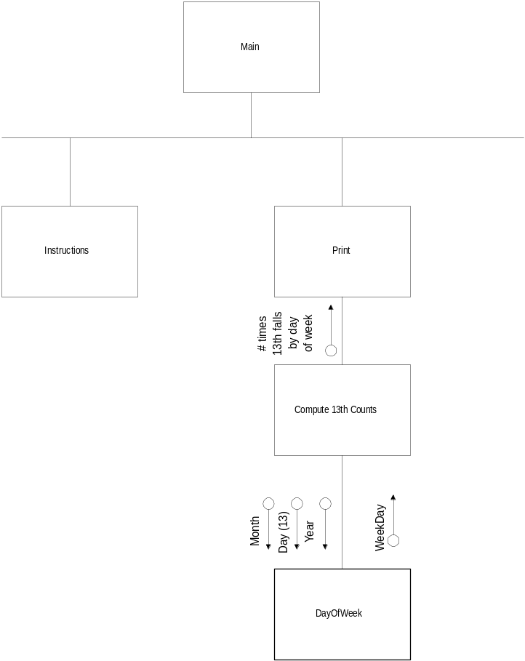
Only those functions written for the application are included. Library functions are common to all programs and are omitted.

Once all the functions are listed attention is placed on describing how the functions communicate between themselves and their caller (and those they call). Variables are described as a small circle with an arrow indicating the direction of data flow. Flags are described similarly but with the circle filled in black. If an argument (a variable) is bi-directional, then it is shown twice. Arrows pointing down indicate an inward flow to the function, those pointing up indicate an outward flow back to the caller.

When a structure chart covers many layers, it may be possible to trace variables up and down many layers of hierarchy. By tracing them at this high level, it is possible to locate the specific function where the variable is changed, thus simplifying any search for that code.

End Notes

Material presented here is somewhat superfluous to the main Course Portfolio, but felt to be of sufficient import that it should not “get lost”. Hence, it is presented here.

Red Marks

As noted in the section on Assessment of Student Work, I tend to make more red marks on papers that are of better quality. The typical response is “Why?” and “How does that make a student feel?’

Many students are conditioned to see red marks on their work as a sign of failure. For this reason, some instructors take to using different colored inks when remarking on those papers. Some simply attach a typewritten page of comments.

To minimize the effect of “seeing red”, I make a point of telling the class, ahead of time, that I use red because it is a great contrast to the usual black ink or pencil submissions, and that I tend to make more red marks on better papers. Now the students are semi-conditioned to think in reverse. Good luck, that!

These reasons are valid. I have used green ink and found that some simply cannot tell the difference. I have used black or blue and it gets lost, especially on hand-written paper. I don’t want to try yellow. White would be silly. Now all the primary colors are chosen. Hmm. I do use orange ink in assigning points on mid-terms and finals, but that’s only because it’s such a rare color.

But to the point, eh? Why mark more on better papers? In large part it is because I can make comment only on work that is present in sufficient depth and detail to warrant some discussion. If a student presents a ¼ page of nonsense, there’s not much to say (or write). If several pages are presented and much of it is really good, but some is marginal, then the marginal stuff gets commented upon.

So, the point of the marking is to guide and direct the student toward better work. A mentoring view rather than a critical one.

There is one mark I will make on a very poor paper: “You need to make an appointment with me to discuss this.” Unfortunately, most students who get that comment never do make the appointment. Why? Probably because they are not really interested in the course and are hoping to get a minimal grade, just for the “credits” on their transcript.

Student Comments

Students love me, hate me, and really don’t care one way or the other. Full spectrum. Those who seem “forced” to stick with the class, and who don’t like working that hard, express their frustration by “hating me.” Some have said that I’m “a good programmer, wish he could teach!” (Ouch! No, it doesn’t hurt, it’s only one comment in a host of comments, some good, some not.) Now and again a student really loves the class and gives me great marks in evaluation. There’s nearly always someone who does not like it at all (probably doesn’t like me either). A few times there have been students who actually take the time to come up to me and thank me for delivering the hardest, and most enjoyable, class they’ve ever had. So, it varies.

One of the things Chris Martin did with this class was to talk to them for at least ½ hour asking for their input on how they saw the class. Nearly all considered this to be a rigorous class with jumps in difficulty from assignment to assignment. A real challenge. They feel the pace is fast, sometimes too fast. Those who did not have the programming prerequisite feel most burdened by the pace and rigor. Nearly all found their initial optimism about doing well in the class to be ill-founded; by mid-course they were no longer expecting high marks in the class. Several students comment that text books don’t help in this class. The more exasperated students are those who have not had the requisite programming: they want a much slower pace with greater coverage of basics.

Running the class without a break is an issue for some students. It is typically a 2 hour, 10 minute class, twice a week, and some students have a difficult time with that. Some just needed to learn to better prepare themselves for the class while others simply cannot go that long without a smoke. Having previously experienced 5-hour-long classes with just one break, I don’t even notice the length of this class.

That may lead to another criticism sometimes voiced: the lesson plans don’t always seem to have ‘structure’ or follow the assignments and tests. Ah, insight: if you fall asleep, drift away, or stop focusing after the first hour and a half, you may not catch that phrase or two that is apropos to the assignment! (Okay, it’s not that bad, but …) Things get lost when the time just keeps running on. (A very valid criticism, and a take-away from this course portfolio project: use more breaks, constrain the lesson plans to a one-hour period, and mix up the kinds of activities during a single class meeting.)

I probably should mention that students also say good things, and that many of them are also consistent across different students and different classes. In-class examples, willingness to help and answer questions, help in program design, positive attitude, detailed lecture and example, daily outline, are all things students value.

One comment that took me by surprise was that my sense of humor, while welcome to most students, is fairly dry. The problem is that English-as-a-second-language students have serious difficulty with that. I don’t know if I can stop using humor … maybe I can stop having ESL students?

Students do get their opportunity to evaluate me via end-of-course evaluation forms. For the class observed during this portfolio, the computerized results sheet for this course shows a fairly solid in-the-middle evaluation. Some students ranked things toward Excellent and others towards Very Poor, while the solid set was smack in the middle. Written comments trend toward “slow down, be linear, use the book more.” Even so, they are difficult to categorize and range from complimentary to not. Consensus is not an easy to fathom product of this class!

Student Involvement

Learning occurs in the mind of the learner, and I as the instructor cannot directly implant knowledge into the student’s brain (well, not ethically; I’m not a brain surgeon). Ah, who is the learner? Whilst developing this Course Portfolio, I think I was learning as much, or more so, than many of the students I taught.

So, how did I learn? First I had an interest in the material I was studying. Second I went after discovering that knowledge. Third I had encouragement from my peers. Fourth I had the prodding of Josh Tenenberg (our facilitator). Fifth, I found ways to express what I’d learned, to share that, to reflect on it, and to accept constructive criticism of it. Sixth, I presented what I’d learnt.

Ah. Say, isn’t that what a student does? Don’t students in the class deserve the same chances I made for myself?

Sometimes the hardest part is to get a student to accept that s/he is able to actually do something. The empowering process is hard work (for the teacher), and can be frustrating when the student slips back into the listen-only mode.

One approach I’ve taken in more advanced classes is the group project. For those students who have a degree of understanding of the fundamentals of programming, the group project is a way to push them into discovery by doing. I’ve used the technique in other classes, and over many years. Why not here?

Recently (during the final phases of writing this Course Portfolio) I used the technique in an unusual way: a group of five students in CS-II were given the opportunity to do a mid-term exam as a group effort. They did, and all scored a common grade -- an “A”. Great job, and they all were quite pleased with their efforts. I observed them at work and saw all those things I describe in the second paragraph of this section. Cool.

Now, can I structure CS-I to allow something similar?

Writeup.txt

Mentioned in Assignment 3 as part of the “turn in” for the assignment is the writeup.txt file. This is a staple of all assignments in the course, and has proven to be of great use to me. It is the student’s way to tell me how long they took to do the work, where the hard parts were, and why.

When this feedback is properly addressed, and the student willing to work with me, the writeup.txt file has shown itself to be beneficial (the one student who pulled himself up after assignment 3 first identified his problems in the writeup.txt file).

My experience with this concept is such that I will continue using it, though it may be somewhat modified to be more structured in the future. (Another effect of the Disciplinary Commons, I’ve see how others do similar things.)

Colophon

Preparation of this Course Portfolio was managed on a full-tower PC-compatible (AMD 64 processor) microcomputer running Windows XP Professional, and various software packages including Microsoft’s Word for Windows 2003, Microsoft’s Image Composer 1.0, Adobe PhotoShop 5.0 LE, HP PrecisionScan Pro software and a compatible printer. Hard copy (for editing) has been produced (in black and white) on an HP LaserJet 2100. Soft copy (PDF) was produced using the share-ware program from PDFCreator.

And,

This portfolio is dedicated to my students, those who have struggled with me, and those who will in future! Without these students, there would simply be no need.

Unfortunately, some students who take the prerequisite course may fail to “follow up” soon enough. For these, waiting 3 years is similar to not having taken the requisite at all.
Whether that is “learn from me,” or “learn at all” is the obvious question.
Yes, the challenge is to improve without detracting from what is working ….
Or even relevant, given the general down-turn throughout education regarding computer education …
My concept is learning happens when work is done, even if late. I do threaten to take off 20% for late work, but rarely carry through.
Over time, I have learned to be consistent within the framework of a single class, or course if taught in multiple sessions during the same time frame (semester / quarter). That avoids some student confrontations.
For an elaboration, please see the end-note on Red Marks.
This is starting to sound like a personal problem. Some of these students are rather likeable people who just cannot or will not adapt to the needs a programmer must compensate for.

