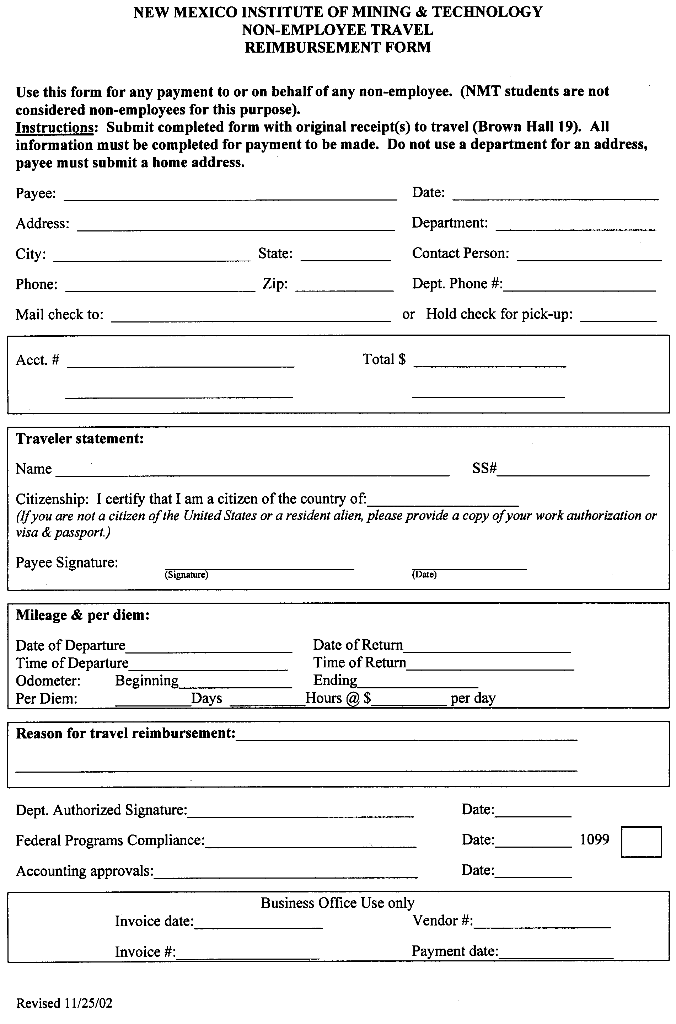

E&ES

Lisa Majkowski
x 6168
Payee

SACR20 710209

NA

NA

30.00

CRONUS-Earth Project – New Hampshire geological calibration sampling trip

