Cleaning Your Mouse:

Is your mouse difficult to manage? Do you find your cursor lacks precision, jumps erratically across the screen, or seems sticky or bogged down? Do these issues make even simple computer use like opening a folder, closing a program, or enlarging a window impossibly frustrating?

More often than not, these problems are not mechanical but hygienic and can be remedied with a basic cleaning. The following steps will walk you through cleaning your mouse and removing obstructions from its moving parts. Once you are finished you will not only have sanitized your mouse, but hopefully you will have rejuvenated its performance as well.

|  |  |
| --- | --- |
| What you’ll need:   * Q-tips * Paper towels * Rubbing alcohol * Pen cap or similarly shaped firm object. * Tweezers (optional) | What you’ll do:   * Wipe down exterior with alcohol * Freshen click wheel * Open the Ball socket * Clean the track-ball * Tidy the interior * Remove build-up on all three roll-bars * Reassemble the device |

1. 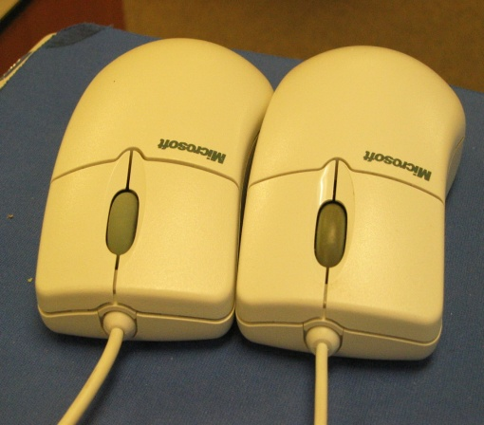**Topside, Exterior** (where you put your hand when using it)

DIRTY

WHEEL

CLEAN

WHEEL

* 1. The exterior of a mouse attracts a lot of grim, oils, and dust, but running a q-tip or paper towel soaked in rubbing alcohol over the entire shell will dissolve most of the buildup.
  2. Be sure to clean not only the two finger buttons and palm rest, but also the rubber click-wheel. You can see the difference between a dirty and clean wheel in the image to the right. A thorough cleaning should restore the wheel’s grippy finish.
  3. Now is a good time to inspect the surface on which you use your mouse. If you use a mouse pad, you can clean it with paper towels and alcohol as well. If you use a regular desk surface, you’ll want to wipe that area down, looking to remove any crumbs, hair, dirt, etc.

Once you’re finished with the top-side, turn your mouse on its back.

1. 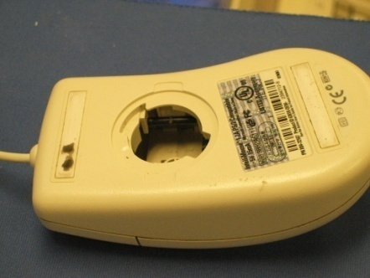**Bottom-side, Interior** (where the working mechanisms are)
   1. *Getting inside:* Having turned over your mouse, you’ll see a little ball behind a hole too small for it to get out of. Around this hole should be two arrows indicating the direction to twist the mouse ball cover. Rotate the cover in the direction of the arrows and with your hand in position to move underneath the mouse, slowly flip the mouse over and catch the cover and ball as they fall out.
   2. *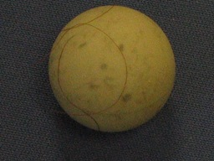The Mouse Ball:* For the mouse to function properly, the ball you are now holding must run smoothly over the desktop and against the interior mechanisms. Remove any foreign substances attached to the outside of the ball. Hair, for example, is often wound around it. Then, using a q-tip or paper towel and alcohol, swab the surface of the ball, giving extra attention to any dark spots. Finally, inspect slope of your ball, making sure there are no bumps, divots, or irregularities. If you find any inconsistencies in the surface that you can’t remedy with a good alcohol scrubbing, you may need to swap out your ball for another.
   3. *The Inner Mechanisms:* There are THREE touch-points (one white, two black) that translate the roll of the ball on the physical desktop into the glide of your cursor on the Windows desktop. Two look like little whitish plastic wheels and the third looks like a metal bar. If it has been a while since your last cleaning, you’ll notice that each of these elements has a band of blackish gunk and/or a tangle of hairs wrapped around it.

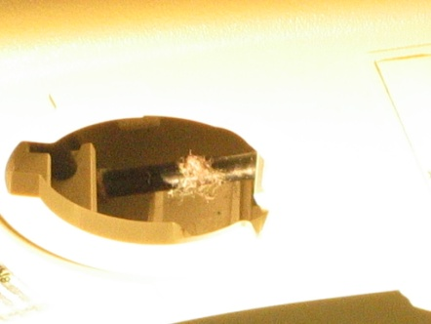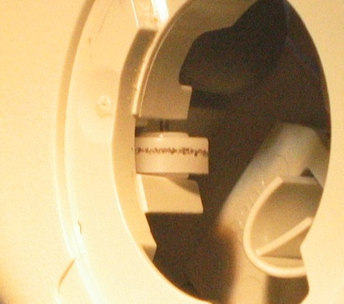

These inner mechanisms can be tricky to clean precisely because they move. Try using a pen cap or similarly shaped object to dislodge the gunk. Usually you’ll be able to etch it off in large pieces. Alternatively, you may use another q-tip with alcohol, which can in most cases dissolve the gunk rings. Hair tangles can be particularly difficult to remove. Tweezers work well, but if a pair isn’t available, persistent picking can also be effective.

*NB. If you happen to dislodge the touch-*wheel, you can reset it by following the procedures illustrated below:

* 1. *Reassemble the mouse:* Drop the mouse ball back into the hole. Replace the cover you removed by lining up the tabs with the slots in the mouse-body. Turn the cover in the direction of the arrows to lock it in place.