Testimony To the Washington State House Committee on Economic Development, Agriculture and Trade

Distinguished Chair Linville, members of the Committee, my name is Theo Eicher, I am associate professor and director of the Economic Policy Research Center at the University of Washington. My areas of specialty are international trade, development and growth. I thank you for inviting me to testify on the Washington State economy. Today I want to bridge academia and policy to make relevant to you and to the state of Washington some recent academic findings regarding the determinants of living standards.

After listening to the testimony of the Forecast Council’s executive director, Dr. Sohn, I feel a bit like trying to speak after Alan Greenspan. What new can I say; you are armed with all of the data you need, at least in the short-run. Instead I want to encourage you to step back and look at Washington State: The Big Picture. This perspective allows us to highlight some basic but important trends. In other words, What Do We Really Know? Then we can look into the future and think about shaping it - What Can Be Done?

Arguably, the most important question a legislator can ask about the state of the economy is - what drives the personal income of my constituency? And: what drives the level of employment in the state? I am going to take time to outline the basic facts of Washington State to identify the personal income and employment drivers. Then we can move forward and examine what fosters higher standards of living.

Figure 1
Personal Income
By Sector (Percent of WA)
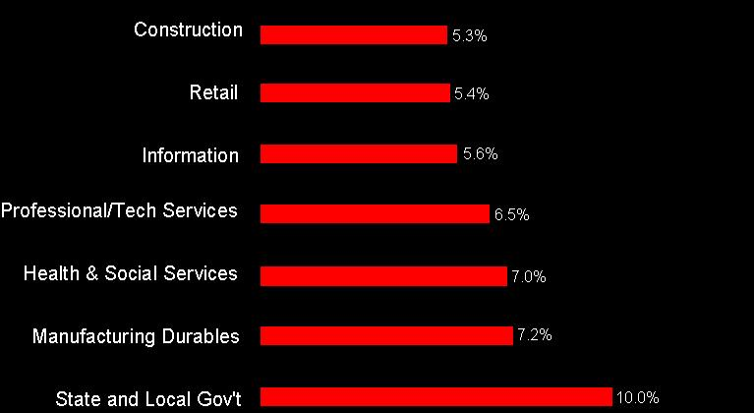
BUREAU OF ECONOMIC ANALYSIS (2004.3) WWW.BEA.GOV3

Let us examine personal income first. In Figure 1 I have broken down Washington State personal income by sector. By sectors I mean a segment of the economy that has been identified by the Bureau of Economic Analysis to contain the activities that fall under the same industry heading. So, for example, Construction includes everything from single family homes to heavy civil engineering projects.

I am interested in highlighting sectors that are the major contributors to personal income in Washington State. I have ranked the top seven sectors that provide about 47% of Washington State’s Personal income in the order of importance. Agriculture is included, so it would be here if it ranked. Construction is about the seventh largest sector providing about 5.3% of the total Washington State income. Retail is sixth, with about 5.4% of Washington State income. The largest private sector is manufacturing of durables, which includes aerospace, with about 7.2% of total Washington State income. The largest sector is state and local government, with about 10% of personal income (1% higher than the national average).

Figure 2
Personal Income and Employment
By Sector (Percent of WA)
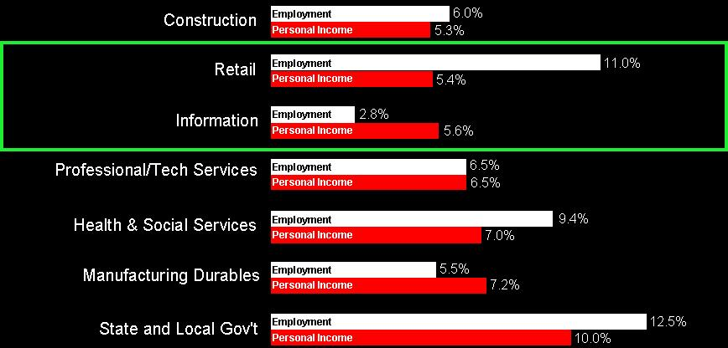
BUREAU OF ECONOMIC ANALYSIS (2004.3) WWW.BEA.GOV3

Now that we have a picture of the important income drivers in the state, let me compare these to the employment numbers in Figure 2. Construction provides about 6% of total employment in Washington State. Retail is surprising: it provides 11% of Washington State employment – but only 5.4% of the personal income. This indicates either an extraordinary share of part-time jobs, and/or low wages. The next surprise follows immediately. The information sector holds only 2.8% of employment in the state, but it provides 5.6% of personal income - more than retail.

The other important sectors, personal services, healthcare, durables, state and local government are just about in line with their income shares. Again, state and local government provides the largest share of total employment.
Let me come back to the two sectors that are blocked in with a box in Figure 2. It turns out that these two sectors are going to guide us to some important understanding about what shapes the future of the State’s economy. The information sector provides a high standard of living. Most of us would probably want to work in a sector that generates the same amount of income as retail, but with a quarter of the employment. That is the American Dream: receiving higher income for the same hours worked; being better off than our parents.

Nevertheless, there are always sounds bites to be heard that we “need to grow employment” or output of a sector. If anybody suggests to you that large sectors are important, listen up and ask if that sector provides good wages, high hourly income. Employment growth itself alleviates pressures on the social safety net, but it does not provide a higher living standard.

So we need to ask ourselves, how can sectors deliver a higher standard of living? A higher hourly wage, if you want. And that is actually the core of my research area. I research why and how sectors manage to deliver a high standard of living.

Turns out research shows again and again that sectors that drive high standard of living share the same three characteristics:

- exhibit abundant equipment investment, because more and better capital generates higher wages for more efficient workers.
- attract highly skilled workers, because better trained workers are more productive.
- invest in innovations, because new products open new markets that increase profit margins. They invent better production process that lowers costs. Both investment and workers become more productive if a sector invests a in innovation.

Let me give you a historical example that highlights how a sector can generate a high standard of living. Let us look back to the 1990s. Something very interesting happened in the US in 1995. The economy experienced a structural break, something that was not forecasted. Investment in IT doubled, investment in non-IT, as a percentage of total investment in the US actually slowed. The growth of productivity - the standard of living - in the United States jumped 63% (from 1.4% to 2.4% per annum) - 81% of that increase is now being attributed to information technology. How could one segment of the economy contribute 81% to this increase in the standard of living?

There are three channels. First, there are two direct channels. IT experienced both, massive investment in equipment and research. Investment in IT doubled after 1995, and innovation has increased dramatically.

The most important aspect, however, was that the rest of the economy was affected positively by spillovers from the IT sector. IT does not produce aerospace products - it makes the design and manufacture of airplanes cheaper. It does not produce apples - it facilitates the development of fungicides that produce richer harvests that are monitored more efficiently with IT distribution systems. These are the spillovers that have shown to possess tremendous, positive impact on the entire economy.

The question remains - am I just telling an interesting tale, or is there a relevant message to legislators? Is there something government can and/or should do to encourage IT innovation and spillovers? My research and most economic theories indicate that the key determinants of IT spillovers, of new innovations, and of better production processes are always twofold:

- Geographic proximity
- Research and Development

Interindustry innovation spillovers seem to dissipate quickly after about 200 miles. Washington State already exhibits strong geographic clusters of proximity, such as the Bel-Red corridor, and the Seattle/Renton aerospace corridor.

In R&D there is a different interaction. Current research shows a strong relationship between sectors that are not only close in their product palettes, but also close in terms of their level of research efforts. The closer such firms/sectors are, the greater they benefit from each others R&D. This relationship does not only hold for firms. Figure 3 relates State’s per-capita R&D to their level of per capita of income.
Figure 3
US States’ Per Capita Income and R&D Expenditures
(Washington State in red)
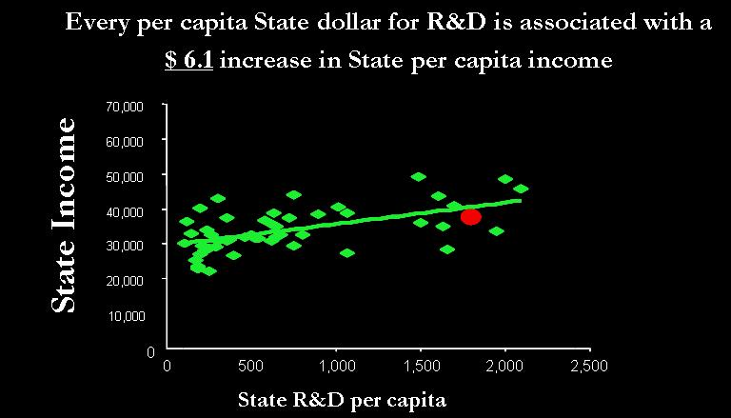
NSF Science and Engineering Indicators 2004
Figure 3 tells us that one extra dollar in per-capita research expenditures on the State level is associated with about 6.1 extra dollars in state-per-capita income. The correlation is surprisingly high, especially since it is contemporaneous.

This leads to the question, who actually conducts R&D in Washington State? In figure 4 I present United States average R&D expenditures and compare them to Washington State’s.

Figure 4
R&D Expenditures
Washington State vs. The National Average
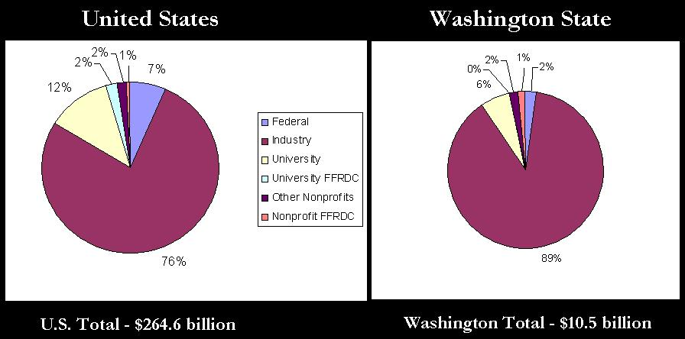
NSF S&E Indicators (2004) for 2000,2001, from Beyers (2004), for the Technology Alliance

Industry conducts 89% of R&D in Washington State, which is a significantly larger share than the national average (76%). On average 12% of R&D in the United States is undertaken by the universities, but in Washington State universities contribute only about half the national average (6%).

The large industry R&D share raises the question which companies are actually research drivers in the state. Figure 5 breaks out the sources of industry R&D in Washington State as compared to the rest of the US. Again the picture in Washington looks quite different than in the rest of the country. The state is the happy beneficiaries of extraordinarily large R&D in the information sector. Forty percent of all R&D in Washington State is provided by information versus only 14% in the rest of the nation. Manufacturing R&D on the other hand is only half of the nation’s average, and that includes the massive amount spent by Boeing! That’s a problem that needs to be addressed; I have just outlined above that sectors that are themselves involved in research are the prime candidates to take advantage of R&D in other sectors. To leverage the massive IT R&D investment, the state must facilitate the attraction of complementary industries.

Figure 5
Industry R&D Expenditures Breakdown
Washington State vs. The National Average
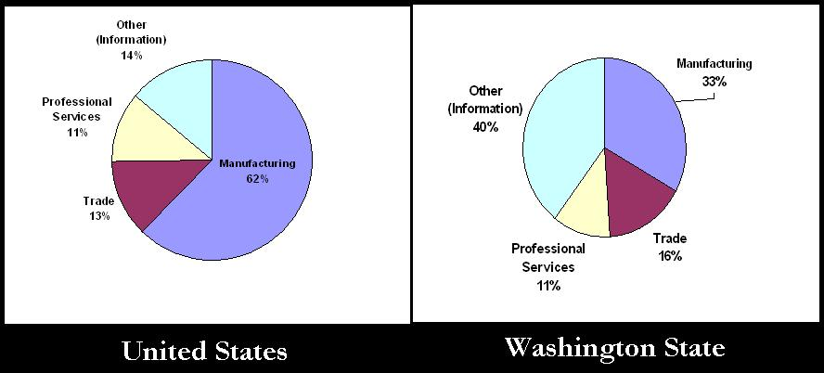
NSF S&E Indicators (2004) for 2000,2001, from Beyers (2004), for the Technology Alliance

Next we turn to the question who actually spends the R&D dollars? It is skilled labor, human capital that conducts research and patents innovations. Figure 6 shows Washington’s standing in terms of the talent it has attracted to conduct research. We are near the top in the nation in terms of numbers of doctorates, scientists and engineers in the population. The State is weak, however, in its supply of doctorates and he graduate students necessary for the future. Washington is lagging far behind in terms of the supply of new talent. There are at least two interpretations of these numbers. First, above average research dollars are attracting skilled workers to the state. On the other hand, the state relies on migration not its own work force to provide the skills of the future.

Figure 6
Human Capital
Washington State vs. The National Average
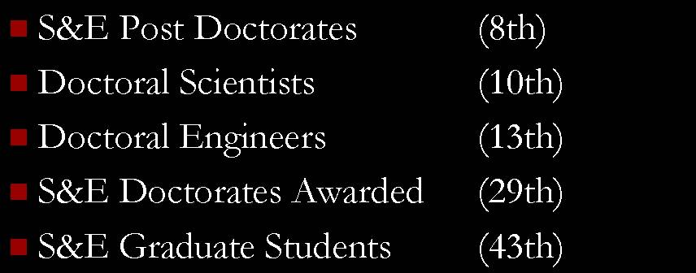
NSF S&E Indicators (2004) for 2000,2001, from Beyers (2004), for the Technology Alliance

Recommendations: The data and information I have provided pertain to the fundamental determinants that shape Washington State economy in the future. R&D, innovation, process innovation, capital investment. Instead of reacting to forecasts, I urge you to determine your future; you can do so with your policies.

- Set specific goals, and target a higher standard of living. How do you do that? Focus on good jobs. Increase high wage employment in the state by X%; set yourself a target. Don’t just create a 100,000 extra jobs, create a 100,000 good, high paying jobs in the state.

- Support the State’s research capacity, it shapes the future of the State today. We have seen that manufacturing R&D, including the R&D that is conducted by Boeing, is only 33% of R&D in the state. This number needs to be at least as high as the national average (62%) to receive the all important spillovers that IT provides. If insufficient R&D is undertaken, problems arise in adopting new technologies from other sectors. Look at small business research and development, such as the National SBIR (small business innovation research) grant program and set a target for the state.

- Develop the Washington workforce to ensure local residents can take advantage of good jobs; increase the percentage of scientists, engineers and graduates. Yes we are in the top ten in these areas, but give the research dollars spent in the state, more good jobs are available, and more skills will only facilitate even further research investment. Consider the effects of importing skills and increase the share of graduates who work in IT not retail in the future.

- Finally, especially after speaking after two forecasters, I want to stress that forecasts are fickle. In 1995 nobody forecasted what happened in IT investment; no one forecasted the large spillovers that would be generated by the new innovations. The only thing we knew then and that we know now is that R&D will drive innovations and eventually will determine the fortunes of the economy of the future. Shape this future with your policies.

Theo Eicher
te@u.washington.edu;
faculty.washington.edu/te
Associate Professor, Department of Economics, University of Washington
Robert R. Richards Distinguished Scholar, University of Washington
Director, Economic Policy Research Center, University of Washington

Jorgenson, Dale, Mun S Ho and Kevin J. Stiroh. “Growth of U.S. Industries and Investments in Information Technology and Higher Education” forthcoming in C. Corrado, J. Haltiwanger, and D. Sichel, eds., MEASURING CAPITAL IN A NEW ECONOMY, Chicago, University of Chicago Press,2004.
Adam B. Jaffe & Manuel Trajtenberg & Michael S. Fogarty, 2000. "Knowledge Spillovers and Patent Citations: Evidence from a Survey of Inventors," American Economic Review, vol. 90(2), pages 215-218, May.

