Quinn has maintained a 3.99 GPA at Spring Street International School, taking several advanced and honors courses as well as travelling extensively with the school, including a Spanish immersion program in Spain and volunteering with community projects in Morocco and Ethiopia. Quinn has pursued his scientific interests by enrolling in cryptology and engineering online courses from both Brown and Stanford Universities, and has worked with Kwiaht’s Indian Island Marine Health Observatory Program as a founding member and independent investigator, engaged in invertebrate monitoring, toxicology sampling and a marine micro-plastics density survey. Quinn was the youngest graduate of the Washington State University’s San Juan Beach Watchers Program, completing over 200 hours of community service monitoring native steelhead through beach seining. Quinn is also composer of music. As a Young Investigator Prize winner, Quinn had the opportunity to work with Dr. Adam Summer’s fish morphology class and spent his time constructing functional models of shark skeletons. Quinn used CT scans to extrapolate basic 3D models of shark jaws and then used a 3D modeling program to refine & reconstruct missing patches & anomalies. Quinn designed his models to be stable and easily printable in plastic using a 3D rapid proto-typer. It is Quinn’s hope that these new models can be distributed online and be easily printed by anyone with access to a 3D printer. They may be especially useful for demonstration and teaching purposes.

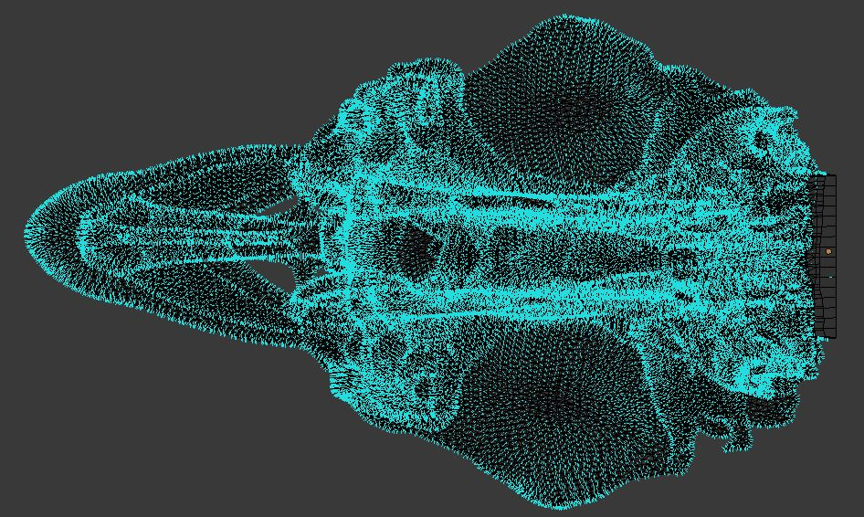

Quinn’s 3D wireframe rendering of Lamnaditropis (salmon shark) bottom jaw view.

