Biomimetics: Lessons in strength from biology

Teacher’s Preparatory Guide

Purpose: to understand how nature makes its hard tissues strong, and apply that principle to making materials we can use through a process called biomimetics.

Subject area(s), Scientific concept(s), & or Key words
Biology, Materials Science and Technology, Physical Science, Physics, Chemistry

Time required:
This activity should 2-3 class periods, including an overnight oven burnout.

If this activity is used in-conjunction with the isolation of proteins from shells, and the three-point bend test for toughness in shells, then is would be part of a week long activity.

Target Grade level
9-12th grades

Advance preparation:
You will need to purchase or scrounge 1 inch thick Styrofoam boards. These can be purchased at many hardware stores as they are sold as insulation panels. Prep work would include cutting the strips for beams, 1\2 x2 x 12 inches and 1x2x12 (bulk beam). A class of 30 students working in pairs would need 8x16 beams. Gorilla glue seems to work best for this application and can also be purchased at any hardware store.
A kiln will work for burning off the organic materials. It would be helpful to have ceramic crucibles as small as possible for the burnout. The shell burn out process needs to be carried out at about 500 C, overnight. The shell will appear as a white chalky substance at this point.
For the biomimicry lesson, several types of adhesive are needed. One adhesive should be an elastic type adhesive such as silicon or rubber cement. This will best mimic the organic layer of nacre. The other types work well in securing the beams but won’t allow for bridging and sliding of the plates. Elmer’s glue will hold well but gives a very rigid beam. One of the reasons that nacre is so tough is that when a stress impacts the shell it is dissipated through the layers, reducing the overall force. This is also true of the XLM structure, except the stress is dissipated between the lamellar layers instead of the tablets.
Weights for the elastic modulus testing can come in many forms. Marbles or pennies can be used, or calibrated weights. If you don’t have real weights you will at least need a scale to weigh the other measures.
The testing device for the three point bend test is really only for qualitative data collection. The device can be easily constructed using a C-clamp, a piece of steel rod, a steel u-shaped beam and a weld. The instructions for this device are enclosed in the teacher packet. GEMSEC at the University of WA will support this activity by supplying you with your first device free. The shell samples for this test apparatus need to be carefully cut before the lesson. Each student group will need 9 samples, 3 prismatic calcite (clam shell), three nacreous (abalone shell) and three crossed lamellar (gastropods, snail shell). The samples need to fit the test apparatus in length, approximately 15 mm. The thickness should all be the same so some samples may need thinning by polishing them down with sandpaper. The width can be 4-6 mm, but each sample should be the same as the others.
Clam shells can easily be found along most beaches in the Pacific Northwest. Gastropods are easily attained at any tourist shop. Make sure you get thin shells, not the Giant pink conch as it is far too thick. Abalone shells can be acquired from any of the abalone fisheries in California. They discard thousands every week.
Preparing the samples can be done using a Dremmel tool with a cutting disc attachment. Also a tile cutting saw can be used but poses much more of a danger with such small samples. Again, keeping the samples thin is easiest for preparation and on your Dremmel Tool. Having an excess of sanding discs is helpful.
Student lab packets will need to be copied.

Crystallographic and Mechanical Properties background:
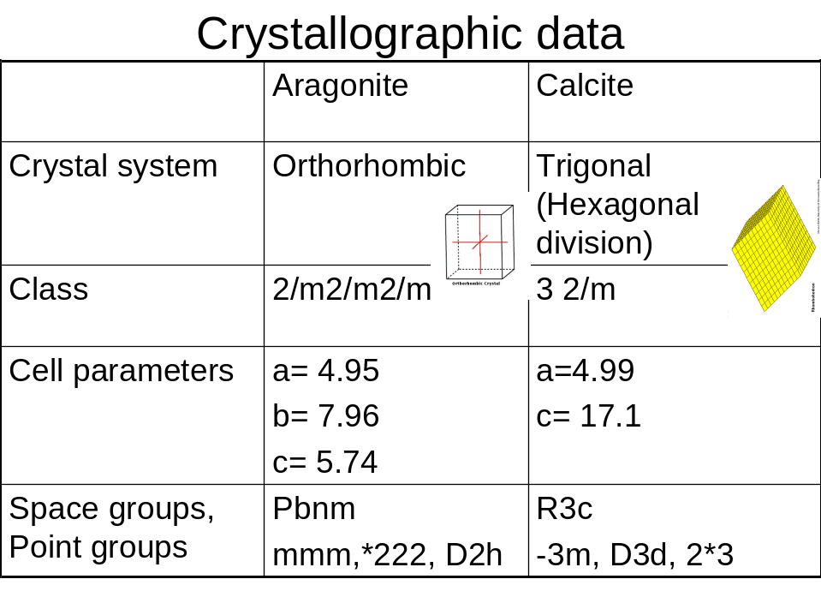
 | Aragonite |  |  | Calcite
Morphology | Short to long prismatic [100]  Flattened {010}  Acicular, tabular {001} |  |  | Acute rhombohedra or prismatic with scalenohedral terminations
Twinning | Typical {110}  Polysynthetic twinning produces striations parallel to [100] |  |  | 4 twin laws  Most common {0112}  {0001}  Uncommon {1011}, {0221}
 | 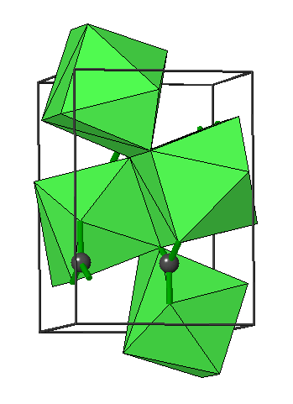 |  |  | 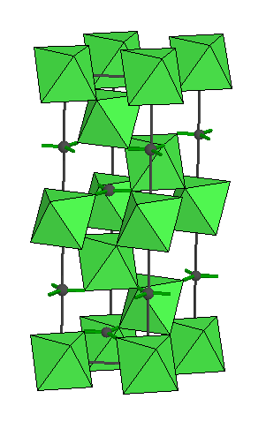
Structure type |  | Tensile Strength  M Pa | Compressive Strength  M Pa |  | Bending Strength  M Pa | Young’s Modulus  G Pa
Prismatic |  | 60 | 250 |  | 145 | 26
Nacre |  | 80 | 350 |  | 200 | 46
Crossed Lamellar |  | 40 | 260 |  | 85 | 52

EALR’s

The EALR’s specifically addressed with this curriculum are:
1.1-3
2.1-2
3.1

