SYNTHESIZING SILVER NANOPARTICLES

Student Sheet part B: Properties at the Nanoscale…
Isn’t silver always silver?

INTRODUCTION
In the last class period, you saw that we can make solutions of different colors by reducing silver nitrate (AgNO₃) in aqueous solution (in water) using different amounts of sodium borohydride (NaBH₄). Hopefully you realized that the amount of sodium borohydride was an independent variable which was different for each group, and the color of the solution produced depended upon the amount of NaBH₄ added.

You also may have realized that the silver you made did not look like silver at all! In fact, it was too small to be seen and a different color from the “silver” color which you may associate with silver.

Today you’re going to read a little bit more about this reaction and answer some questions. Then we will look at a question related to why the silver might not look silver!

THE REACTION

The full chemical reaction which occurs in the lab you did is shown below.

AgNO₃(aq) + NaBH₄(aq) → Ag(s) + 1/2H₂(g) + 1/2B₂H₆(g) + NaNO₃(aq)

1) Interpret this statement in words below:

Silver nitrate dissolved in water + _________________ react to form ____________ ,
^{NaBH4 (aq)} ^{Ag (s)}
________ gas, gaseous diboron hexahydride, and aqueous _______________ .
^{H2(g)} ^{NaNO3 (aq)}

In the reaction, you can see that silver initially has a charge of +1, and afterwards has no charge.

Ag⁺ _{(aq)} -----> Ag _{(s)}

2) To which side of this equation must you add an electron to make it valid in terms of conservation of charge? Why do we say silver is being reduced?

SILVER NANOPARTICLES

When researchers first looked at the colored solutions, there were not sure what was inside. They took samples, let the water evaporate and looked under a light microscope, and small very very small particles. So they used a fancier microscope, called a Scanning Electron Microscope, so take a closer look at the materials dissolved in water in the solutions.

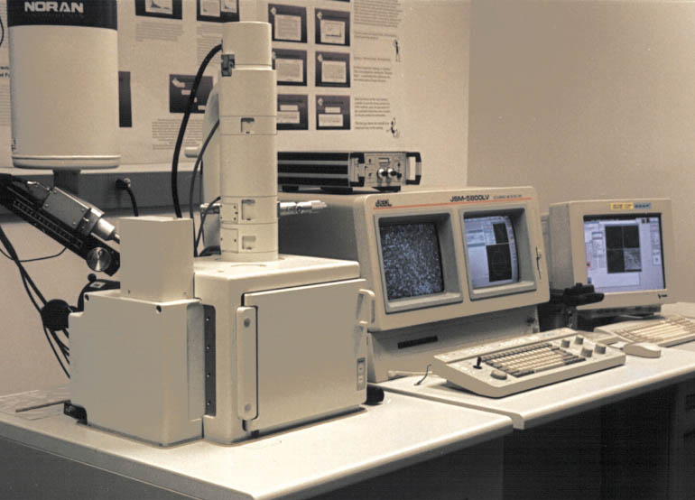
A scanning electron microscope at Carleton College. To learn more, go to http://www.mos.org/sln/SEM/seminfo.html
http://serc.carleton.edu/images/research_education/geochemsheets/techniques/UWSEM.jpg

The picture they saw looked a bit like the one shown below. These are particles made of pure silver.

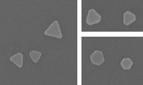
200 nm
200 nm
Yeechi Chen, Keiko Munechika, Jessica M. Smith, David S. Ginger
University of Washington
Department of Chemistry
Unpublished results

- Estimate the size of the particles you see here using the scale bar. How many particles would need to be lined up to equal the length of a meter stick? Show your work.

- How many silver atoms would you estimate are in one of these nanoparticles? Assume that each silver atom occupies the volume of a cube with an edge of 0.30 nm. You can estimate the volume of the nanoparticle by assuming it’s a sphere. The formula for the volume of a sphere is 4/3 π r³ , where r is the radius. Clearly show your work or explain the process you used.

A COLLOIDAL SOLUTION
Last class period, you saw that “bulk” silver can be made by mixing silver nitrate and a more reactive metal. This method of production makes chunks large enough to be seen with the naked eye. But in the synthesis you performed, something stops the production of silver when the particles are much smaller. Because these silver particles have sizes which are measured in nanometers, they are called silver nanoparticles, nanocrystals, or nanoprisms.
What stops the particles from growing into larger, visible pieces of silver? If you have studied stoichiometry and solutions you can answer this question.

- Look at the chemical reaction on the first page. What is the molar ratio of AgNO₃ to NaBH₄? A different way of asking this question is do you need more AgNO₃, more NaBH₄, or an equal amount of each reactant?

So we know that whichever reactant is present in a smaller molar amount is going to be the limiting reagent. You used 1 mL of a 1.0 mM solution of AgNO₃, and about 4 mL of a 10 mM solution of NaBH₄.

- Which solution is more concentrated: the 1.0 mM solution of AgNO₃ or the 10 mM solution of NaBH₄?

- You also added more volume of the NaBH₄ compared to the AgNO₃. So which reactant, the silver nitrate, or the sodium borohydride, was present in a larger amount in terms of moles?

The excess sodium borohydride is required to prevent the silver particles which form from clumping together to form visible particles of silver. A picture of what happens is shown below. The sodium borohydride is dissolved in water and is an ionic compound made up of sodium ions (Na⁺) and borohydride polyatomic ions (BH₄⁻). There is an excess of BH₄⁻ ions because the sodium borohydride is present in excess. The extra BH₄⁻ ions which do not react surround the silver nanoparticles (Ag NP in the picture below), and prevent them from clumping together.
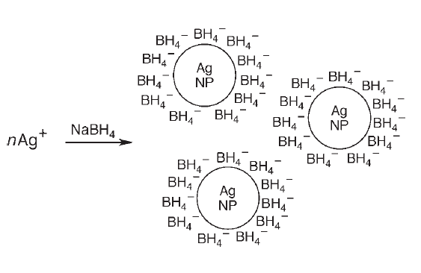
Solomon et. al. J. Chem. Edu. Vol 84 #2, Feb 2007 pg 322
- Why would silver particles surrounded by BH₄⁻ ions not clump together?

Solutions which have small charged particles, which are too small to be seen with the eye, are called colloids. Examples of colloids include soapy water and milk.

Isn’t silver always silver?
You might remember that you added different amount of sodium borohydride, and this led to different colors. Why is this? The answer is that adding different amounts of sodium borohydride leads to different sizes of nanoparticles, and each nanoparticle has its own color!
This is a crucial fact. SILVER PARTICLES WHICH ARE NANOMETER SIZED DO NOT HAVE THE SAME PROPERTIES AS BULK SILVER!!! THE MATERIAL PROPERTIES CHANGE BECAUSE THE SIZE OF THE PARTICLES IS SO SMALL.

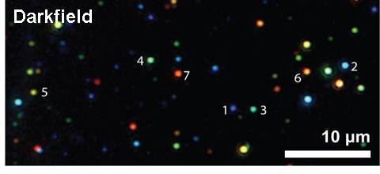
Yeechi Chen, Keiko Munechika, Jessica M. Smith, David S. Ginger
University of Washington
Department of Chemistry
Unpublished results

In this picture, you can see that each silver nanoparticle has a slightly different color depending on how large it is.

Why might different sized particles have different colors? It turns out that the explanation for this phenomenon is very complicated, and is too complex for us to look at. But we can understand why small silver particles might have some other different properties (besides color) compared to larger silver particles by using a two dimensional model of nanoparticles. Here’s an example.
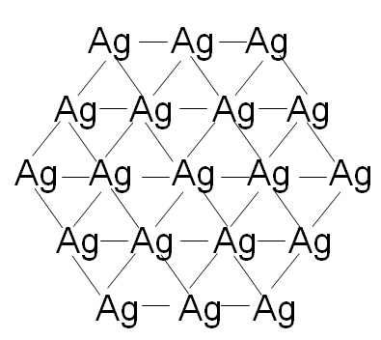
Notice that silver atoms in the middle of the crystal make more bonds than those on the outside. This means that the outside silver atoms have some unbonded electrons and are not “happy”.

- For each of the following three two dimensional silver nanoparticles, count the number of bonds ( lines - ) and silver atoms (Ag). Then determine the number of bonds per atoms by dividing the second number by the first.

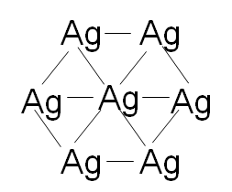
Number of bonds: ____________
Number of silver atoms: ___________
Number of bonds per atom: __________

Number of bonds: ____________
Number of silver atoms: ____________
Number of bonds per atom: ____________

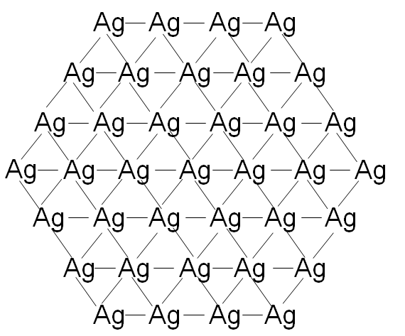
Number of bonds: ____________
Number of silver atoms: ____________
Number of bonds per atom: ____________

- What is the trend in terms of the number of bonds per atom? Do larger crystals or smaller crystals have more strongly bonded atoms on average?

- Based on your answer to question 10), are there any properties which you might expect to be different for larger versus smaller silver nanoparticles? Think about properties which depend upon the strength of bonding. State your predictions clearly (I would expect smaller nanoparticles to be …. because … ).

