Student Sheet part D: Color and the Nanoparticles

Introduction
The silver nanoparticles you have created in the laboratory have some very interesting visible characteristics. You might have noticed that they have a primary color, but also a secondary color which is more visible if you hold them at certain angles. In this activity, you will learn the relationship between absorbed light and color, and why different sized nanoparticles exhibit different colors. You will demonstrate your knowledge by describing how you might engineer an alien sunscreen.

This document assumes you have some familiarity with the concepts of color, frequency, and wavelength. As a reminder, you might choose to watch the Brainpop movies on electromagnetic waves (http://www.brainpop.com/science/energy/electromagneticspectrum/preview.weml) and color (http://www.brainpop.com/artsandmusic/artconcepts/color/preview.weml ).

Remember that visible light is only one part of the electromagnetic spectrum with wavelengths between 400 nm (violet) and 700 nm (red).
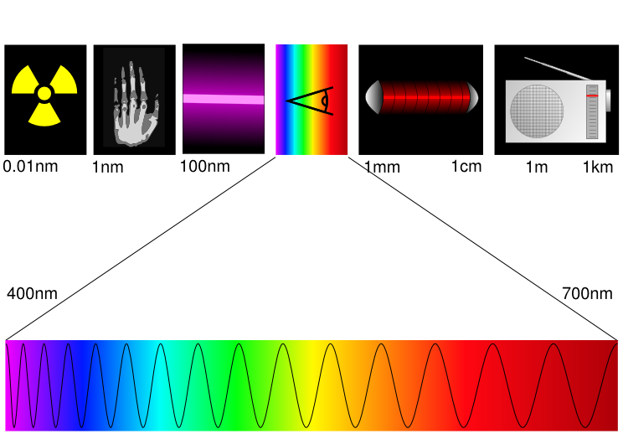
http://en.wikipedia.org/wiki/Electromagnetic_spectrum

Procedure:
You will use a spectrometer to test the sample which you prepared. The spectrometer works by shining white light (light with all the colors of the rainbow) through the sample. Some colors are absorbed by the sample. The rest are transmitted (pass through). The light which passes through is run through a prism which separates the colors and allows us to see which colors were absorbed by the sample and which passed through.
White
Transmitted
Prism

Sample
Absorbed

Refer to the specific directions provided or verbally given by your teacher.

SAMPLE SPECTROPHOTOMETER DATA: (0.4 mL NaBH₄)

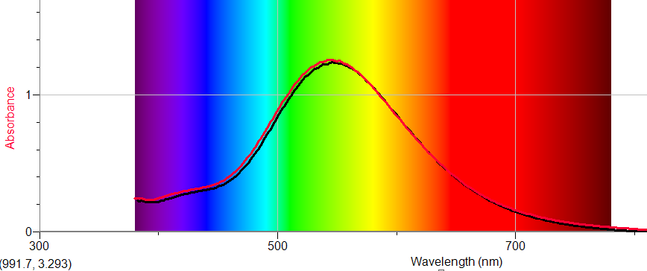

- What colors does your sample absorb?

This sample absorbed strongly in the green and yellow regions of the spectrum.

- What color does your sample appear to be?

This sample appeared to be violet.

- What is the relationship between the colors which the sample absorbs and the color which the sample appears to be?

The sample transmits blue and red, and absorbs green and yellow. The transmitted colors are the ones not absorbed and they determine the actual sample color.

It appears that the color of the sample is made up of all the wavelengths (colors) which are not absorbed by the sample. A great example of this is leaves. Leaves appear green because two compounds, chlorophyll A and chlorophyll B, absorb red and blue light, allowing green and yellow to pass through.

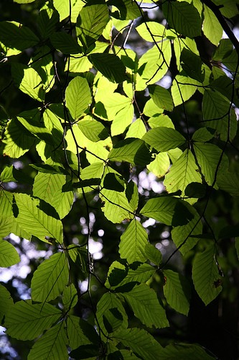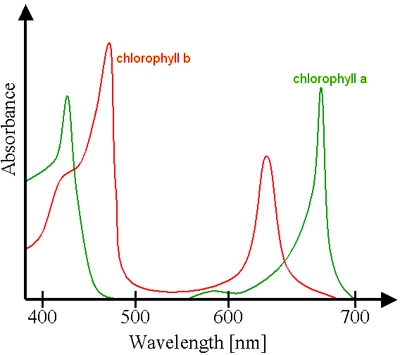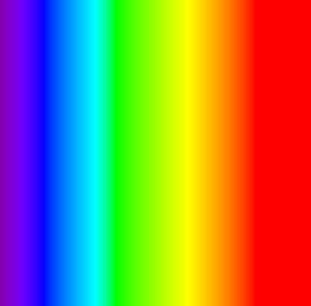
reflected light
absorbed light
incident light
transmitted light
http://en.wikipedia.org/wiki/Chlorophyll
Follow up questions:

- The spectrum of a dye is shown below. What color would you expect the dye to be? Explain your answer. Purple (mix of red and blue)
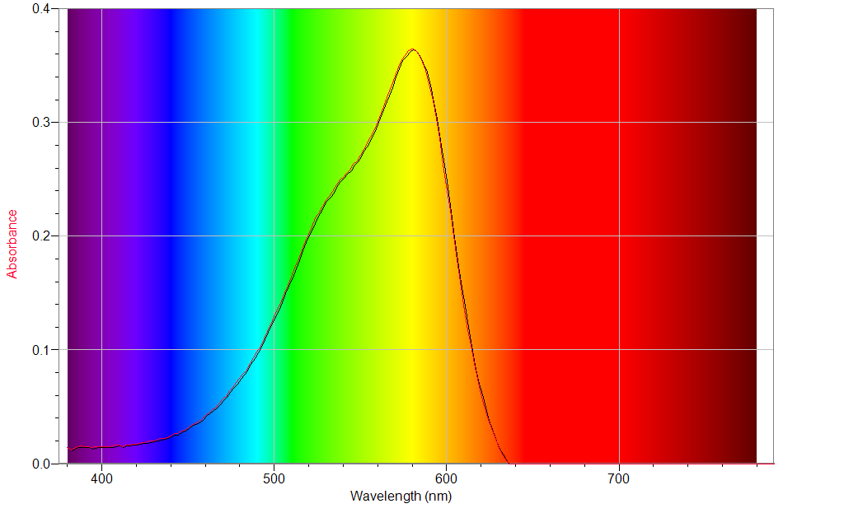

- An alien life form comes to earth. You need to design a “sunscreen” for this being. The aliens, however, are not sensitive to ultraviolet light, but rather to red and infrared light wavelengths. Describe the procedure or set of experiments you would use to determine what material (s) could be used for the sunscreen. What are some materials you might test? What would you be looking for, specifically?

Students should state that they would test materials to look for ones that absorb strongly from 600-1000 nm or so.

Extension
What happens if the incident light is not white, but colored? That is, what if the incident light does not have all the wavelengths in it? A sodium arc lamp produces yellow light with a wavelength of 590 nm.

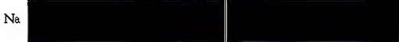
http://www.800mainstreet.com/spect/emission-flame-exp.html

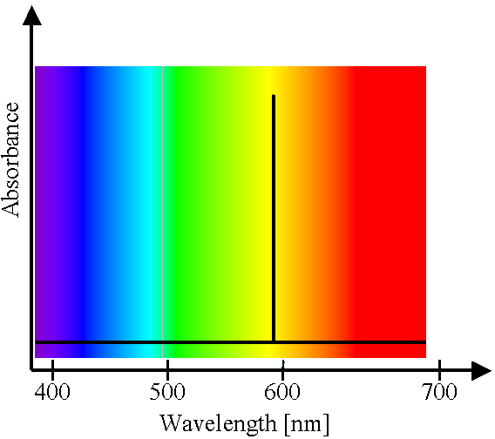

What color would your nanocrystal sample appear to be if illuminated with a sodium arc lamp? Hint: will you sample absorb or transmit the yellow light?

If the sample absorbs yellow light, then it will appear colorless. If it does not absorb yellow light, it will appear yellow.

DIDN’T FINISH SECTION ON WHY DIFFERENT NANOPARTICLES EXHIBIT DIFFERENT COLORS, OR ON SCATTERING.

