Biomimetics: Lessons from Biology
Spider silk, is it all it’s made out to be in the movies?
Karen Hinkley
Forest Ridge School of the Sacred Heart
GEMSEC, Dept. of Materials Science, University of Washington



Part One
Introduction:
In several recent science fiction/fantasy type movies the spider has been blessed with some incredible talents, mostly stemming from its ability to spin a web.
Today, you will be the MYTHBUSTERS as we to try determine if Spiderman could actually be suspended by a spider silk strand of a diameter shown in the image above. Is the Spiderman myth plausible or to be busted.
In order to really understand how Spiderman’s silk works we need to study the true masters of web construction, the spiders. All spiders are capable of making silk. Some form intricate webs to capture prey while others make a messy mat of silk to find their food. The “silk” material is extruded (pushed out through a small opening) from the abdomen using special glands in their abdomens called spinnerets. The extruded spider silk comes out in a continuous stream as the spider moves along or creates its web. The silk hardens as soon as it is exposed to air. This actually supports the Spiderman movies version of spider silk.
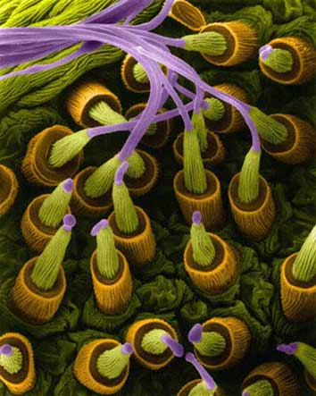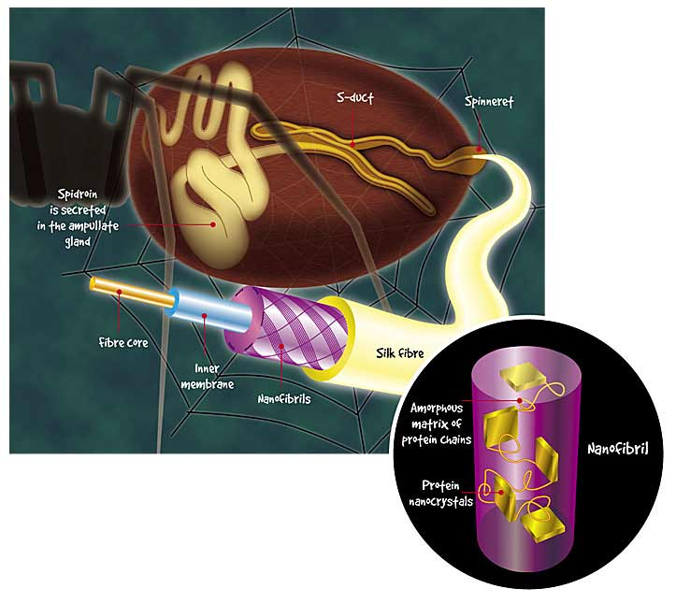
Left - Spinnerets imaged at a magnification of 3740X using a scanning electron microscope*. The image is color enhanced. Right – Schematic anatomy of a spider’s abdomen and silk extrusion.

*Dennis Kunkel Microscopy ,Z Shao, X Chen and F Vollrath, Soft Matter, 2006 [clarify this citation that appears to cite 2 sources – put next to proper caption]

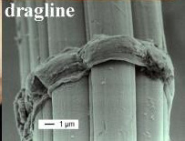
Spiders can produce 3 main types of silk. Dragline silk is the very strong material that forms the outline of the web and anchors it to the support. . A second type of silk, the capture strands, make up the main part of the web, are coated with glue, and are primarily used to catch the prey. Because this part of the web must take the impact of flying prey, it is tough and flexible, but is not as stiff as the dragline silk. The third type of silk is used to wrap and subdue the prey. This material has different properties from the other two silk types. Each type of silk has differentsets of amino acids. Jointly, they provide beautiful examples of how DNA differences result in changes in structure and function.
Scanning electron micrograph
of Nephila clavipes spider
dragline silk shows diameter
of 12 microns overall with
threads up to 4 microns
(courtesy of Dr. K. Augsten IMB-Jena)
�
�

The physical properties of the spider silk are quite amazing. One source [cit.] says gram for gram it is a stronger fiber than steel. How can this be? Let’s compare its characteristics with some other, more familiar materials. In order to understand these properties we will need to learn a few engineering terms so we don’t become confused.
Tension is a force in a pulling direction on a material. A material in tension, like a rope, will often narrow as the tension increases. We can measure the strain in the rope by calculating the change in the length over the original length. We can measure the stress in the rope as the force over the area of the ropes cross section. This is really the area of a circle. We can then plot the stress over the strain and determine the tensile strength. Tensile strength measures the force required to pull something such as rope, wire, or a structural beam to the point where it breaks.

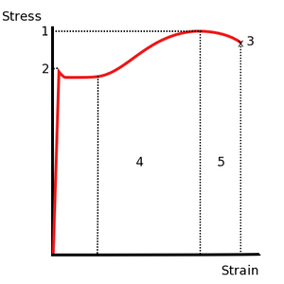
Stress vs. Strain curve typical of structural steel
1. Ultimate Strength
2. Yield Strength (the point after which the change in the material is permanent) [This implies that between baseline and 2, the material will elastically return to its original form, correct? Isn’t there a term for this region/property, too? Is this resiliency? Need to define this term as you use it below.]
3. Tensile strength[What are 4 and 5?]
[Define terms used in Table]

Table I. Average Values of Mechanical Properties of Silk Fibers and High-Performance Synthetic Fibers
Fiber Type |  | Density (g/cm³) | Modulus of Elasticity E (GPa) | Tensile Strength σ_{R} (GPa) | Breaking Strain ε_{R} (%) | Resilience (MJ/m³)
Spider Silk
 | Argiope trifasciata | 1.3 | 1-10 | 1.2 | 30 | 100
 | Nephila clavipes | 1.3 | 1-10 | 1.8 | 30 | 130
Silkworm silk
 | Bombyx mori | 1.3 | 5 | 0.6 | 12 | 50
Nylon 6.6 |  | 1.1 | 5 | 0.9 | 18 | 80
Kevlar 49 |  | 1.4 | 130 | 3.6 | 3 | 50
PBO |  | 1.6 | 270 | 5.8 | 3 | 70
Steel |  | 7.8 | 200 | 3.0 | 2 | 6

Procedure:
- Your initial work will be background research. Using the internet and our library sources online, find out the tensile strength of spider dragline silk. [Have you given them this value in the Table?] Also find an average diameter for the dragline silk. Record your findings in your lab notebook. Your data may be slightly different than those of your classmates.
- Define a Pascal and a Gigapascal.
- Convert the tensile strength into units you will be able to use, such as kg/m⁻¹.s⁻²
- Spiderman, (Toby Maguire) is 5’8” and about 150 lbs. Convert these measurements into SI units.
- Using your powers of deduction and mathematical reasoning, determine the diameter of a spider dragline silk needed in order to support the weight of Spiderman.
- Tensile strength is really the stress applied to the material as it breaks. Stress is defined as force/area. To find the area we can assume the silk threads are cylindrical.
- 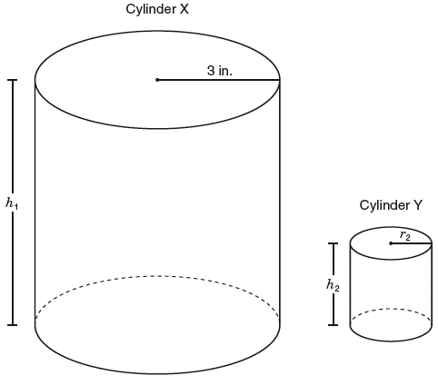[What is the purpose of this diagram? Why is it a step? What are students supposed to do?]
- Given your estimated diameter of Spiderman’s strand of silk, determine the force required to break the silk using the tensile strength as the stress. Please show all your calculation in an organized manner in your lab notebook. [If you want them to determine the tensile strength, why not just say so?]
- Is this myth busted or plausible? Explain your conclusion in a paragraph.

Part Two: Spider silk is very resilient. Would Spiderman’s silk stretch as he swung from building to building? Could Spiderman’s web really stop a train?
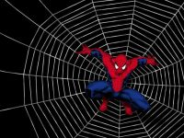

Introduction:
We have seen in the previous section that spider silk has good tensile strength, is very elastic, and is resilient. In engineering terms, elasticity is the property of returning to an initial form or state following deformation.. Resilience is the property of a material that enables it to resume its original shape or position after being bent, stretched, or compressed. [These sound virtually identical – clarify the distinction explicitly. Also ove or copy these definitions up to the table] In some species the spider silk can elongate (under strain) to 140% of its original length [before breaking? Or – and then return to its original state]. This would imply that if Spiderman produced a 10 meter strand of silk to swing on, then it should stretch to 14m as he applied his weight to the silk. Is Spiderman’s silk shown to stretch in the films? [The spider silk is also resilient so it will spring back to its original length after the load has been removed. ] –isn’t this redundant?
Let’s take a deeper look at the second type of spider silk, the capture strands of the web. If, instead of just ejecting a single dragline strand, Spiderman spun a web to capture a bad guy or stop a moving train, would the web be able to withstand the impact? The capture silk strands spun by spiders are coated with a proteinacious glue, and the actual fiber is also different than the dragline silk. Capture silk proteins fold into highly organized beta sheets, increasing its density. As a load is applied to the capture strands, the beta sheets unfold, elongating the material, andwhen the load is released, the beta sheets reform, and the strands resume their original length.
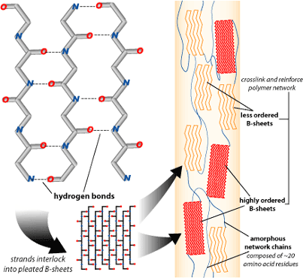

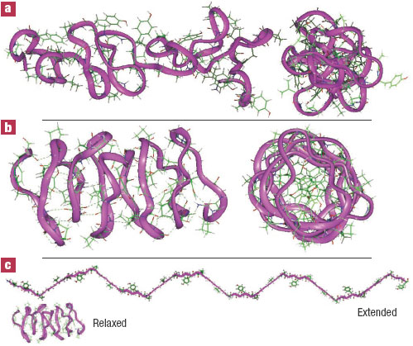 hansmalab.physics.ucsb.edu

The tensile strength of the capture spiral [Why now “spiral” – vs. strand] is 1,338 MPa, while the tensile strength of the radial thread [what are these – dragline?] is 1,154 MPa. For comparison, the tensile strength of "mild" steel is 400 MPa (Vogel 1988, p. 185). The capture spiral [if “spiral” is important, and it sounds like it is, maybe a brief sentence describing the spiral structure and the reasons for its construction is in order.] must absorb most of the kinetic energy from an insect's initial impact, while the radial threads serve primarily as scaffolding for the spiral(ref 1 – keep citation formats constant). The kinetic energy is transformed into heat (ref2 - ditto) and then dissipates. If this did not happen [no – various possibilities exist. I think what you mean here is “If the kinetic energy of the prey insect’s impact was entirely used in returning the web to its original form,…] the insect would be rebounded back of the web and the spider would go hungry.
In order for a web to trap a flying insect, its motion must be stopped. The force required to stop its motion is inversely proportional to the distance over which the motion must be stopped. In other words, the greater the distance over which the insect is slowed down the smaller the force necessary to stop it. The capture spiral's high extensibility enables spiders to trap insects with a fairly minimal amount of force, and reduces the potential for damage to the web [Yes, this is what needs to be introduced above when you first refer to the spiral]. The extensibility and tensile strength of spider silk in general, combined with its light weight, enable it to resist damage from wind and from being pulled by anchoring points of the web.
In this activity we will look at elasticity, tensile strength, and resilience of several different fibers, compare them with spider capture silk, and finally determine if Spiderman’s webs are capable of stopping a human or a train.

Mythbusters part two.

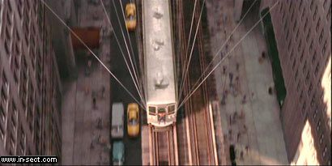

Materials: [see comments in TG]
2x4 with eye screws
Monofilament fishing line
Braided fishing line
Elastic
Kevalr
Weights
Meter stick

Procedure:A
In this part of the experiment you will learn about elasticity and resilience in fibers.
- This process will be repeated for each of the four types of fibers: Cut a 60 cm piece of fiber.
- Tie one end to the eye on the 2x4.
- Tie a loop in the other end so that the piece of fiber between the eye and the loop is 30 cm long [A figure would be very helpful here for envisioning this.]
- Measure the length [need to define – from eye to knot or from eye to end of loop – again, a diagram will help] of your fiber precisely and have your partner check your measurements. Record this initial length IL in your lab book. You will need to make a data table like this…

Type of fiber | Mass 1 | Mass 2 | Mass 3 | Mass 4
 | I L ∆L FL | I L ∆L FL | I L ∆L FL | I L ∆L FL
Monofilament
Braided line
Elastic
Kevlar

- Apply a load (a weight) to the loop (either tie it on or suspend it using a hook).
- Record the mass of the weight.
- Record the change in length of your fiber ∆L.
- Record the final length (FL) of the fiber after you have removed the load. Did it go back to its original length?
- Repeat this process, increasing the weight and recording the change in length every time, until the fiber breaks or fails.
- Plot the stress (force/area) against the strain (change in length/original length) on a graph using Excel. You will be generating your own stress/strain graph to determine the tensile strength, elastic modulus, and resilience. Elastic modulus is just another way of saying the elasticity or rididity of the material. [Again, these terms should all be defined clearly and explicitly when first introduced.]
- When Spiderman swings on his line, does it elongate? Watch a video clip on UTUBE* to ?????

Procedure B: [For parallelism, you might want a phrase here as you have in “A”]
The kinetic energy of a moving object can be determined using KE=1/2mv². If we assume the mass of a human to be 150lbs(convert to kg) and his running speed (fleeing from the police or Spiderman) to be 6.5 miles/minute[?? Not sure if my change is correct here – seems pretty speedy?? But the other is an odd way to express velocity] (convert to km/sec), then we can find the kinetic energy. Spiderman’s web would have to be capable of absorbing the kinetic energy by elongating the capture threads and turning the energy into heat.
- Assume the mass of a human as being 150lbs and convert it to kilograms .
- The velocity of a man running fast is about 6.5minutes per mile (this is odd – speed is usually distance per unit time rather than the converse). Convert this to meters per second.
- Calculate the Kinetic Energy of this running man.
- Capture silk will expand 140%. This means a fiber starting at 1 cm will expand to 1.4 cm. If the capture thread is 2 m long and extends 140% to 2.8 m long then this is the distance the guy travels while being slowed down and stopped by the web.
- We can say that work is the change in kinetic energy. Work = force x distance

- Force equals (or = for consistency) mass x acceleration. (Acceleration is going to be negative because the man stuck in the web is being slowed down.)
- Substituting KE for work, find the distance that the capture silk would expand when a 150 man hits it.
- . Does the man’s impact on the web fall within the 140% elongationlimit of the silk or will it break.
- Now we will ramp up our calculations to see if Spiderman could indeed stop a train with 4 strands of capture silk. Using information gathered at these two web sites, determine the speed and mass of the train in order to calculate the kinetic energy. http://www.chicago-l.org/multimedia/Spiderman2/. http://www.chicago-l.org/trains/roster/2200.html. According to the film, the train had 6 cars. –[clarify what the students should do with this last piece of info]
- Is this myth busted or plausible? Make sure all your research and calculations are in your lab notebook. Write a paragraph in conclusion of this part of the Spiderman myth.

