Feel the Force: Using Atomic Force Microscope Models in the Classroom
Modeling how scientists use the AFM in nanotechnology research

Purpose
This lesson is to teach students why scientists use the AFM and how the AFM works to produce an image.

Subject area(s), Scientific concept(s), &/or Key words
Biology, Chemistry, Physical Science, Atomic forces, Nanometer

Time required
2 class periods if using the PowerPoint – One class period is needed for the introduction, sand paper activity, and instructions for using their model AFM. The other class period is to use the model to collect data and summarize the lesson.

3 class periods if not using the PowerPoint – Students may take longer when reading through and going through the check points.

Target Grade Level
7th -10th grades

Advance Preparation
You need to choose if you want to present the lesson with the PowerPoint or not. If using the PowerPoint, you will need the student worksheet without the additional pictures and directions and it can be copied in black and white. If you are doing the lesson without the PowerPoint, you will need the student worksheet with additional pictures and instructions and you may want to print off a class set in color.
Your students will need access to Excel in order to graph a surface graph in one of the activities. The worksheet is designed for the students to print off their graphs, so they can glue or tape them to their worksheet.
You will need a piece of cardboard with three pieces of paper, each of different textures using sand paper of different grits. Label the pieces of paper A, B, and C. See picture below:
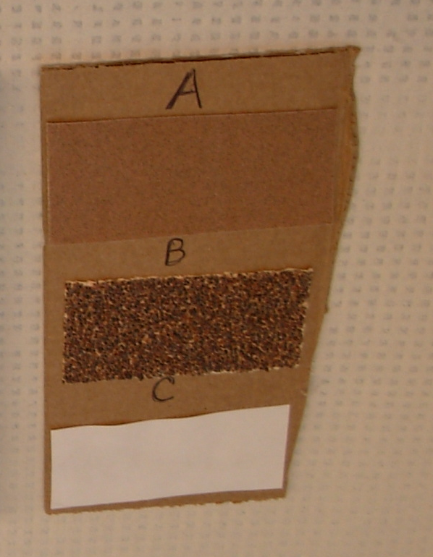

Building your models: You will need to build one model for each group. You can choose which type of model (shoe box or Lego) you want for your classroom.

Shoebox model:
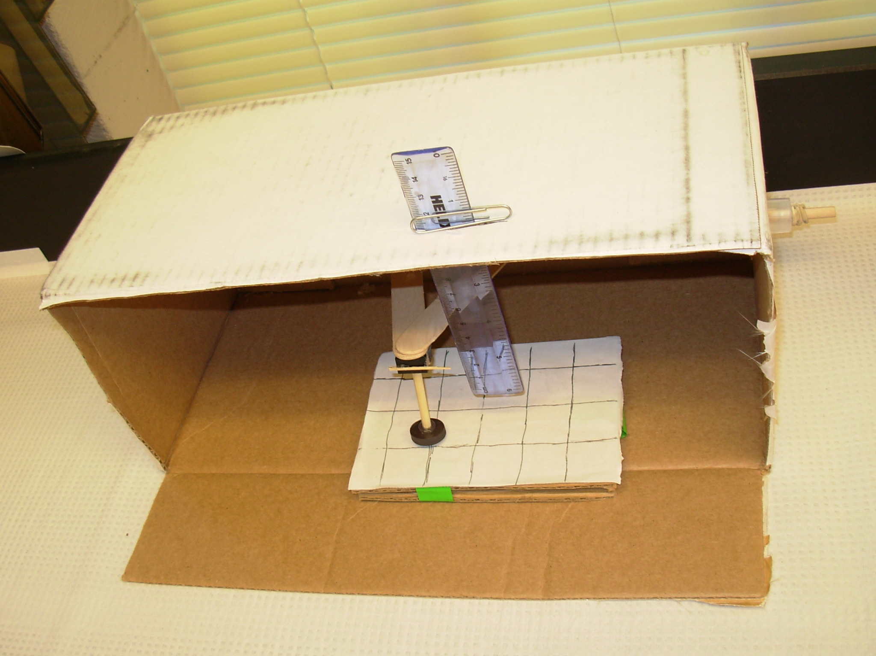
Materials:
-1 cardboard box – shape of a shoe box
-1 small ruler (6”)
-1 large paper clip
-3 wooden dowels – 3/16” in diameter (one must be long enough to go further than the length of the box, one should be cut into 3 pieces about 2” long, and one should be cut into three pieces about 3” long)
-1 wooden dowel – ½” in diameter – cut into three 3” pieces
-masking tape
-1 toothpick
-glue gun with glue sticks
-2 tongue depressors
-5 magnets
-1 Lego piece – thick, small square

Building procedure:
1. Lay shoebox on its side, with the opening facing you.
2. Cut two holes on either side – about 1” from the bottom and 2” from the side that is laying face down on the table.
3. Slide the long 3/16” dowel through the holes and use masking tape on each side to prevent the dowel from moving side to side – but it should still be free to twist. In the picture, there are plastic caps and rubber bands to stabilize the dowel from moving from side to side. This was more durable for continuous use, but not necessary.
4. Glue the two tongue depressors to the wooden dowel and to each other to form a triangle.
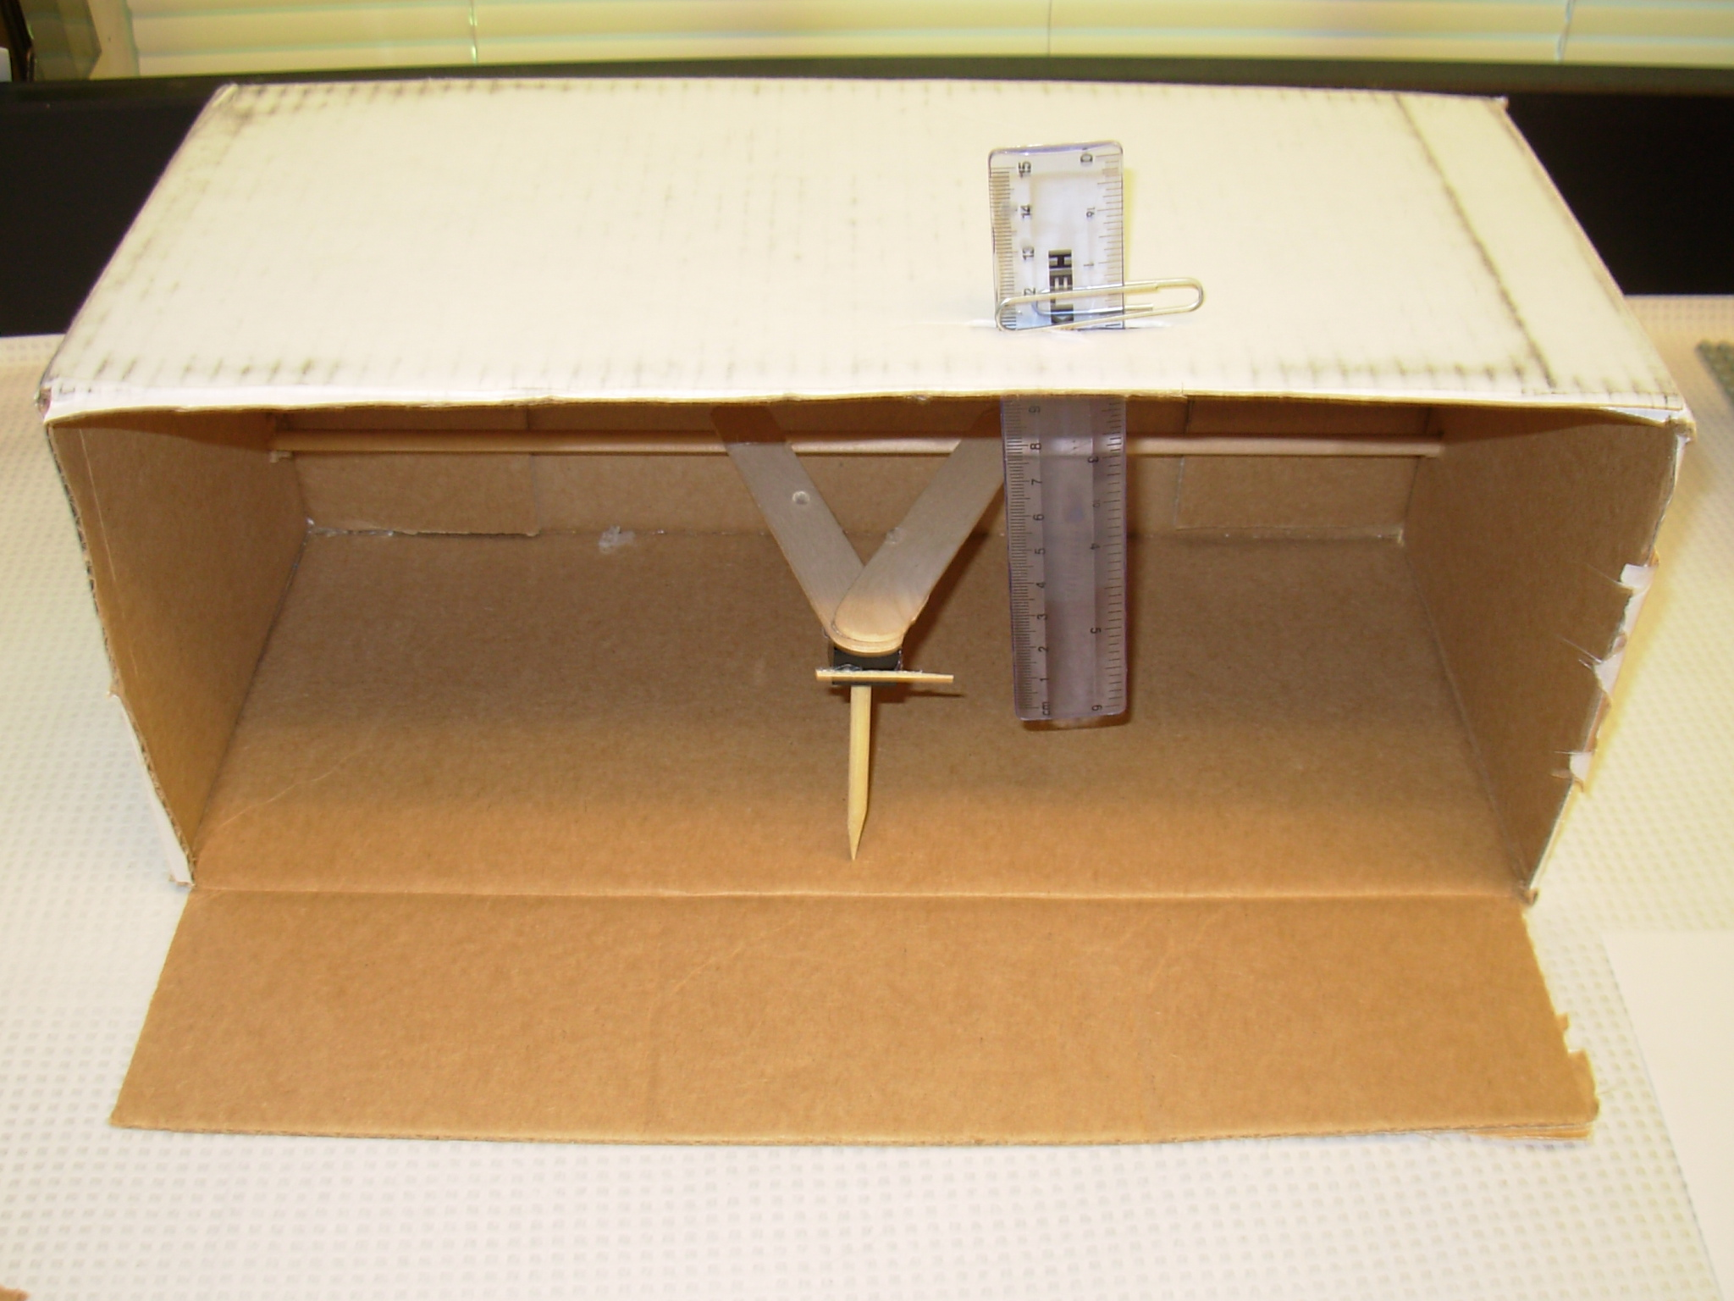
5. Glue the Lego piece to the tip of the tongue depressors with the end with the hole facing down and the bumpy end being glued. (This will be where wooden dowels can be inserted.)
6. Glue the toothpick on the Lego piece, so that it is pointing to the right side of the box.
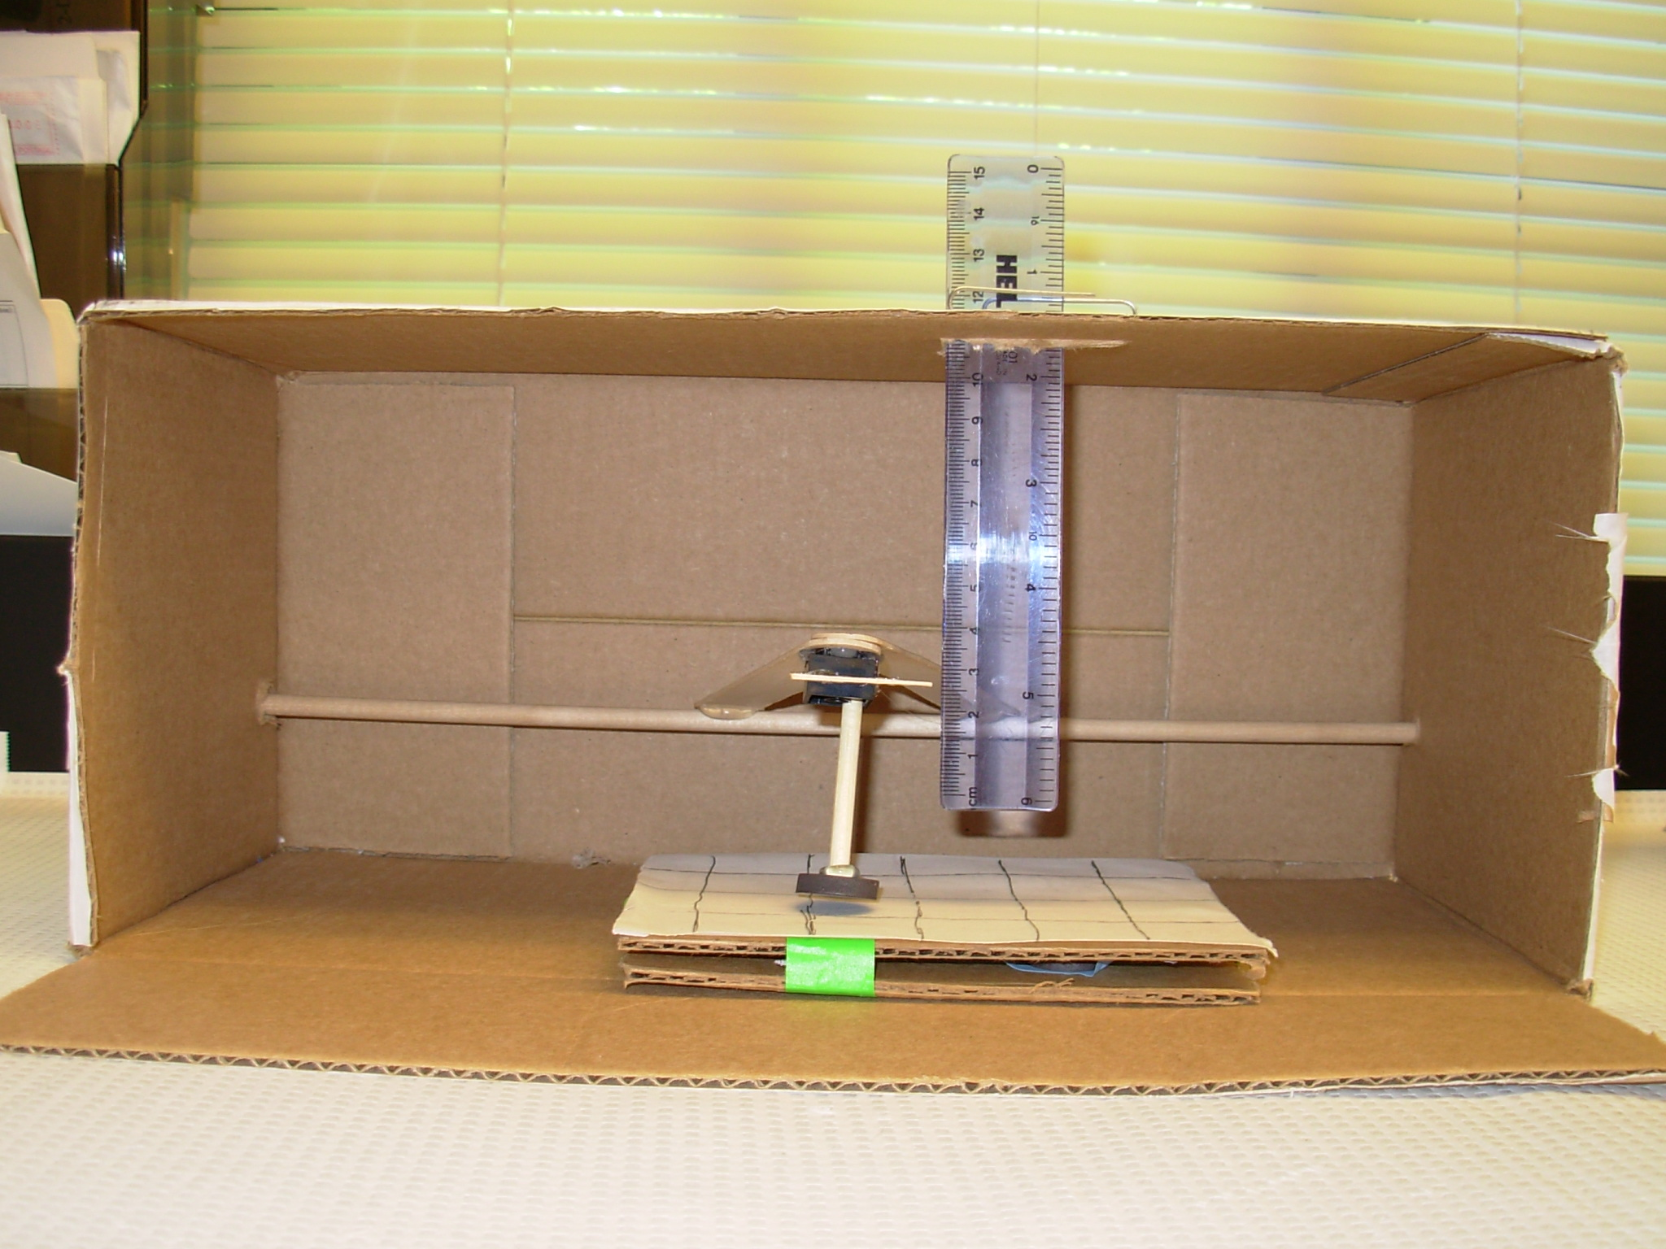
7. Cut a slit in the side of the box that is facing upwards, for the ruler to be placed through. This slit should allow the toothpick to point to the scale on the ruler.
8. Place the ruler through the slit and use the paperclip to secure the ruler and prevent it from sliding to far through the slit.
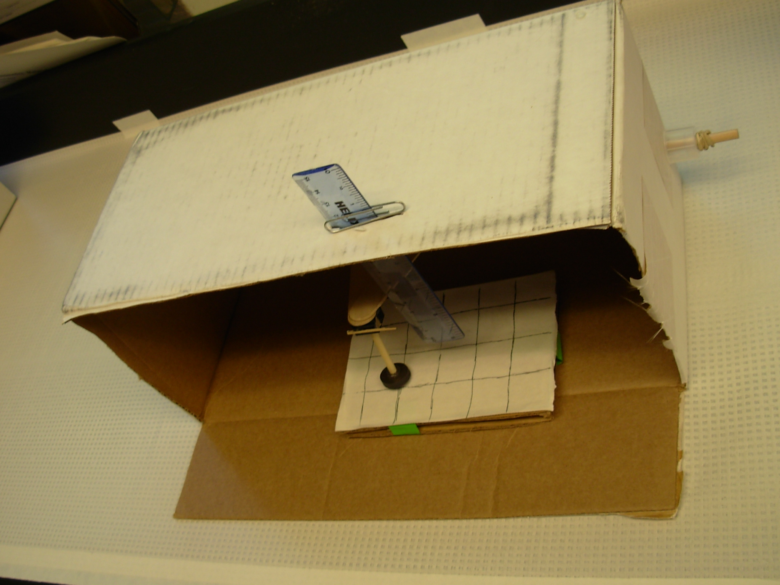
To make the tips:
1. Sharpen with a pencil sharpener one 3/16” – 2” dowel piece.
2. Glue a magnet on the end of another 3/16” – 2” dowel piece.
3. Keep the end blunt (cut straight across) of the third 3/16” – 2” dowel piece.
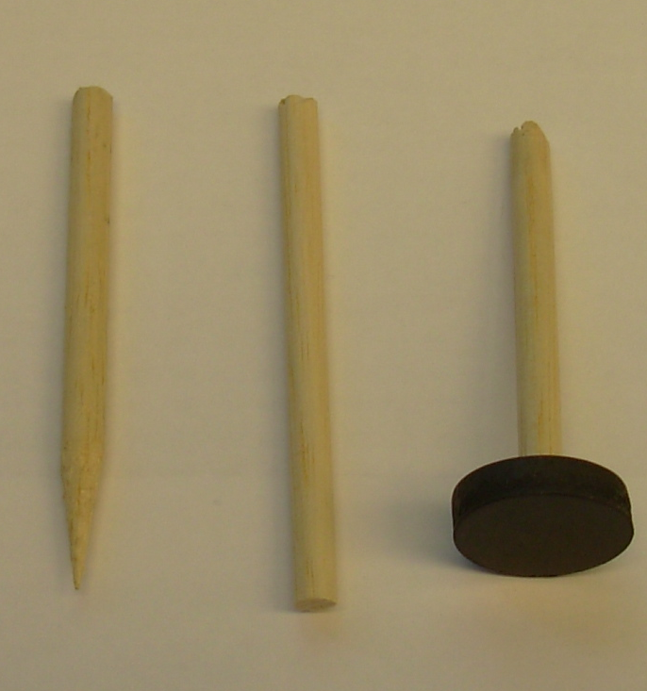
To make the stages:
Use the cardboard from the flaps of your box or the top of your shoe box to make the following.
1. Cut 3 6”X4” pieces of cardboard.
2. On one piece of cardboard, glue the three 4” – 3/16” dowels, side by side.
3. Leave about 1” of space and glue the three 4” – ½” dowels, side by side.
4. The magnets and the other two pieces of card board will be used in the activity to sandwich together and have magnets hidden in different places on the board. So masking tape will be used to hold the magnets in place and to hold the two boards together. On the top of one of the pieces of cardboard, you may want to glue a piece of 1”x1” grid paper – to allow for easier data collection.
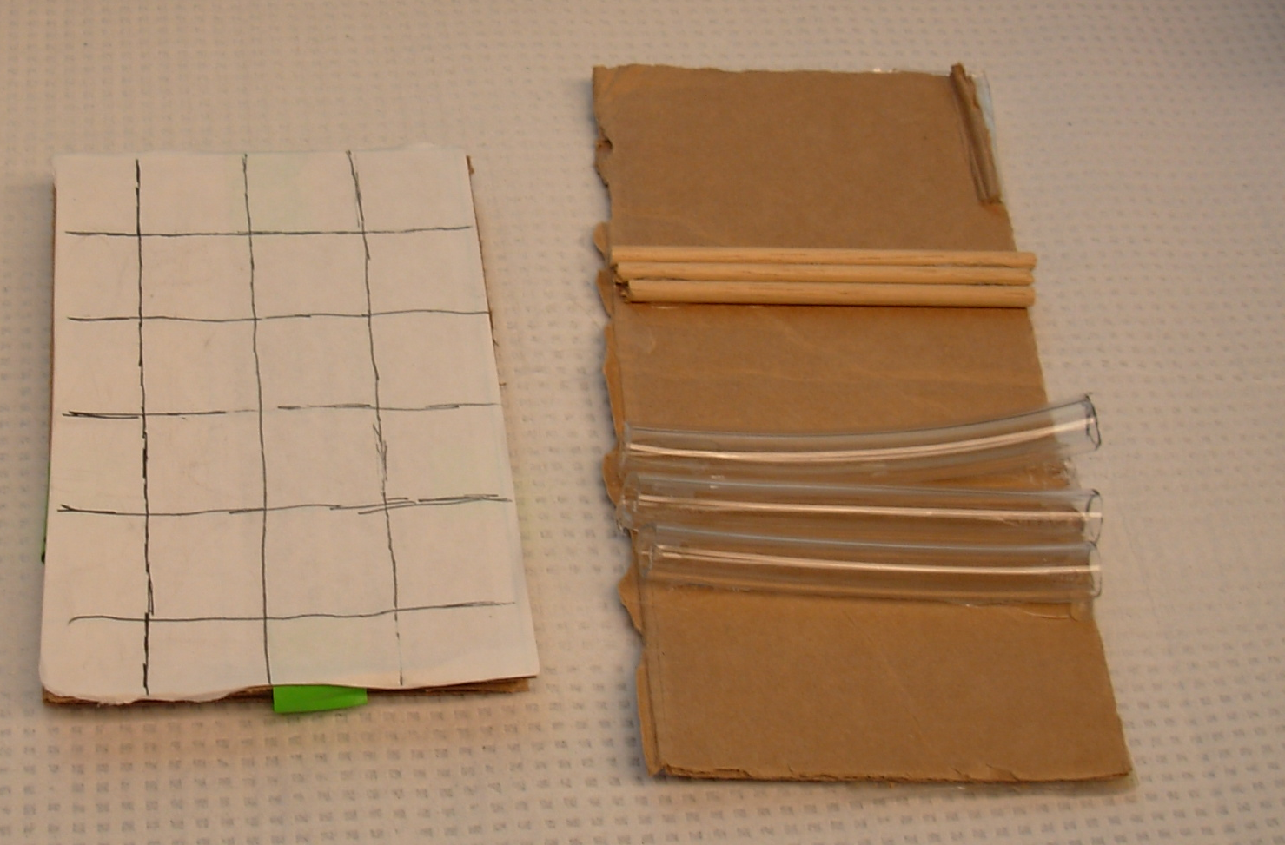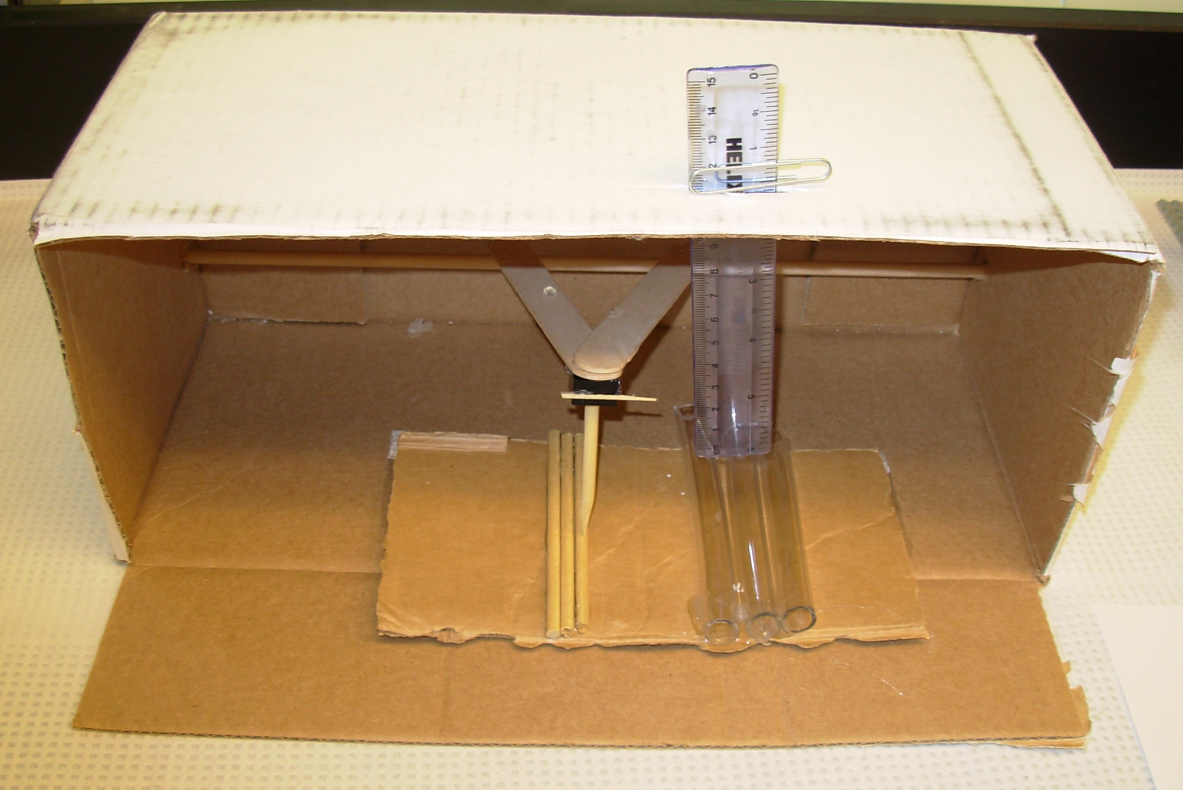

Lego Model:
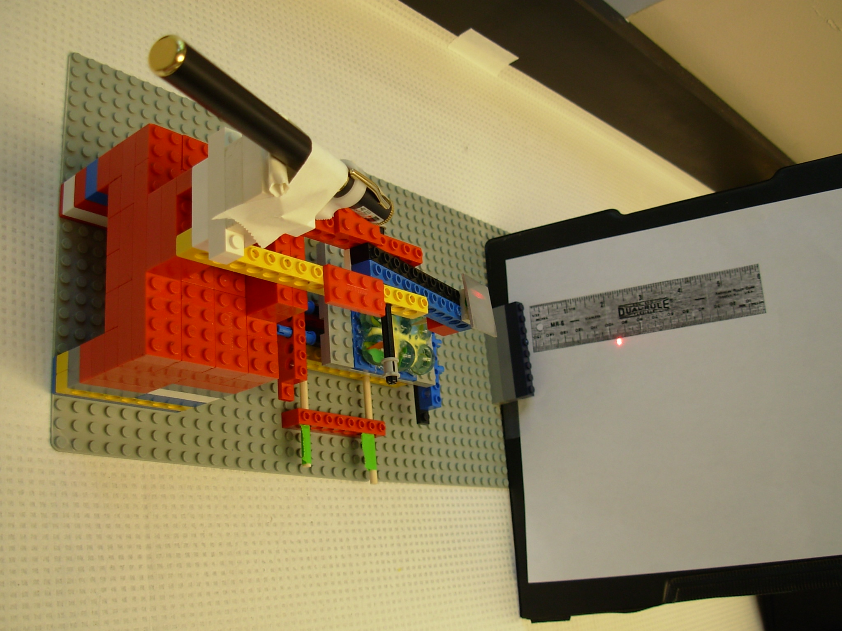
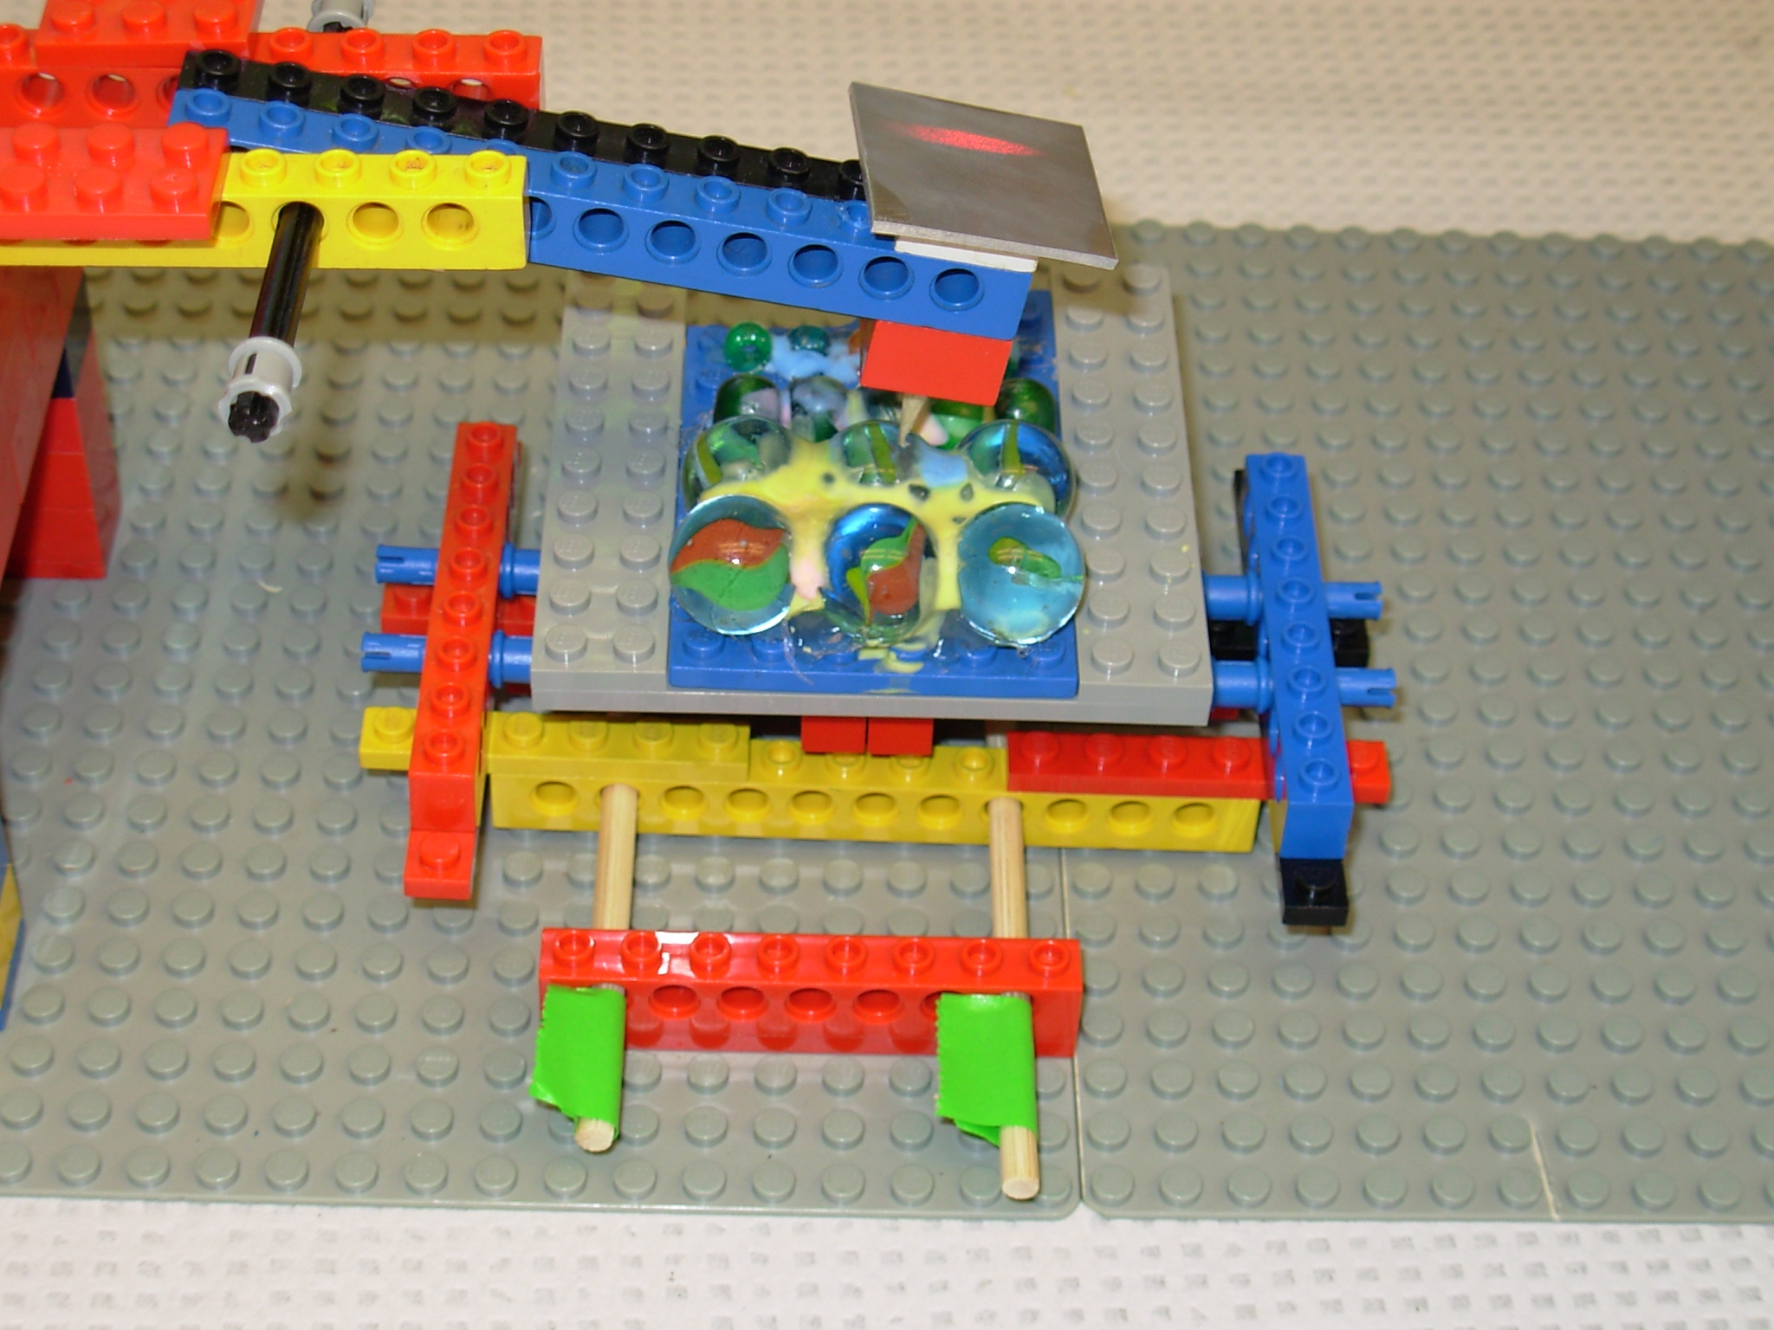
Materials:
-Legos of various sizes
-Laser pen
-small mirror
-piece of stiff cardboard (about the size of a piece of paper)
-wooden skewers (optional)
-photocopied ruler on a piece of paper
-small clamp
-1 wooden dowel (3/16 diameter) cut into three one inch pieces
-1 small powerful magnet
-glue (strong glue or a glue gun with glue sticks)
-3 marbles
-3 small beads (about half the size of the marbles)
-masking tape

Building procedure:
Use the pictures below and the Lego materials available to you to build your Lego AFM step by step.

Base Platform: Use a large flat Lego piece to act as your platform to build the detection system, the stage, and the laser tracking panel on.

Detection System:
a. Build a raised platform, about 2 1/2 inches tall and 2 inches wide. This raised platform will hold the laser and the cantilever arm.
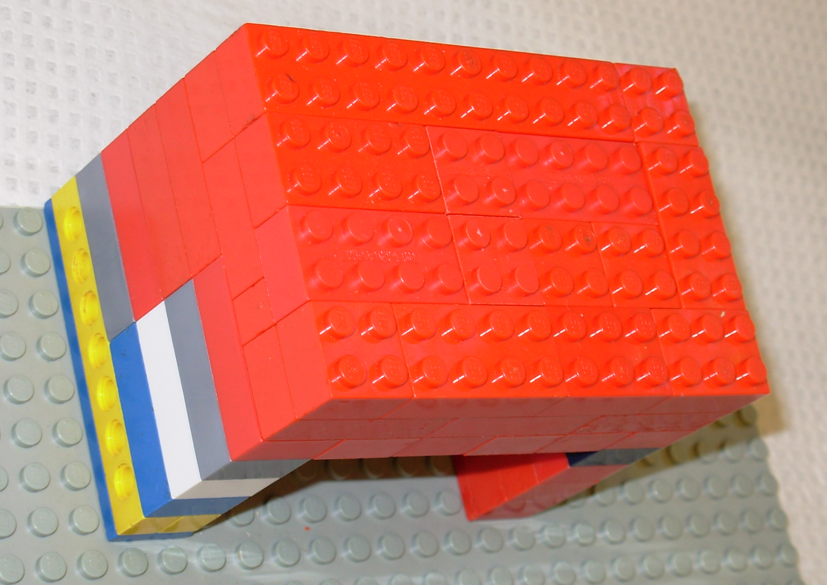
b. Build a smaller raised platform about 2 inches on the top of the raised platform, and attach the laser pen to this platform using masking tape. The laser will be about 4 inches from the base platform. The laser must be at an angle pointing the laser towards the mirror that will be attached to the detection arm (cantilever).
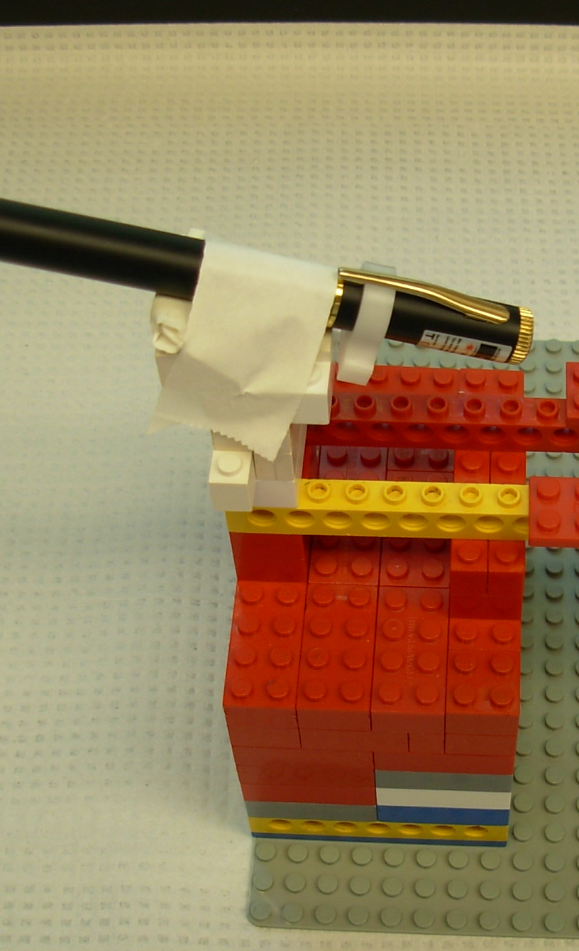
You will need to find a small clamp to keep the laser button pressed “on”, while students are using the model. Then the clamp should be removable for when the laser is not being used. In the photo, we are used a small test tube clamp.
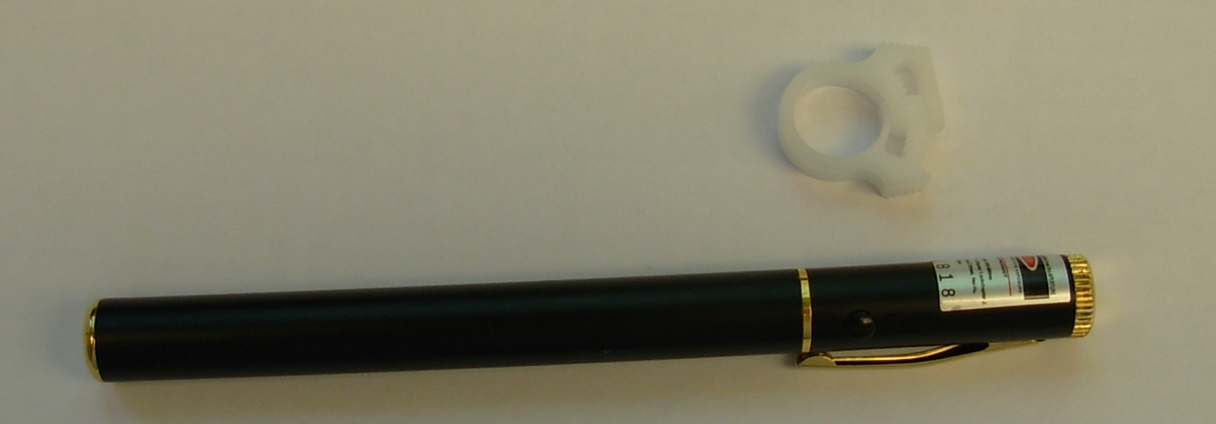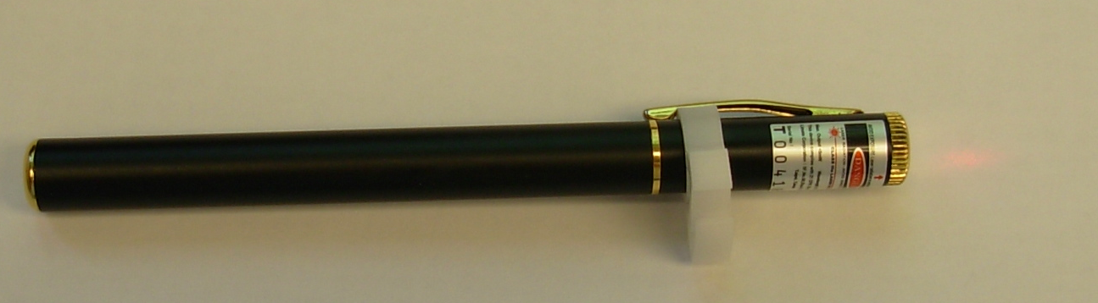
c. Build the cantilever (detection arm) as seen in the picture. The arm must be able to move up and down on the hinge. The mirror must be at an angle to catch the laser light and be projected onto the Laser tracking panel.
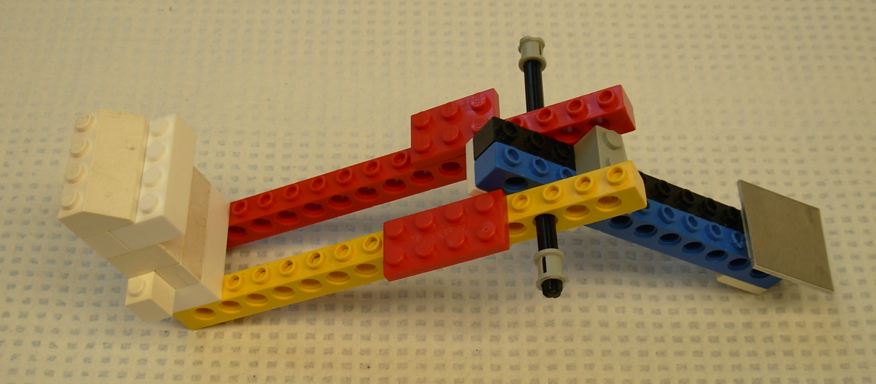
On the bottom of the cantilever is where three different tips can be placed. One has a sharpened tip, one has a blunt tip, and one has a small powerful magnet attached.
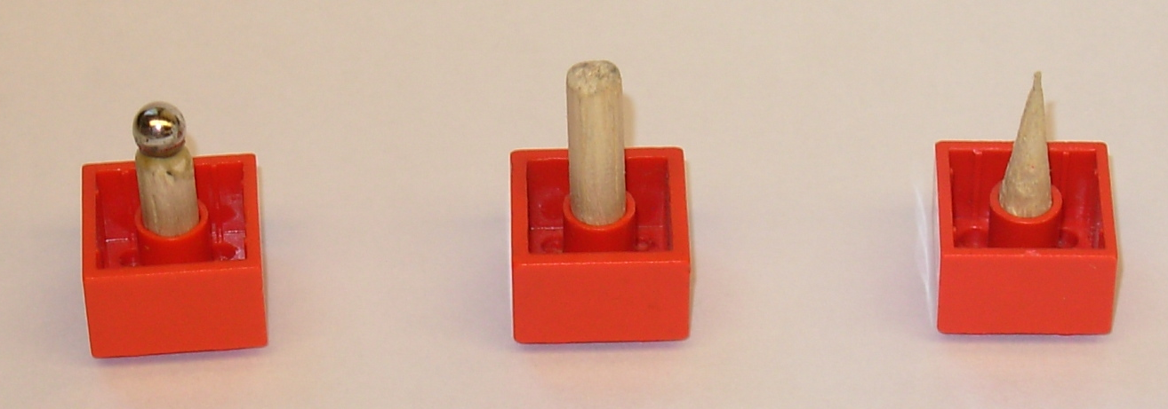
Stage:
a. The very bottom of the stage (part A) has two immobilized rods made from wooden skewers that are horizontal to the platform of the detection system. This will hold the next level of the stage (part B) so that it is able to glide back and forth on the rods.
b. Part B is hooked to part A, so that it glides horizontally back and forth. Part B has another set of immobilized rods that are black in the picture that are vertical to the platform of the detection system. Part B has the longest red and yellow Legos running on the wooden skewers that are connected to the blue and red Legos at the top and bottom of the picture that are holding the black rods. These rods will allow part C of the stage to glide back and forth vertically.
c. Part C is the two small yellow/red pieces running on the black rods on part B so it can glide vertically back and forth and hold the samples that the students will be testing.

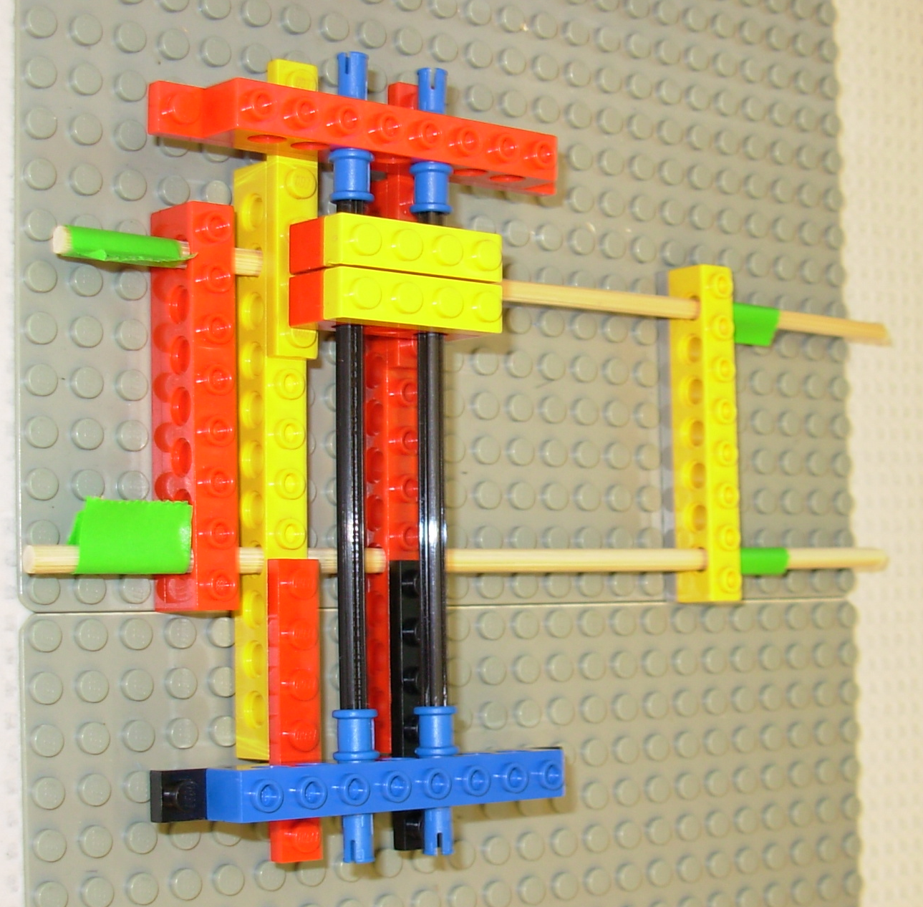
Samples for the stage:
Sample 1: This is a flat Lego piece with magnets taped to the bottom of it. There are small Legos that will allow you to attach the sample to the stage. On the top of the flat Lego piece is a piece of transparency, in order to make the top surface smooth for the tips to glide over.
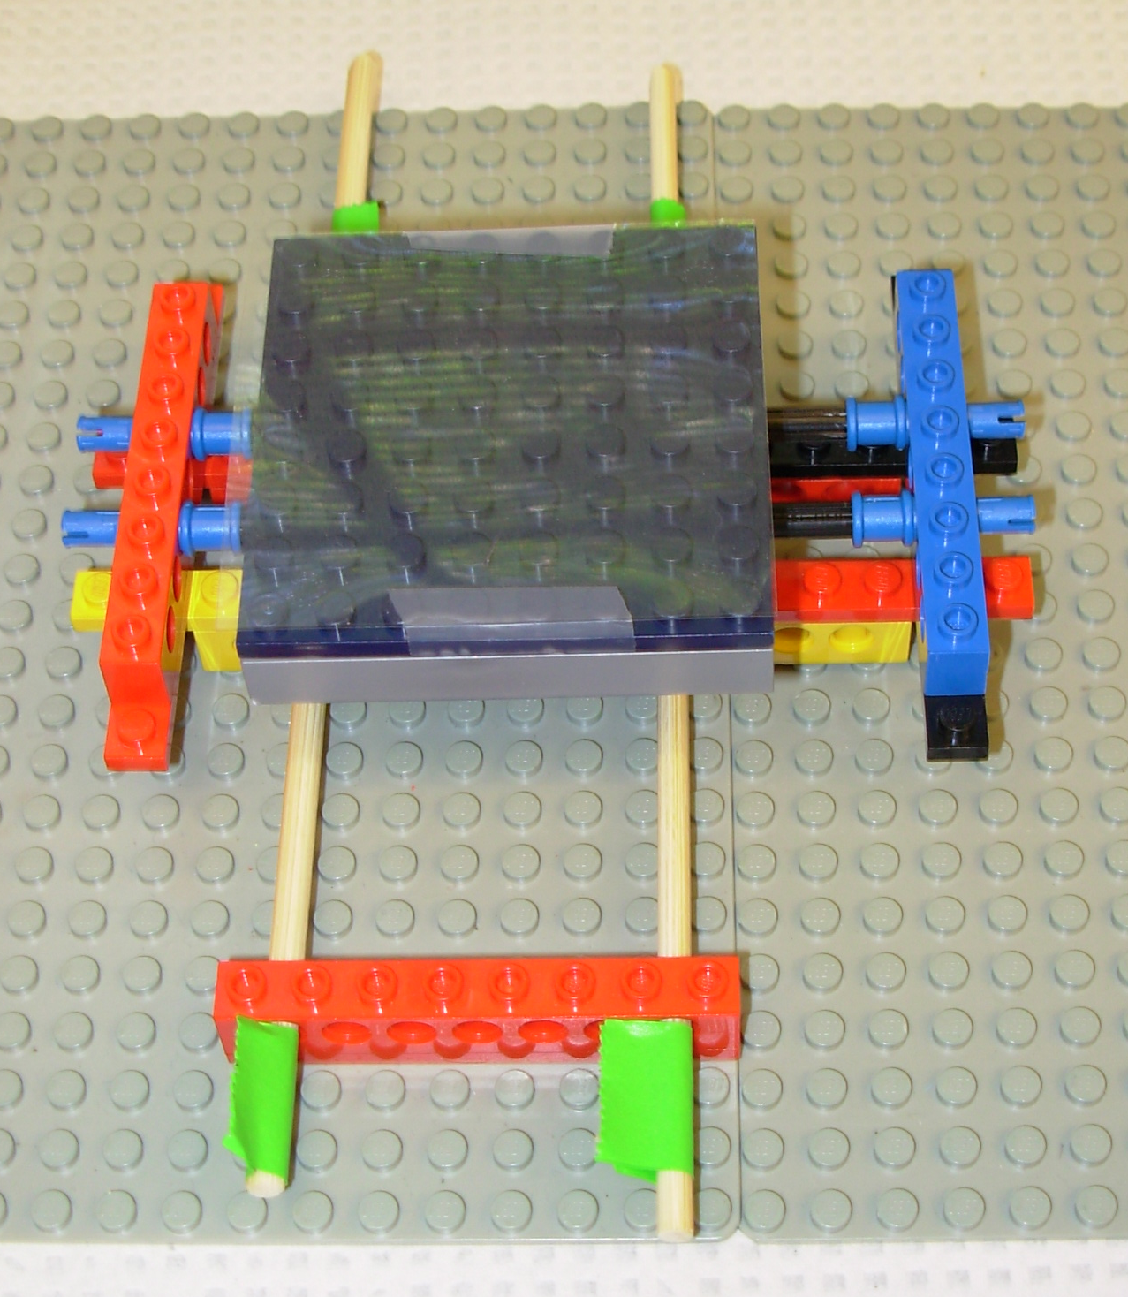
Sample 2: This is a flat Lego piece with lines of different size marbles or beads glued to the top. In the lesson you will need at least one line of large marbles and one line of small beads. This also can be attached to the stage.
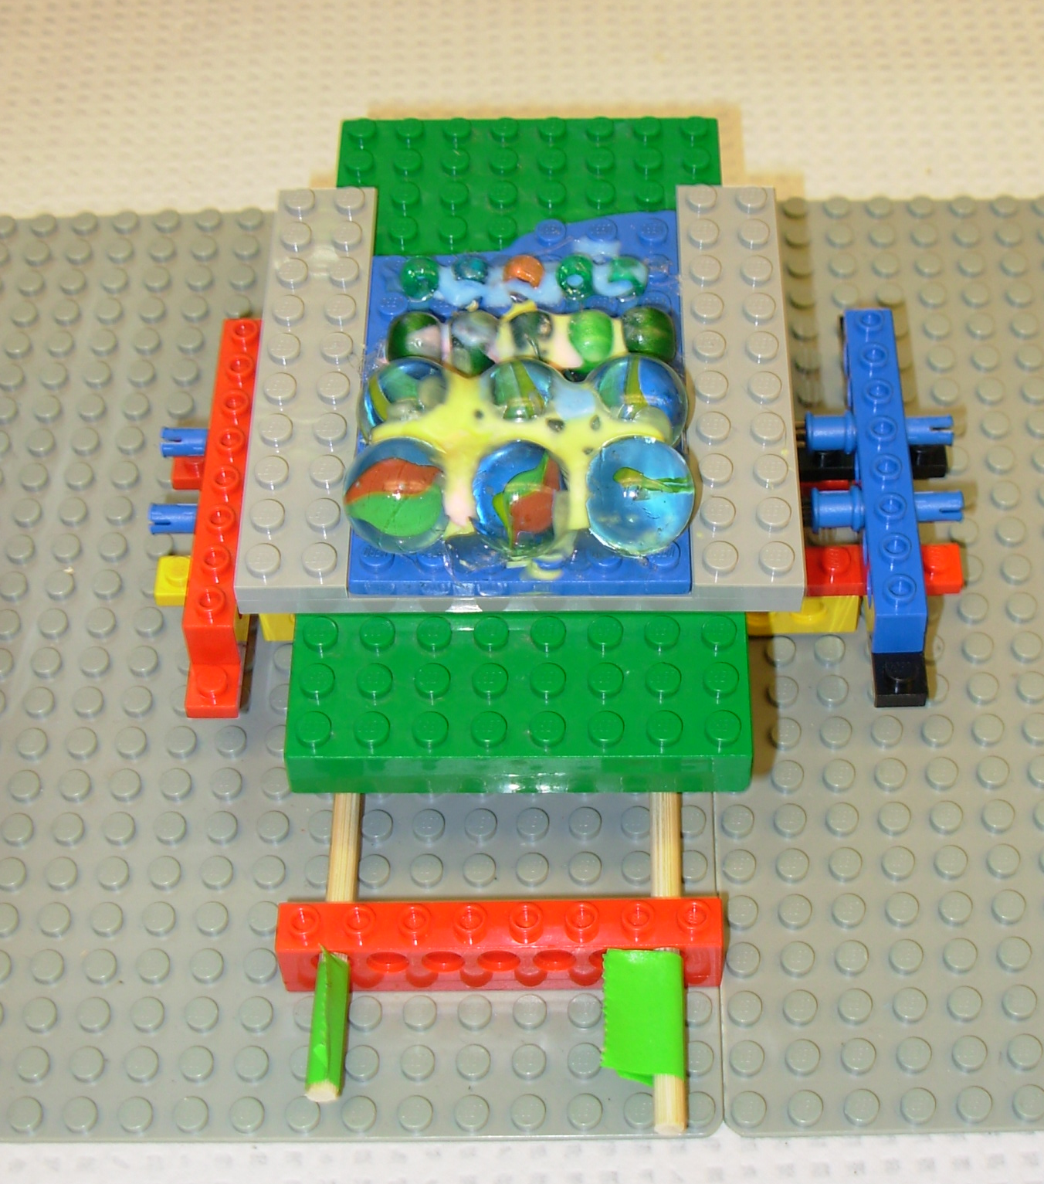

Laser Tracking Panel:
Build two piles of Legos about 1/2 apart on the base platform behind the stage. This makes a slot that holds a stiff piece of cardboard – about the size of a piece of paper. In the picture we used the cover of an old binder. On the cardboard tape a piece of paper with a picture of a ruler on it. The paper cannot be permanently attached, but just held by a small piece of masking tape. This will allow students to move the paper to place the laser pointer at the zero mark on the ruler.

When you’re finished the laser should be reflecting off the mirror onto the piece of paper with the ruler. As the tip moves up and down, you should be able to measure how far it moves by the laser light on the ruler. If the light is not on the paper, you may need to adjust the mirror angle or the laser angle to get it just right.
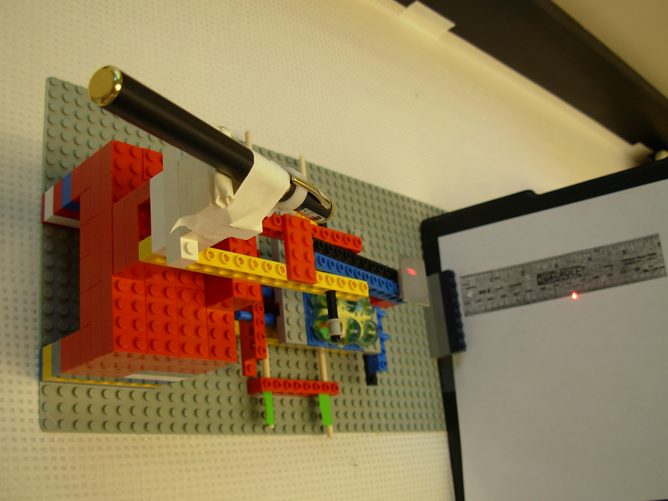
I would highly recommend you try collecting the data with your first model, before building the rest or trying the lesson with your students, so you will become familiar to how the models work, make the rest of the models well, and allow the lesson to run smoothly with your students.

Safety Information
The glue from a glue gun can be very hot, so be careful not to touch the hot glue or the tip of the glue gun when it’s warmed up. If using the laser with the Lego model version, be sure that students do not shine the light directly into each others eyes.

Teaching Strategies
Objectives of the Lesson
The objective of the lesson is to teach the following points about the AFM microscope:
- AFM is used to scan the top of a sample of a thin layer of molecules to produce a topographical image that can be used to find patterns and molecular arrangement.
- The AFM is different form the light microscope in that you are not “seeing” the sample with your eyes through a lens.
- The AFM scans by moving an incredibly tiny tip (that can be made of many different materials) over the molecular layer, sensing the atomic forces. The movement of the tip is sensed by a laser that reflects onto a photo-sensor grid. This information is calculated by computer software and changed into an image.
- The smaller and sharper the tip, the more defined the image. (Softer samples are sometimes “tapped” by the tip, while on harder samples, the tip is dragged.)
- Gravity is not a factor at such a tiny level, only the interaction of the atomic forces, such as hydrophilic/hydrophobic qualities.
- Scientists who build tiny layers of molecules through a self-assembly system, regularly use the AFM to “see” the results of their work.

Lesson Guide- Using the PowerPoint presentation
Using the PowerPoint presentation, you may want to have students only working in groups when using the models for the two tests – otherwise have them in their assigned seats for better participation. Use the student worksheet that does not have all the instructions.

- Slides 2, 3,4 - show AFM images. The students should guess what they are and then you can tell them.
  - Slide 1: tooth enamel – inside and surface
  - Slide 2: the outer layer of a moth’s eye
  - Slide 3: mica – a shear clear rock that peals in thin layers
- Slide 5 – establish through class discuss approximately how big each of the following is:
  - Person = 2 meters
  - Brain = 20 cm
  - Paramecium = .5 um (micrometer)
  - 1-10 nm (nanometers)

- Slides 6,7 – reinforce how small a nanometer is
- Slide 8 – shows an AFM image of the tops of tobacco mosaic viruses that are nano-sized and shows how small these images really are.
- Slide 9 – shows a picture of an AFM – note no lens for the eyes to look through
- Slide 10 – question that leads to slide 10
- Slide 11 – Have the students write two similarities and two differences between the images of bacteria (the bacteria in the AFM is 250nm in height) – one from a light microscope and one from an AFM image. Then discuss their answers as a class.
- Slide 12 – This image shows the tip and how it scans the surface of the sample. It lets students know that gravity is not a factor at this tiny level. Up in the corner is a hyperlink to an animation of the tip and cantilever in action.
- Slide 13 – This image shows where the tip is found in the AFM. This is also where the sample is placed. It emphasized the small size of the tip and asks the question – What is missing? This refers to the eye lenses.
- Slide 14 – Guides students through the sandpaper activity, where students run their finger over three types of paper and rate the roughness, without looking. This is an example of how the AFM works to scan the surface of a sample.
- Slide 15 – Shows really how bumpy the smooth paper really is. It also show give clues for the next activity that will reinforce that the smaller the tip the more detail the AFM can detect in the surface of a sample.
- Slide 16 – Shows a smooth gold plate to the naked eye and an AFM image of the surface, showing that it is quite lumpy at the atomic level.
- Slide 17 – This slide reminds you to start them on their tip size test. The student worksheet has the instructions and guides them through the process. You may want to demonstrate the procedure to the class to get them started.
- Slide 18 – Has review questions to reinforce that the smaller the tip the more detail the AFM can detect. There is also an animation link on this slide that will help demonstrate this.
- Slides 19, 20 – Review how small the images really are with the students
- Slide 21 – introductory slide to the next section that will teach about the atomic forces that the tip is responding to.
- Slides 22, 23 – molecules may be neutral or have a charge – making them hydrophobic or hydrophilic. Like charges repel, opposite charges attract, charged molecules are attracted to water and neutral molecules repel water
- Slides 24, 25 – show in greater detail how the movement of the tip is translated into an image by a laser beam moving over a photodetector and sending the information to computer software to be made into an image.
- Slide 26 – shows a website that sells different types of tips – the scientist can choose which type of material he/she wants the tip to be based on their sample.
- Slide 27 – Cues you to start the students on the force test, where they use the magnetic tip on their model AFM to collect data.
- Slide 28 – Reviews what the students should have learned about the way the AFM works to produce an image using atomic forces between the sample and the tip.
- Slide 29 – Scan the hand test instructions for the students – after they have made their drawings and answered their questions – show how the “pin” toy makes a topographical image of the hand and discuss their answers to the questions as a class
- Slides 30,31,32 – Gives examples as to how scientists use the AFM in their research
- Slide 33 – ends the presentation
- Slide 34 – credits any pictures that I used from the internet

See below for a copy of the worksheet with the answers.

Lesson Guide – Without the PowerPoint presentation
Have the students work in groups and hand out the student worksheet that includes all the instructions. Distribute the models and materials to each group. Below is an answer sheet to the hand out.

Guess the images:
Image 1 - ____________guess_______________________

Image 2 - _____________guess______________________

Image 3 - ______________guess_____________________

How big is the:
Person ___~2m_________

Brain ____~20cm_________

Paramecium ___~100um_______

Molecules _____~20nm________

Write two similarities and two differences between the images:
Similarities:
1. bacteria appear hot dog shaped

2. both are colored and not moving

Differences:
1. bacteria are different sizes

2. much more surface detail in image B

Roughness Scale:
Sample A: ____ Sample B: ____ Sample C:____

The Tip Size Test: Using your AFM model you will recording data by using the two different shaped tips – the sharp and the blunt – on the same sample to decide which shape will give a better reading of the actual sample.

Problem: Which tip – the blunt or sharp – will give a more accurate reading of the sample?

Hypothesis: guess a tip type (blunt or sharp) and support why

Procedure:
1. Put one of the two tips into the cantilever (the arm).
2. Put the sample with the marbles or tubes on the platform.
3. Line up the pointer or laser to the zero point on the ruler. (If using the laser, be sure it is reflecting off the mirror.)
4. Slowly run the tip over each marble or tube.
5. Read and record below each measurement of the tops of each tube or marble and gully of the tube or marble.
6. When finished reading the six large ones and six smaller ones, repeat the process using the other tip. (If you used the sharp tip first, now use the blunt tip or vice versa.)
This data depends on the size of the objects you are measuring and what units you choose.
Large objects:
blunt
sharp

Small objects:
blunt
sharp

Calculations:
You must calibrate your data now! Your sample size is smaller than the actual numbers you collected above as data. So in order to get the actual size you must calibrate your numbers.
Here’s how it’s done:
First measure how think your stage is that your sample is on. ________mm = a
Then measure the actual distance from the bottom of the stage to the top of the large marble. _________mm =b

Now subtract those two numbers (b)______mm – (a)______mm = _________mm(c)

Take the difference (c) and divide it by the depth of the stage (a) and that will equal your magnification.
_______mm (c) divided by _______ (a) = ________ magnification!

So in the following calculation table, take each piece of data from your data table and divide it by the magnification number and enter it into the table below.

laser number _______ divided by the magnification number _______ = calibrated data (actual size)

Large objects:
sharp
blunt

Small objects:
sharp
blunt

Graphing the data: Type the data onto a spread sheet in Excel, in the same pattern as in the data table. Highlight one table and push the graphing key. Select the “column” graph and print out the graph. Do the same for the other data table. Cut out the graphs and past them below:

Large Objects Graph:
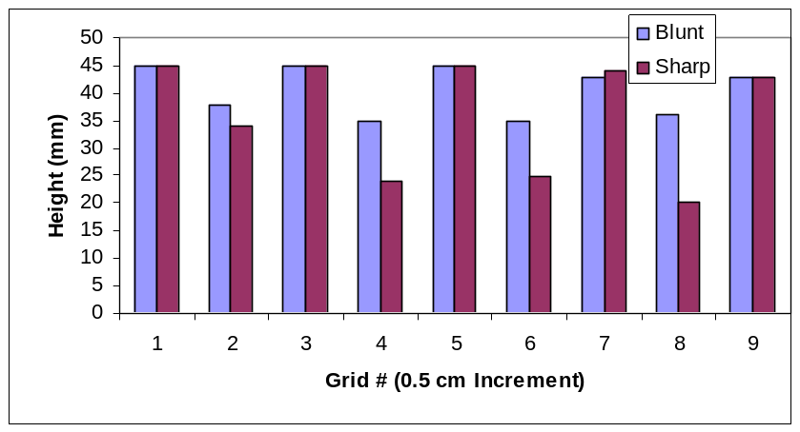

Small Objects Graph:
Graph would look similar – just shorter in height

Conclusion:
Hopefully they will find that a sharper tip gives more detail and include numeric data to support their answer.

- Which tip “feels” with more detail?
- Why is this type of tip able to “feel” with more accuracy?

The Force Test: In this activity you will simulate how the tip is really moving up and down only based on an attraction or repulsion of the tip to the sample. Each is made of specific molecules that have atomic forces that interact.

Procedure:
1. Have one person place four magnets under the cardboard/Lego platform. Be sure that other students are not looking as to where the magnets are being placed.
2. Insert the magnetic tip on the AFM.
3. Zero the pointer.
4. Have another student run the sample under the tip, moving in a grid like pattern from left to right, and moving up one row each time.
5. When the tip stays on the sample, that reading is a “zero”. When the tip repels the sample, measure how far, on the ruler, and record that number in that section. (You can use the grid below to record your data, but you may have to modify your data table depending on the reach of the arm on your AFM.)
This data depends on where they put the magnets. A spot without, should be a zero and the spots with a magnet should be a positive number.
Data:

Calculations:
Again you must calibrate your data in the spots that are larger than zero. The great part is that you already have the magnification of your AFM. So just use the following calculation on the grid data that is above zero. The boxes that are zero, stay zero.
So take the laser number _______ divide it by the magnification number _______ = and that equals the calibrated data (actual size).

Calculations:

When you have recorded your calculations, enter your data on a spread sheet in Excel, highlight the numbers and choose “surface” graph. Print out your graph and paste it below:

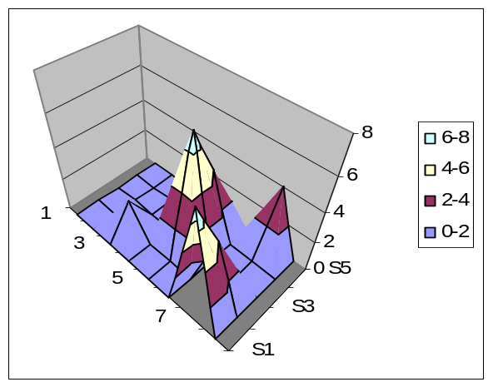Force Graph:

Lift the platform and see how close your image is to compared to where the magnets were placed.
Did you find all the magnets?_____
If you missed any, why do you think you missed them?
Arm couldn’t reach the whole sample – fits the AFM

- What made the tip move?

The interaction of force between the magnets causes the tip to move.

- What is detecting the movement of the tip?

The laser or your eye – depending on your model

- How is the image generated?

Using the data from the movement of the tip and making an image on a graph.

- Why is this instrument called the Atomic Force Microscope?

It senses the forces between atomics to form an image.

Hand Drawing:

The drawing should show the top and side of the hand, but not the bottom. It should look raised and have detail of the skin, hair, and nails.

What can’t you see of your hand with an AFM image?

The bottom of the hand and the inside of the hand are not visible.

How do scientists find the AFM useful?

Scientists use the AFM to look at the atomic surfaces of nano-systems that they built through self-assembly.

Great Job! May the force be with you – always!

