Identifying Poor Growth in Infants and Toddlers

INTRODUCTION

Monitoring children's growth is a universally valued part of their health care. Every parent wants to know whether his or her child is growing well; every clinician wants to be able to reassure parents if growth is appropriate or to seek help if it is not. Measuring children and plotting their measurements on growth charts are the first steps in growth assessment; the next step is interpreting the plotted charts.
The aim of this module is to help the clinician detect poor growth in young children and describe the growth in exact terms.

Objectives

Upon completion of this module, you will be able to:

- identify infants and toddlers who are growing poorly by looking at plotted growth measurements on growth charts

- describe children's growth in quantitative terms

Table of Contents

1. Anthropometrics: weight, length and weight-for-length

2. Identifying Poor Growth

3. Describing Growth in Quantitative Terms

4. Evaluation of Reasons for Poor Growth

5. References

6. Glossary

1. Anthropometrics: Weight, length, and weight-for-length

The three measures of body size shown on the growth charts for infants (birth to 36 months of age) are length, weight, and weight relative to length. The latter is an indicator of how the child's weight matches his or her length. Weight-for-length corresponds to body-mass-index-for-age (BMI) in older children.

In children less than 2 years old, recumbent length is measured; in children over 3 years old, stature (height) is measured. For children between 2 and 3 years old, there is a choice. Either length or stature can be measured. To continue to use the set of charts for birth to 36 months, measure length; to use the charts for 2 to 20 years, including the BMI-for-age chart, measure stature.

CDC recommends using the BMI-for-age charts beginning at age 2 years because BMI-for-age can be used to track overweight into adulthood. On the other hand, for children between 2 and 3 years, the birth to 36 month charts offer continuity with their earlier data and show data in a more expanded display that is easier to interpret.

In this module we use the set of charts for infants and children from birth to 36 months. These charts include weight-for-age, length-for-age, head-circumference-for-age, and weight-for-length. (The use of head circumference-for-age is reviewed in the module, Interpreting Growth in Head Circumference.)

Are BMI-for-age and weight-for-length the same?

You may wonder whether BMI-for-age and weight-for-stature are equivalent measures of overweight and underweight. The NCHS growth charts of 1977 showed weight-for-length of young children and weight-for-stature of older ones. In the revised charts of 2000, the birth to 36 month charts still show weight-for-length; the charts for 2 to 20 years show BMI-for-age. Weight-for-stature is available for children whose heights are between 77 and 121 cm (approximately 2-5 year olds) on optional charts.

A study at CDC (Mei et al.) evaluated the ability of those two measures to identify children as underweight (less than the 15th percentile) or overweight (greater than the 85th percentile) with low and high percentages of body fat. The study found that the two measures were equally valid for children aged 2-5 years, but the BMI-for-age was slightly better for older children and adolescents. Thus, under 24 months, weight-for-length is recommended; between 2 and 5 years, use either measure (CDC recommends using BMI-for-age after 2 years of age). For children age six years and over, use BMI-for-age.

With all of these measures, monitoring an individual's measurements over time provides the best information. Growth faltering, or slowed growth velocity, often indicates a problem. Cutoff values are also used to classify children's growth as normal or questionable. See Overview of Growth Charts for more information about guidelines for growth assessment.
Several guidelines have been established to identify poor growth. The most common cutoff point for concern is the fifth percentile, though other cutoffs are also used. The table below summarizes recommendations of several agencies and organizations. Criteria refer not only to weight but also to length and weight-for-length.

CRITERIA TO IDENTIFY POOR GROWTH
Source | Indices | Cutoff point | Reference
Institute of Medicine | Length-for-age, height-for-age, weight-for-length or weight-for-height | 5th percentile | Institute of Medicine, 1996
WIC | Length-for-age, height-for-age, weight-for-length, body-mass-index-for-age | 10th percentile | US Department of Agriculture
CDC | Body-mass-index-for-age | 5th percentile | BMI Module
WHO | Height (or length)-for-age, weight-for-height, weight-for-age | 2.3 percentile (-2 SD)* | WHO, 1995
Medical practice | Weight-for-age, weight-for-length, length-for-age | 5th percentile | Kessler and Dawson, 1999
Medical practice | Weight-for-age, length-for-age or height-for-age | Dropping downward across percentiles | Kessler and Dawson, 1999, page 22

The Institute of Medicine made recommendations for the identification of children needing special nutrition services through the Special Supplemental Nutrition Program for Women, Infants, and Children (WIC). WIC, with its preventive emphasis, recommends the tenth percentile weight-for-length as a point for intervention. The fifth percentile of weight-for-age is commonly used in medical settings. The World Health Organization (WHO) takes a worldwide perspective and emphasizes the needs of developing countries. The WHO cutoff, 2 standard deviations below the mean, is slightly lower than the 5th percentile used in the US.

Surveys of the prevalence of poor growth (how common it is in a population) use measures of children's growth at the time of the survey. They use attained growth in length, weight, weight-for-length, or combinations of those measures.

For an individual child, it is important to consider growth faltering or slowed growth velocity. A commonly used criterion for growth faltering is that the child has dropped across two major percentile lines on the chart (for example, from the 75th to the 25th percentile) over the course of a few or several months. Another criterion for growth faltering is that the rate of the child's growth, or growth velocity, is below the velocity in the reference data. Guo, et al (1991) report reference data on gains in weight and length during the first two years of life, based on the sample for the 1977 growth charts. Both these criteria are used in clinical practice. However, no standard definition of these criteria have been developed.

The fact that a child meets criteria for poor growth does not necessarily imply that something is wrong. Many children meeting these criteria are growing normally. However, others have nutritional or medical problems such as problems with feeding or illnesses that impair growth. If a child meets criteria for poor growth, further evaluation is needed.

Self-test questions

1. In deciding which growth chart to use for a child aged 27 months, you may consider certain factors. Which of these statements is NOT true?

- either the set of charts for birth to 36 months or the set of charts for 2 to 20 years is acceptable
- the birth to 36 month chart is easier to read
- the 2-20-year chart allows you to start using body mass index (BMI) to watch for the development of overweight
- if the birth to 36 month charts are used, stature should be measured, since the child is older than 24 months of age

The correct response is d. if the birth to 36-month charts are used, stature should be measured, since the child is older than 24 months of age. This response is NOT true. If the birth to 36-month charts are used, length should be measured.

2. Several criteria can be used with the growth charts to detect children with poor growth. If a child meets one of the criteria for poor growth, then he or she:

- may be growing poorly
- may be normal
- should be evaluated
- all of the above

The correct response is d. all of the above.

2. Identifying poor growth – examples

You will now be presented with four growth charts to interpret.

Example 1, Part 1.
This child's growth appears to be poor because she is below the 5th percentile.
However, assessing growth is more than identifying the child's growth indices as below the 5th percentile. It is important to look at the trend over time. The child may be following her own track.

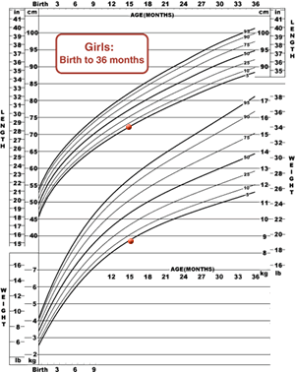 | 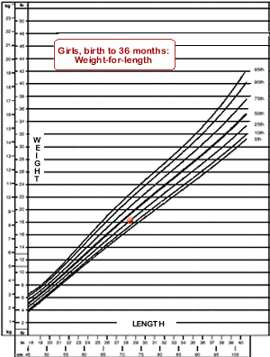
Figure 1a. Weight-for-age and Length-for age, birth to 36 months. Both weight-for-age and length-for-age are at the 5th percentile. | Figure 1b. Weight-for-length, birth to 36 months. Weight-for-length is at the 25th percentile.

Example 1, Part 2.
This is a look at the longitudinal growth of the child in Example 1, Part 1.

This child’s parents are both small, and it is likely that she is genetically predisposed to being short. After an evaluation was done, concern about this girl’s growth pattern was lessened. There are other factors that can affect growth potential, including being born small for gestational age.

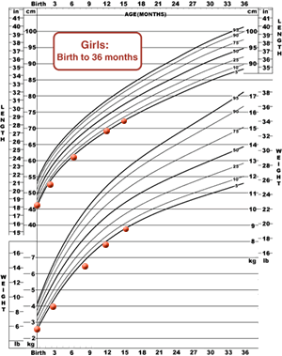 | 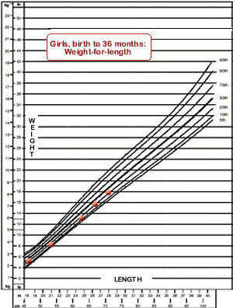
Figure 1c. Weight-for-age and Length-for age, birth to 36 months. Weight-for-age and length-for-age have consistently been at the 5th percentile. | Figure 1d. Weight-for-length, birth to 36 months. Weight-for-length has consistently been at the 25th percentile.

Example 2.
This child, whose weight-for-age, length-for-age, and weight-for-length are also below the 5th percentile at age 15 months, does present concerns. Her weight-for-age, length-for-age, and weight-for-length have decreased over time.

Now one should be more concerned because the child is more likely to have a nutritional or medical problem. The child is growing poorly. In this case, all 3 growth measures—length-for-age, weight-for-age, and weight-for-length--dropped together. That is not always the case.

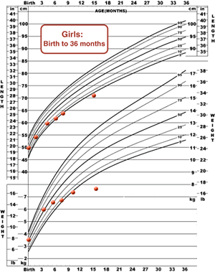 | 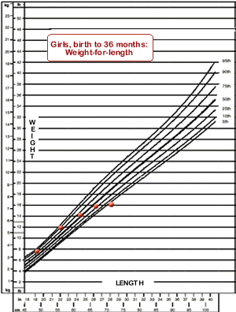
Figure 2a. Weight-for-age and Length-for age, birth to 36 months. Weight-for-age and length-for-age have decreased to below the 5th percentile. | Figure 2b. Weight-for-length, birth to 36 months. Weight-for-length has decreased to below the 5th percentile.

Example 3.
In this instance, the child maintained his growth in length, but gained weight slowly. He became thin, with his weight-for-length below the 5th percentile. His gain in weight-for-age faltered somewhat, but did not go below the 5th percentile.

This child's slow growth might be missed if one plotted only weight and length. This example underscores the importance of using weight-for-length.

It is important to use the back of the growth chart, which shows weight-for-length. Here chubby babies are high on the graph and lean ones are low. This graph helps to detect children who are underweight for their height, especially those who are tall but thin.

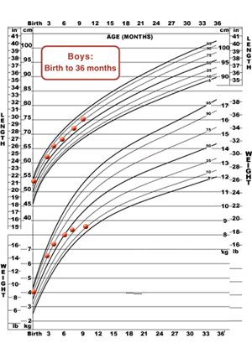 | 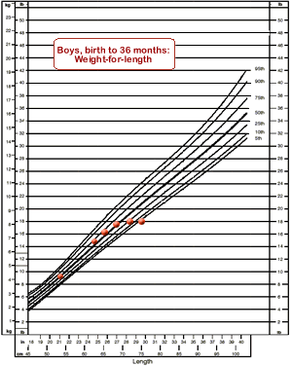
Figure 3a. Weight-for-age and Length-for age, birth to 36 months. At age 9 months, this child's length-for-age remains at about the 75th percentile, but weight-for-age has decreased to the 10th percentile. | Figure 3b. Weight-for-length, birth to 36 months. Weight-for-length has decreased to below the 5th percentile.

Self-test questions

1. Several criteria can be used to identify children who may be growing poorly. Which of these criteria have been recommended?

- weight below more than two standard deviations below the mean
- length below the 5th percentile
- weight above the 20th percentile
- weight-for-length below the 10th percentile
- growth faltering
- a, b, d, e

The correct response is f. a, b, d, and e.

2. The use of the back of the growth chart is recommended at all well-child visits. Which of these statements is reason for doing so?

- with young children, it allows you to look at weight-for-length, so that you can pick out a child who is getting thin
- with children over two or three, it allows you to use the body mass index, which varies with age
- it allows you to track head growth (for a child under 3 years of age)
- all of the above

The correct response is d. all of the above.

3. Describing growth in quantitative terms

In order to tell whether an individual child is overweight or underweight, the simplest method is to plot his or her growth measurements on a growth chart and interpret the percentiles from the chart.

If you'd like to calculate percentiles exactly, you can use computer programs. One is Epi Info 2000, a program that allows you to enter and analyze data. The anthropometric component of Epi Info 2000, Nut-Stat, can be used to calculate percentiles exactly. The program can be downloaded at no cost from www.cdc.gov/epiinfo.

For Statistical Analysis System (SAS) users, CDC has written a code that calculates percentiles (www.cdc.gov/growthcharts). Instructions for using the CDC growth chart data to calculate z-scores, as well as the data files, can be found on-line.

When a child's growth is far from the norm, percentile changes carry less meaning. In these situations, it is convenient to use the special charts that show the 3rd and 97th percentiles. Another approach is to quantify “less than the 5th percentile.” It's hard to interpret, for example, the fact that a child's growth may have gone from the 1.5 percentile to the 2.0 percentile. Then it may be best to describe growth in terms of standard deviations or Z scores. For example, a very underweight child might be described as being at 2.5 standard deviations below the mean (z=-2.5). For more information about standard deviation scores, see chapter 2 in Kessler and Dawson, 1999.

The use of percentiles and standard deviations for cutoff values

Percentiles refer to the position of a child among a group of normal children ranked by size. For example, if 100 children of a given age and sex are lined up by height (stature), the one at the 10th percentile is among the smaller children, tenth from the bottom. Clinicians usually use percentiles because their meaning is straightforward. Many cutoff values are based on percentiles.

Some cutoff values are based on standard deviation. Standard deviation is a number that tells how far the data are from the average (mean). If the standard deviation of a distribution curve is large, then the data, in general, are far from the average; if the standard deviation is small, then the data are close to the average.

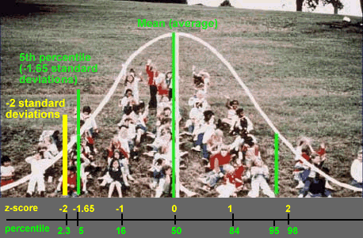

This graph shows a normal distribution of data. The mean (average) is in the middle.
The graph shows that the 5th percentile and 2 standard deviations below the mean are close but not the same. The 5th percentile corresponds to 1.65 standard deviations below the mean; the 2.3 percentile corresponds to 2 standard deviations below the mean.

For more information about standard-deviation scores (Z-scores), see the module, Describing the Growth of Groups of Children. (This module is under development. The link will be posted when the module is available.)

4. Evaluation of reasons for poor growth

Children who appear to be growing poorly may be quite normal, or they may have medical or nutritional problems. There are many possibilities.

- Normal reasons for apparently poor growth include family patterns of growth. Children may be short because their parents are short, or thin because their parents are thin; they may be short during childhood and grow in late adolescence, if that is their family pattern. However, one should not make such conclusions without evaluating the child, nor should one make such conclusions if the parents' growth might have been impaired, as by undernutrition in a developing country.

- Nutritional causes can include low-nutrient food choices (for example, too much juice pushing out other more nutrient-dense foods) and difficulties in feeding (for example, children with physical problems who cannot tolerate certain textures or toddlers who don't want to be fed).

- Medical causes can include frequent ordinary illnesses, such as diarrhea and ear infections, and unusual conditions, such as cystic fibrosis and genetic disorders. Low-birth-weight infants often grow slowly (see the module, Using the CDC Growth Charts with Children with Special Health Care Needs).

Children whose growth appears poor on charts may require services from clinicians or professionals in more than one field: nutrition, medicine, child development, and others. Results of an evaluation may range from normal to the discovery of serious problems.

Evaluation is especially important if the child is young (for example, in the first few months of life, rather than age 2 years), if the growth deviation is severe, or if there are symptoms of illness, clues to problems in feeding or family relationships, or unusual feeding practices. Evaluation is accomplished most effectively by a multidisciplinary team, but referrals to registered dietitians, feeding specialists, medical providers, and mental health professionals can also accomplish the work.

5. References

Guo S, Roche AF, Fomon SJ, et al. Reference data on gains in weight and length during the first two years of life. Journal of Pediatrics. 1991; 119:355-362.

Institute of Medicine. WIC Nutrition Risk Criteria: A Scientific Assessment. Washington, DC: National Academy Press, 1996.

U.S. Department of Agriculture, Food and Nutrition Service. WIC Policy Memorandum, 98-9, Nutrition Risk Criteria. Available from state WIC agencies.

Kessler, DP, Dawson, P. Failure to Thrive and Pediatric Undernutrition: A Transdisciplinary Approach. Baltimore: Paul H. Brookes Publishing Company. 1999. Available at www.brookespublishing.com.

Mei Z, Grummer-Strawn LM, Pietrobelli A, Goulding A, Goran MI, Dietz WH. Three screening indices for body composition: which is the best indicator of overweight and underweight in children and adolescents? American Journal of Clinical Nutrition. Forthcoming.

Needlman, R.D. Assessment of growth. In Behrman, R.E., Kleigman, R.M., and Jenson, H.B. (eds.), Nelson Textbook of Pediatrics. 2000. Philadelphia: W.B. Saunders.

World Health Organization. Physical status: The use and interpretation of anthropometry. WHO Technical Report Series 854. Geneva. 1995.
Glossary

Body mass index (BMI): weight (in kilograms) divided by the square of stature (in meters)

Length: the measure from crown of the head [the superior point] to the bottom of the feet with the subject lying horizontally in a supine position. Length is always measured recumbent.

Normal curve: a bell-shaped, symmetrical curve showing the observed frequencies of a variable

Percentile: a position in the distribution of a variable. For example, the 20th percentile is the position where 20% of occurrences of the variable are smaller and 80% are larger.

Standard deviation: a measure the amount of variation among the values of a variable in a population

Stature: the maximum height of an individual. The CDC Growth Charts use the term stature. Stature or height is defined as the measure from crown of the head [the superior point] to bottom of feet. It is always measured standing.

[END OF MODULE]

