Whole Mount X-gal Histochemistry of Transgenic Animal

Procedure
- Remove tissue or fetus and fix in fresh 4% paraformaldehye/PBS (pH 7.0-7.5) for 1 hour at 4ºC.
- Rinse three times, for thirty minutes each, with rinse buffer (recipe given below) at room temperature.
- Stain between 4 and 48 hours, typically overnight. About 90% of potential staining will occur in the first 24 hours.
- Post-fix overnight in 10% formalin (10% formalin is fine because freshness isn't critical) at 4ºC.

Recipes
- PBS:
  - 100 mM sodium phosphate (pH 7.0-7.5)
  - 150 mM NaCl
- Rinse buffer
  - 100 mM sodium phosphate (pH 7.0-7.5)
  - 2 mM MgCl2
  - 0.01% sodium deoxycholate
  - 0.02% NP-40
  - Stable at room temperature for at least a year
- Staining solution
  - Rinse buffer plus:
  - 5 mM potassium ferricyanide, from 0.5 M stock stored at room temperature in the dark
  - 5 mM potassium ferrocyanide, from 0.5 M stock stored at room temperature in the dark
  - 1 mg/ml X-gal, from 25 mg/ml stock in dimethylformamide (DMF), stored at -20ºC
  - I always prepare it fresh from stock solutions.
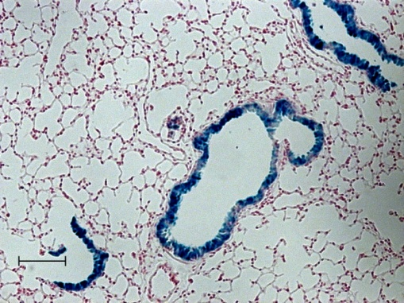
Adapted from : http://wmc.rodentia.com/

