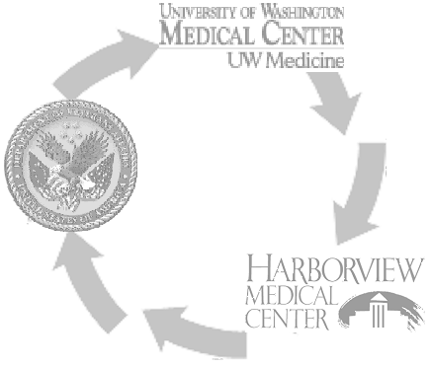

Conservation & Effective Linen Control Measures
- Scrub suits are only to be worn in surgical areas of the hospital and are to remain on the hospital premises.
- Storage of clean linen in the patient rooms is highly discouraged because when the patient leaves, these items are regarded as soiled linen and must be processed again by the Laundry.
- Torn, stained or unacceptable linens should be placed in the "soiled linen" bags and returned to the Laundry for disposition.
- Patient items, equipment, trash or any other foreign objects are to be removed from the soiled linen prior to bagging.
- This will minimize the amount of needle stick occurrences at the Laundry, and will also ensure adequate disposal of hazardous waste.
- Pillows should be used to position patients, instead of blankets.
- Borrowing linen from another unit is discouraged in order to maintain par stock on each unit.
- Sleeves of patient gowns should not be cut in order to change an IV.
- Bath towels, washcloths, or any other piece of patient linen should not be used to clean up spills; rags are available for this use!
- Bath towels should not be used as floor mats outside the tub or shower area.
- Pillowcases used to cover props, should only be changed if visibly soiled.
- Linen items such as towels, blankets, etc., should not be used as props.
- Flat sheets should be placed on top of thermal blankets or spreads to provide optimal warmth for the patient.
- Linen should never be offered to the patient when they are being discharged.
- Housekeeping should use rags for clean up; washcloths should not be put on their carts.
- The rags are dyed blue for proper identification.
- Hospital personnel must not throw linen away, regardless of whether it's a rag or a piece of patient linen.
- All soiled linen must be returned to the Laundry.
- If this procedure is followed, the potential for outgoing linen theft, will be minimized.
- If a stain is unable to be removed, the Laundry will "rag out" the item.

