Making Recordings (students) and Collecting Recordings (instructors)

I. Making a recording with Solost (what Students do):

- Double click on Soloist
- At the Soloist login screen, type in Your First Name for User ID.
- Hit the ATTEND button
- Click to record your voice. Begin speaking through the microphone when the small indicator turns red
- Click  when you finish recording

II. Collecting students’ recordings with Virtuoso (what instructors do):
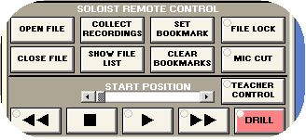
- Click on “Collect Recordings”
- Navigate to your folder:
Collected _ ELP _ Your class folder
- Change the settings and COLLECT
  - Stereo or Monaural
  - wav or mp3
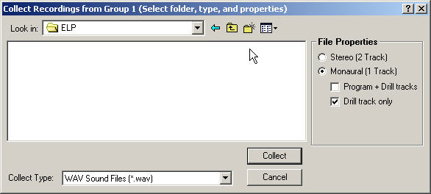

- To look for the recordings, start from “My Network places” on the desktop:
My Network places_ Sony on Goya_ Content _ Record _ collected _ ELP _ your folder

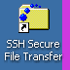
III. Upload recordings to Homer:

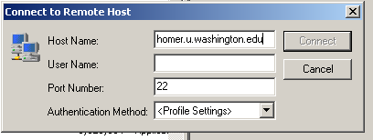
- Open SSH secure File transfer
- Enter your use name and password to access your homer account

- Navigate to your folder from “My Network places” on the left hand column, select the folder, and upload.

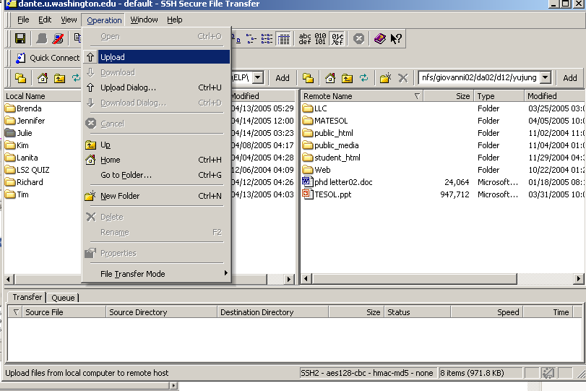

IV. Retrieving your files on another computer (King, Lewis, home, etc.)
Open your Homer SSH window either from the Start menu or a desktop link like this: .
If you get this window, click OK.
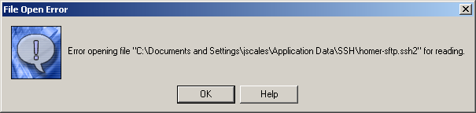
When you get this window, click “Quick Connect.” Click “OK” again if you get an error message.
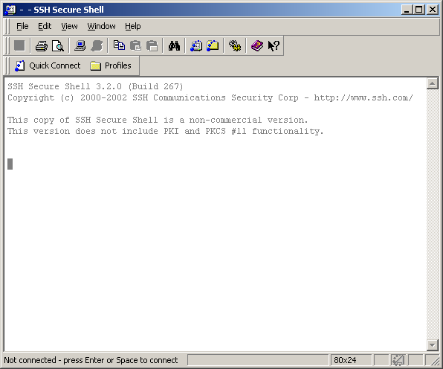
In the next window, fill in the host name as below, your UW NetID, then click Connect.
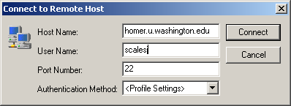

In the next window, fill in your password, and click OK.
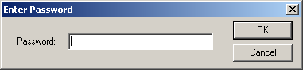
Next, click on the New File Transfer Window.
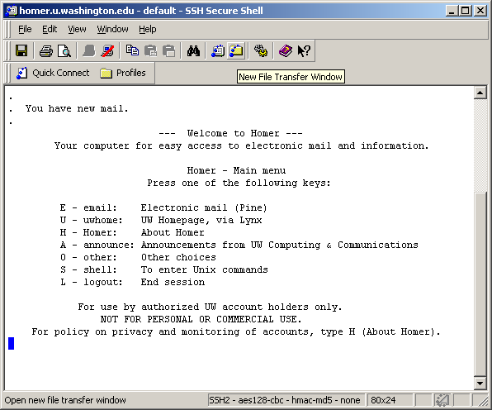

Click on the place where you saved the file in the LLC. Select the files you want to save to your computer. Press Ctrl and click to save several at the same time.

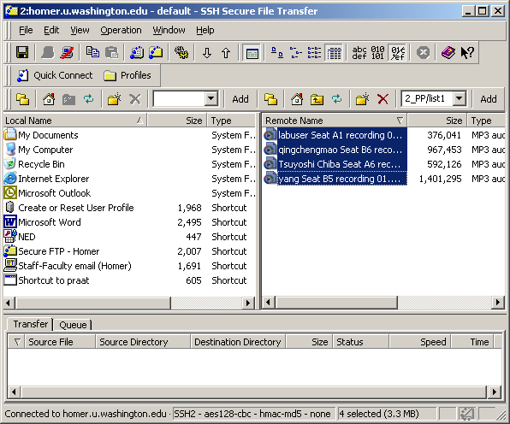

Click and drag them to the location where you want to save the files on that computer.

Open the files with Windows Media Player, Audacity, or other audio software program.

