Using Praat

Praat is a freeware that you can download for “doing Phonetics by computer,” as the authors put it. For more information, go to: http://www.fon.hum.uva.nl/praat/

We’ll use it for you to have visual feedback on pitch and rhythm.

This handout will show you how to:
- open Praat
- record your own voice
- download a file from a website
- compare rhythm and pitch on two recordings
- edit and save a file


1. Double click on the Praat icon.

2. Close the “Praat picture” window.
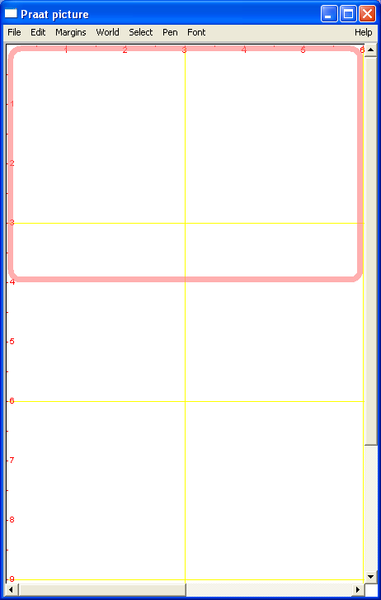
We won’t be using it.
Click here to close

3. To record your own voice

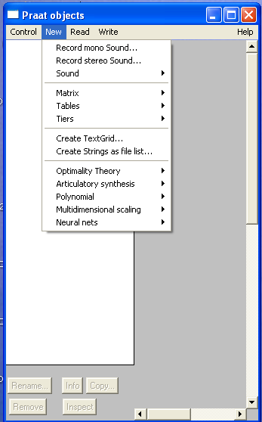From the “Praat objects” window, select New
Select Record mono Sound…

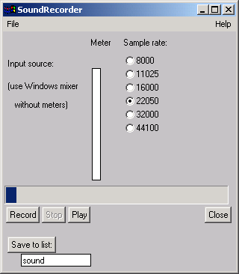
You’ll see a window like this:

Press record and say one of the phrases below

My name is Julie Scales and today I’d like
to tell you about using Praat.

(Substitute your information for underlined
words.)

When finished, type your name where it says
sound .

Click on Save to list.

Your file will appear in the Praat objects window.

4. To see your pitch
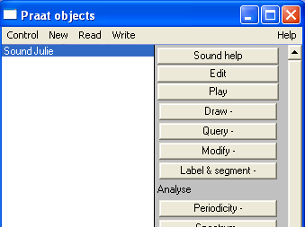
Go back to the “Praat objects” window.
It should look like the screen to the right.

Click on the Edit button to see pitch.

It should look similar to the screen below.

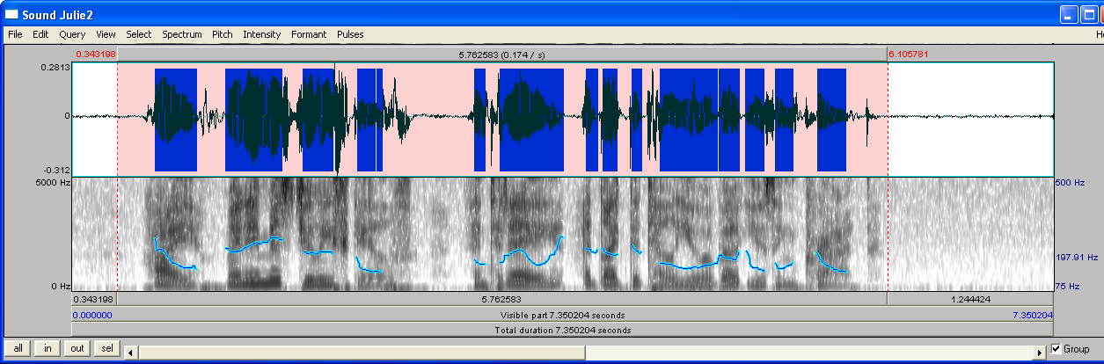

Some useful commands:

Select part of recording | Use mouse to highlight. A pink shaded area will appear.
Play | Press Tab  Hint: Highlight a certain part to be able to listen to it repeatedly.
Stop | Press Tab
Zoom in | View/Zoom In OR Control I
Enlarge a specific Part | Highlight the part you want to see  Click View/Zoom to selection OR Control N

Solving some common problems:

Problem | Solution
Red dots all over screen | Click Formant, then Show formants
Can’t see blue pitch line | Go to Pitch, then Show Pitch
 | OR if selection is very long View, then Zoom in…
Want to hear one part repeatedly | Click and drag mouse over the part you want to hear  The selection will be highlighted in pink  The click Tab to play
Want to save | From Sound window  Select Write selection to WAV file  Save it to your preferred location

