

Department of Radiology

Diagnostic Imaging Sciences Center

**SOP for COVID prevention strategies**

**Interim Director: Swati Rane Levendovszky**

Date: 2/11/2022

Version 1.4

# PURPOSE

The purpose of this SOP is to provide operational guidelines for Staff, Project Coordinators, and Human Subjects safety at the Diagnostic Imaging Sciences Center (DISC) in the face of COVID-19. DISC operations must adhere to the guidelines by the Governor of WA, UW Human Subjects Division, and the UW Environment Health and Safety. The safety procedures outlined in this document follow the recommended guidelines by the School of Medicine, Environmental Health and Safety, and the Human Subjects Divisions at the University of Washington. The DISC team will ensure that all policies are strictly adhered to.

# Critical Personnel: Tim Wilbur, Cole Anderson, Tina Guan,

**Location:** AA-wing

# PROCEDURES

UW approved social distancing, and handwashing instructions are displayed throughout the facility. All individuals entering the facility should strictly adhere to these instructions.

This SOP describes procedures for 1) **MR operators and on-site staff**, and 2) **Research Coordinators** who will be escorting subjects to DISC for scanning. DISC operators and Project Coordinators are required to read all sections of this SOP. Deviations from this SOP are not permitted unless deviations are clearly identified, justified, and approved by DISC personnel and the COVID Supervisor.

**2.1 Scheduling and screening for COVID.**

* Project coordinators should contact research subjects 3 days before the scheduled scan and complete COVID-19 assessment (See **Appendix A**) by phone or email as deemed necessary by the study. This process should be repeated on the day of the scan prior to entering the DISC Lab by phone or email.
* If the scheduling call occurs more than 3 days before the scan date, the COVID assessment should be repeated 3 days prior and on the day of the scan**.
* Coordinators will request all participants to arrive in masks. If they do not have masks upon arrival, the coordinators should provide all participants with a procedure mask (metal piece removed, not cloth coverings) prior to entering the DISC Lab. They should ensure that participants come directly to the imaging facility with minimal wait or loitering on UWMC premises.

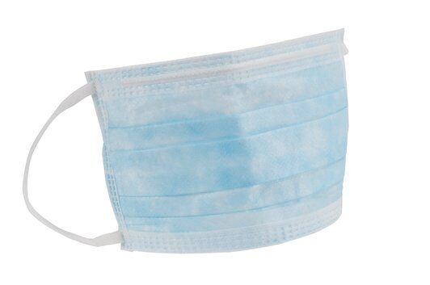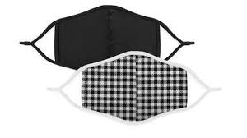

* Coordinators should ensure the least number of visitors for each study visit and discuss this prior to study visit.
* All DISC personnel will complete the daily COVID attestation provided by the University prior to arriving at work and interacting with participants or coworkers in Workday.
* If the participants travel for their study visit, please contact DISC for scheduling. The visit will have to be scheduled for a Friday afternoon to allow sufficient time for disinfection of the MRI suite.

**2.2 Scan procedures at DISC**

* If the study requires more than one coordinator and more than one visitor to accompany the participant, the DISC Lab must be contacted prior to scheduling to determine how their study protocols can be modified to minimize COVID-19 risk.
* The subject, as well as any visitor, may be asked about COVID symptoms again at DISC and will have access to a touchless temperature monitor. Participants and visitors can voluntarily check their temperature in the DISC Lobby.
* Anyone entering the building is required to wear a face covering as per UWMC guidelines. If individuals show up without a mask, they will be provided one.
* All areas and routes, where the participant, visitor, and coordinator, are permitted, will be marked with blue arrows on the floor. Participants, visitors, and coordinators will not venture into other areas marked with yellow arrows reserved for DISC and other sister labs without prior clearance. Examples are below.

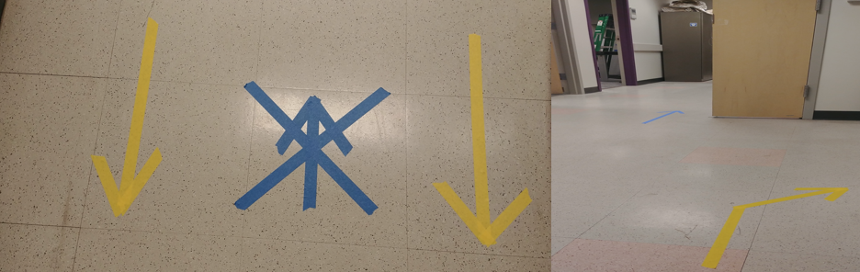

* The participant, visitor information, and coordinator information per scan will be noted and retained at DISC for contact tracing requirements. See **Section 3**

**2.3 Enforcement**

* DISC *always* reserves the right to contact HSD to determine the eligibility of study.
* DISC *always* reserves the right to refuse service if guidelines are not followed to ensure the safety of staff and all visitors and participants.

**2.4 Social distancing and contact minimization**

The picture below shows the PPE worn by the MRI technologist who will image the research participant.

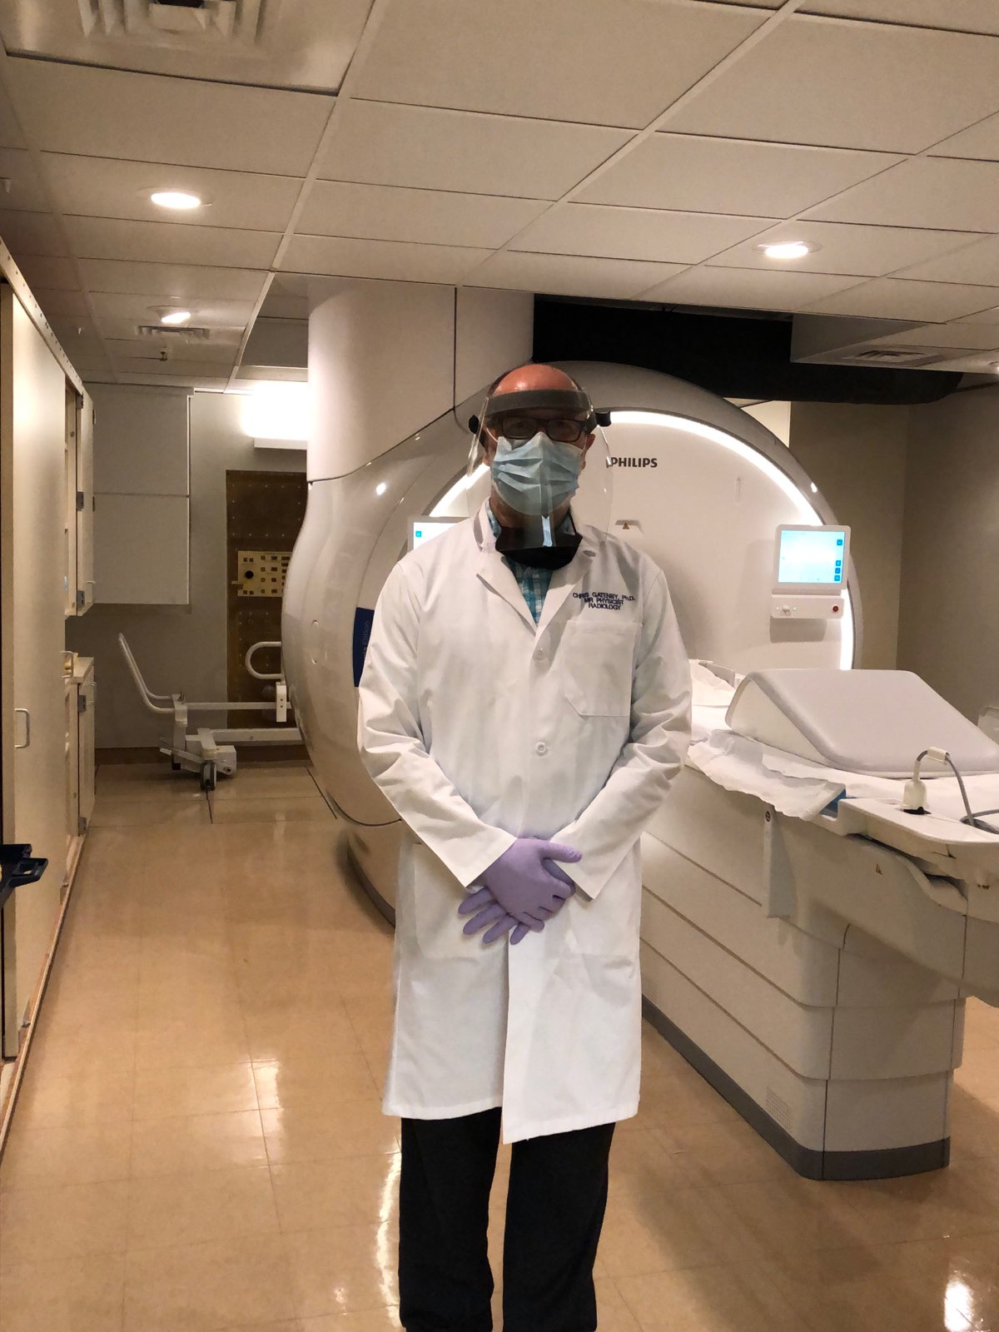

* As much as is feasible, the MR technologist must maintain a six-foot distance from any other persons occupying DISC space. Only while attaching devices such as imaging coils, and monitoring devices, the MR technologist may briefly come within 6 ft of the participant. A brief physical contact may be involved.

Our estimate for physical contact (if at all) is at most 2 minutes long with the technologist and research participant being within 6 ft. distance is at most, an additional 3 minutes. The research participant lies alone in the scanner room for 45-75 minutes. The MRI technologist is in another room i.e., control room during this time.

* The technologist will wear a procedure mask (not a cloth mask), disposable gloves, and face shield, as well as a cloth lab coat to prevent skin-to-skin and biofluid contact with the participant. Gloves will be discarded, and face shields will be disinfected after each scan. Hand hygiene will be performed after discarding gloves. Face shields, procedural masks, and lab coats will be changed only if there is fluid/skin contact. Lab coats will be periodically washed by the UW approved laundry service.
* The coordinator and participant will be required to wash hands thoroughly before entering the MRI scan area using soap and water. Hand sanitizer will also be available in the subject preparation room and the control room.
* The participant must wear a procedure mask (not a cloth mask) for the entire visit.
* The participant may be asked to wear gloves before entering the scanning room. If the participant is not compliant, the technologists will reserve the right to cancel the scan for safety reasons.
* The technologists will *always* reserve the right to cancel any scan to ensure the safety of themselves and others within the lab.

**2.4 Cleaning Procedures/Times**

* To allow for cleaning and disinfection, there will be a minimum of 15 minutes allotted between scans. This time will be strictly used for cleaning and disinfecting the scanner. Imaging protocols will not be allowed to run over into the cleaning time. Scanner time will be blocked on the online calendar system to ensure proper cleanup.
* All contact surfaces will be cleaned in a clockwise, linear, top to bottom pattern of cleaning all visible surfaces using **EPA approved wipes**. The MR scan room (magnet bore, patient table, leg rest, receiver coils, any monitoring devices if used) and all contact surfaces (seating, table, computer if used, door handles, lights witches) in the participant preparation rooms will be disinfected using **EPA approved wipes** and a handheld extendible mop to ensure that technologist’s lab coat does not touch any of the surfaces. If deemed necessary, disposable lab coats will be available.
* To minimize contamination and simplify disinfection, subjects will be provided with a plastic bag to keep their belongings. Locker and other storage areas in the preparation rooms will be inaccessible.
* Cloths, pillowcases, and other linens or materials used by participants will be replaced immediately.
* Masks and gloves that are discarded will go into the biohazard waste.
* In the event of a breach of protocols or post-scan identification of a COVID positive participant, scanning will be closed with immediate effect for 72 hours. All parties who were potentially exposed will be contacted.
* The control room (only used by the MRI technologist) will be disinfected (tables, computer) every 3 hours with **EPA approved wipes**.

**Wipes used at DISC approved by the EPA (List N for** Products with Emerging Viral Pathogens and Human Coronavirus claims for use against SARS-CoV-2**) on March 2020. CDC recommends use of disinfectants from this list.**

**3 Visitation Log for Contact Tracing\*\***

* All individuals entering the DISC facility will be asked to fill out a visitation log. A sample page is shown in Appendix B. A new form will be filled for each participant and kept confidential under lock and key at DISC for 4 weeks. After that all log information will be destroyed (shredded).
* If a positive COVID-19 case is identified amongst DISC personnel, the study coordinator and study PI will be informed immediately. They must follow-up with the participant.

**4 References**

* Mossa-Basha M, Medverd J, Linnau K, Lynch JB, Wener MH, Kicska G, Staiger T, Sahani D. Policies and guidelines for COVID-19 preparedness: experiences from the University of Washington. Radiology. 2020 Apr 8:201326.
* <https://www.acr.org/Clinical-Resources/Radiology-Safety/MR-Safety/COVID-19-and-MR-Use>
* Kooraki S, Hosseiny M, Myers L, Raman SS, Gholamrezanezhad A. COVID-19 Precautions: What the MRI Suite Should Know. Journal of the American College of Radiology. 2020 May 21.
* University of Washington: <https://www.ehs.washington.edu/covid-19-health-and-safety-resources>
* University of Washington: https://www.washington.edu/research/hsd/covid-19/

Swati Rane Levendovszky

Interim Director, DISC

[srleven@uw.edu](mailto:srleven@uw.edu), 206 543 6159

June 10, 2020

# APPENDIX A. Symptom Screening Questions for Subjects (electronic or paper-based)

* Have you experienced any of the following symptoms:
* A new fever (100.4 F or higher) or a sense of having a fever?
* A new cough that you cannot attribute to another health condition?
* New shortness of breath that you cannot attribute to another health condition?
* A new sore throat that you cannot attribute to another health condition?
* New muscle aches that you cannot attribute to another health condition or that may have been caused by a specific activity, such as physical exercise?
* New respiratory symptoms, such as sore throat, runny nose/nasal congestion or sneezing, that you cannot attribute to another health condition?
* New chills or repeated shaking with chills that you cannot attribute to another health condition?
* New loss of taste or smell that you cannot attribute to another health condition?

**If the answer to any of the above questions is ‘Yes’, subjects must be rescheduled.**

**On the day of the scan, the participant, coordinator, and the visitor companion should sign a COVID assessment form confirming that they do not have the above symptoms as follows:**

I attest that prior to coming to DISC on today's date that I do not have any of the above symptoms. Please check the boxes below

 I read the above statement.

 I attest that I do not have any of the above symptoms.

Please initial here: _________

# APPENDIX B. Visitation Logs (Confidential and maintained under lock and key at DISC, 1 sheet per scan (For example, it will include, study participant, coordinator). A new sheet will be provided for every scan). Logs will be shredded every 4 weeks.

|  |  |  |  |  |  |
| --- | --- | --- | --- | --- | --- |
| **No.** | **Name** | **Phone** | **Email** | **Arrival time** | **Departure time** |
| 1 | John Doe (participant) | 999-999-9999 | johndoe@mail.com | 10:15 AM | 11:30 AM |
| 2 | Jane Doe (coordinator) | 999-999-1111 | janedoe@mail.com | 10:00 AM | 3:10 PM |