November 17, 2017

5:30-7:30

HUB Game Room

The School of Social Work Student Advisory Council invites you to an evening of fun with your fellow social work students.

Door prizes, bowling, board games, pool, ping pong, food, drinks and more! All Social Work cohorts and their guests are welcome.

The Organization of Student Social Workers (OSSW) will be selling t-shirts, mugs, pens and candy at the event. Payment is accepted via: Cash, Venmo, and Squarereader (MasterCard/Visa).

Alcohol for those 21+ served only in party room out of respect for those in recovery.

School of Social Work

**SAC Winter Social**

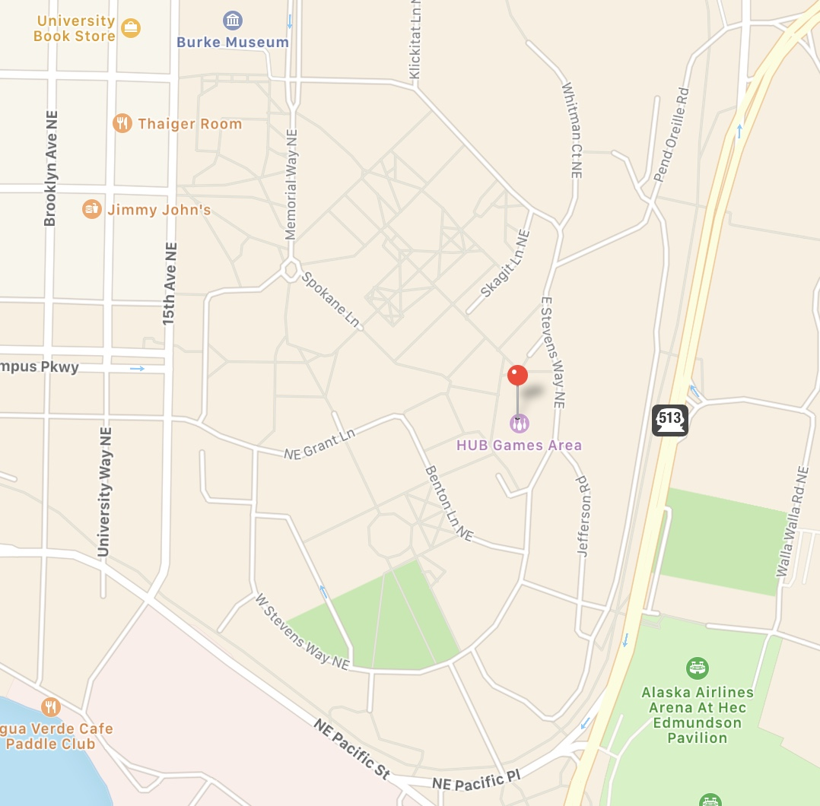

SSW

Please [RSVP](https://l.facebook.com/l.php?u=https://catalyst.uw.edu/webq/survey/nberry/343183&h=ATOHaXmtZtPRCgqI_Lo4ZXRrR4Wr2M46EloJGvcC8m7hNUVEIZFRtnrZSK5x_jutbi_TiKnin3HGdbK0tK4QFHfUC5Fa_zTaH6IVKwqtoHiTz8a8ZOp_Y3XVhrQk5h8CGzm7sZ5FyNT2vmt1ufz43Ykr-MNHKAjat3GPRjn1dXR9Pg) via Catalyst so we have enough food for you and your guests. Thanks!