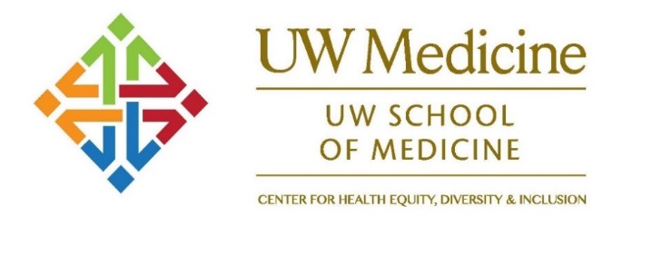
CONJ 570 A: Clinical Management of Trans* Patients
Winter Quarter 2018
Tuesdays, 5:30 to 6:50 pm – T747 HSB
January 9th through March 6th
SLN: 12790 A
Course Chair: Roberta Dalley, MD, Associate Professor, Neuroradiology
1 Credit
Please note: This course is a requirement for the LGBTQ Health Pathway certificate

This course will provide an overview of the clinical management of Trans patients, detailed information about the steps necessary for providers to help their patients transition (both surgically and non-surgically), potential health challenges that patients may face in their lives and will give providers information necessary to build transgender cultural competency. UWSOM students or other Health Sciences Graduate Studies Only. No Add Code required.
For more information:
NormaAlicia Pino, M.A.
Center for Health Equity, Diversity and Inclusion
pinon@uw.edu

JOIN US TO DISCOVER TRANS HEALTHAND BECOME A BETTER PROVIDER FOR ALL YOUR PATIENTS!!!

