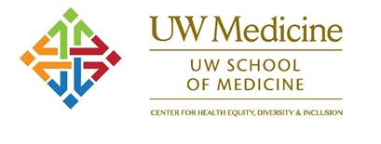

ANNOUNCING WINTER QUARTER NON-CLINICAL SELECTIVE****

**UCONJ 530 INDIAN HEALTH ISSUES: Past, Present and Future**

***Thursday evenings from 6:00pm to 7:20pm PT***

***January 4th – March 8th, 2018***

***Room E308 HSB***

***SLN:*** [**21641**](https://sdb.admin.washington.edu/timeschd/uwnetid/sln.asp?QTRYR=WIN+2018&SLN=21641) **A**

***2 credits***

Pre-Requisites:

* Medical student or graduate standing in Social Work or the Health Sciences
* Ability to complete 4 hours of community service (Options will be organized through the course manager)

*Students will have an opportunity to learn about the most pressing health issues facing American Indian and Alaska Natives and explore strategies to remedy problems in public health and health care delivery systems for these communities.*

*While this course targets medical students, the presence of graduate and professional students in the health and allied disciplines enriches the learning environment. It appeals to those with interests in public and global health, and health in underserved populations.*

***For more information email Norma Alicia Pino, MA at*** [***pinon@uw.edu***](mailto:pinon@uw.edu)