Monthly rental, S700 per month, private bedroom & bathroom and shared apartment.
Queen Anne, close to Ballard Bridge and Burke Gilman Trail, 3-4 miles from UW, Bus #32.
Outside entrance, with outside deck and view. Cable available, most pets okay.
Call Mary Kaiser, 206-390-3927 / UW, School of Social Work, mbk2@uw.edu

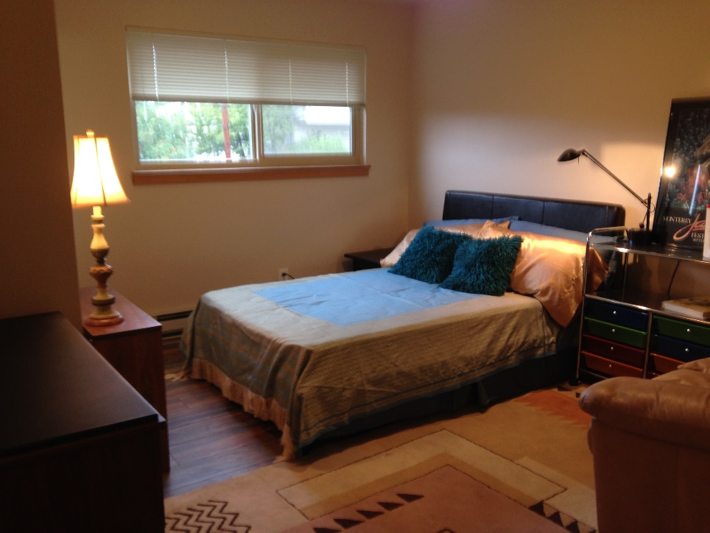
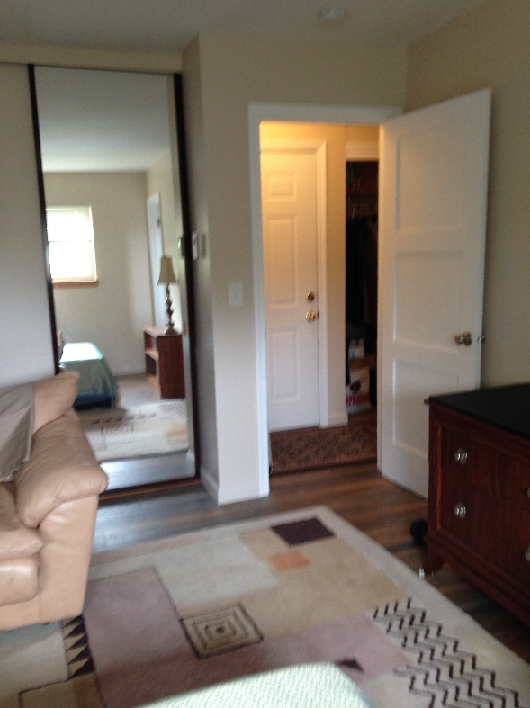

Door to outside entrance and hallway,
Bathroom is off the foot of the bed.
