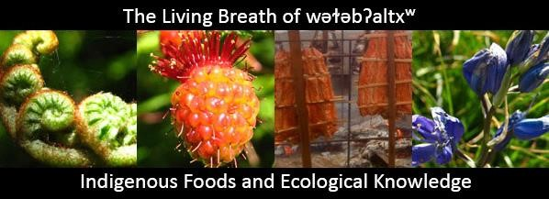

SAVE THE DATE!

May 3 and 4, 2019

“The Living Breath of wǝɫǝbʔaltxʷ”

Indigenous Foods and Ecological Knowledge Symposium

University of Washington, Seattle, Washington

Register at <https://www.brownpapertickets.com/event/4099924>

*“Reclaiming Food as Family Medicine”*

This symposium brings people together to share knowledge on topics such as traditional foods, plants and medicines; environmental and food justice; food sovereignty; health and wellness; and treaty rights. Indigenous peoples in the Northwest have maintained a sustainable way of life through a cultural, spiritual, and reciprocal relationship with their environment. This symposium serves to foster dialogue and build collaborative networks as we, Native peoples, strive to sustain our cultural food practices and preserve our healthy relationships to the land, water, and all living things.

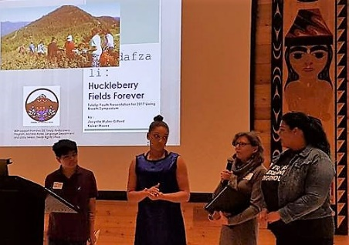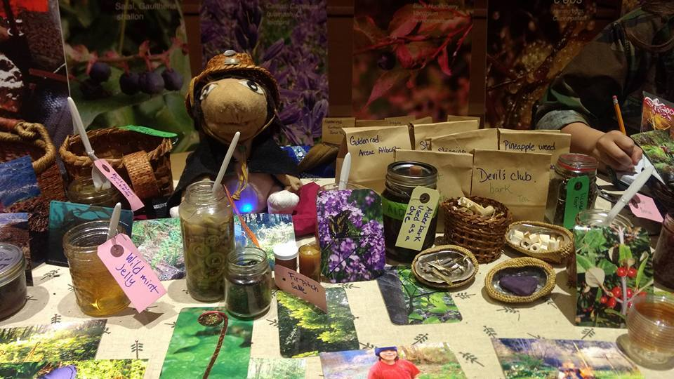 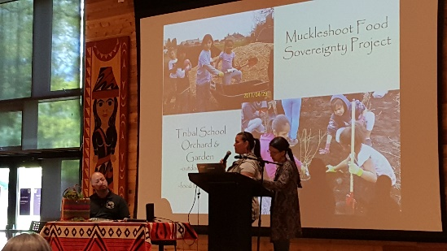

**Information on past events:**

**Visit our website,** [**http://www.livingbreathsymposium.org/**](http://www.livingbreathsymposium.org/)**,**

**Facebook** [**www.facebook.com/UWLivingBreath**](http://www.facebook.com/UWLivingBreath)**, and**

**Twitter** [**@LivingBreathUW**](https://twitter.com/LivingBreathUW) **#livingbreath2018 #indigenousknowledge.**