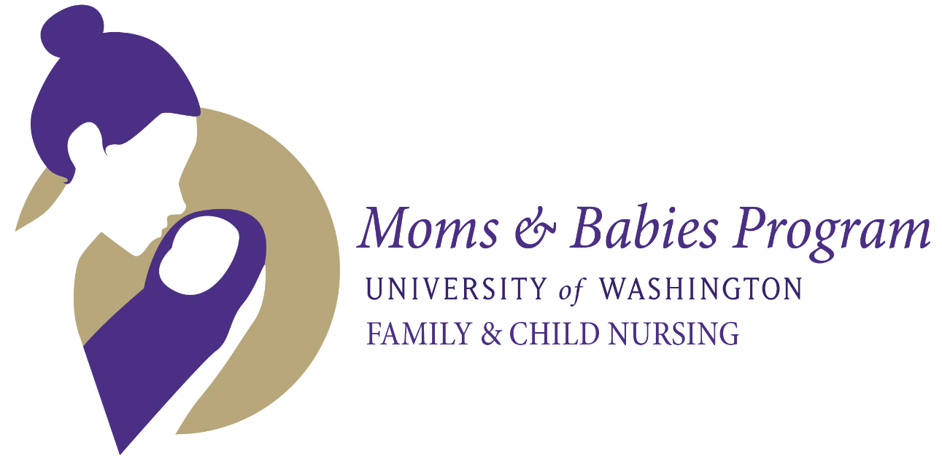

**FOREIGN LANGUAGE TRANSLATORS NEEDED!**

The Moms & Babies research study needs translators for these languages:

* Amharic
* Tonga
* Somali
* Swahili
* Japanese

**Location:** CHDD South Building room 205

**Time commitment:** Approximately 1 hour

**Compensation:** $25 gift card of your choice

**What’s involved:**

Understand and sign our confidentiality agreement

Watch three short (about 5 minute) videos of a mom and baby

Translate the mother’s speech for our coder

**For more information, please contact Mary Jane at mjlohr@uw.edu**