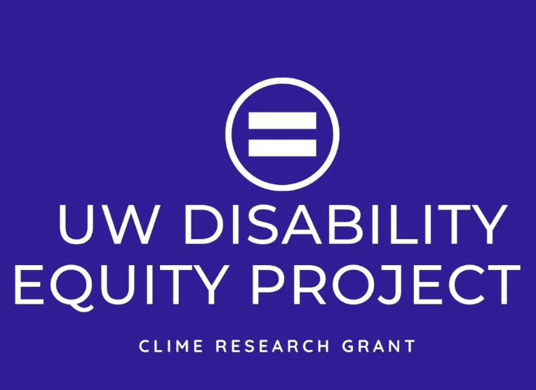

Participate in a Study on

Disability Equity and Inclusion

# A research team from the UW Disability Studies Program, The D Center, and the Department of Rehabilitation Medicine is recruiting UW students, staff, and faculty who have a disability, physical or mental health condition, a chronic illness, or are d/Deaf to contribute to a research project on disability, equity, and inclusion on the UW campus. (IRB # STUDY00009838)

**You may be eligible if you:**

* Are 18 years or older.
* Are a student, staff, or faculty member who attends or works at UW at least part-time.
* Identify as having a disability, physical or mental health condition, chronic illness, or are d/Deaf.

**Participants will:**

* Attend a 60-90-minute virtual focus group or interview.
* Discuss experiences of ableism or discrimination as well as allyship and community in academic and healthcare situations.
* Receive a $30 electronic gift card for participating.

**If you are interested in participating, contact us at** [**uwdisabilityequity@uw.edu**](mailto:uwdisabilityequity@uw.edu) **or visit our website at** [**https://uwdisabilityequity.washington.edu/**](https://uwdisabilityequity.washington.edu/)**.**

All study information will be kept confidential. CART, ASL or other access will be provided. This study is funded by the UW CLIME competitive small grant program.