

Making Connections
Mentor Application
2016-2017

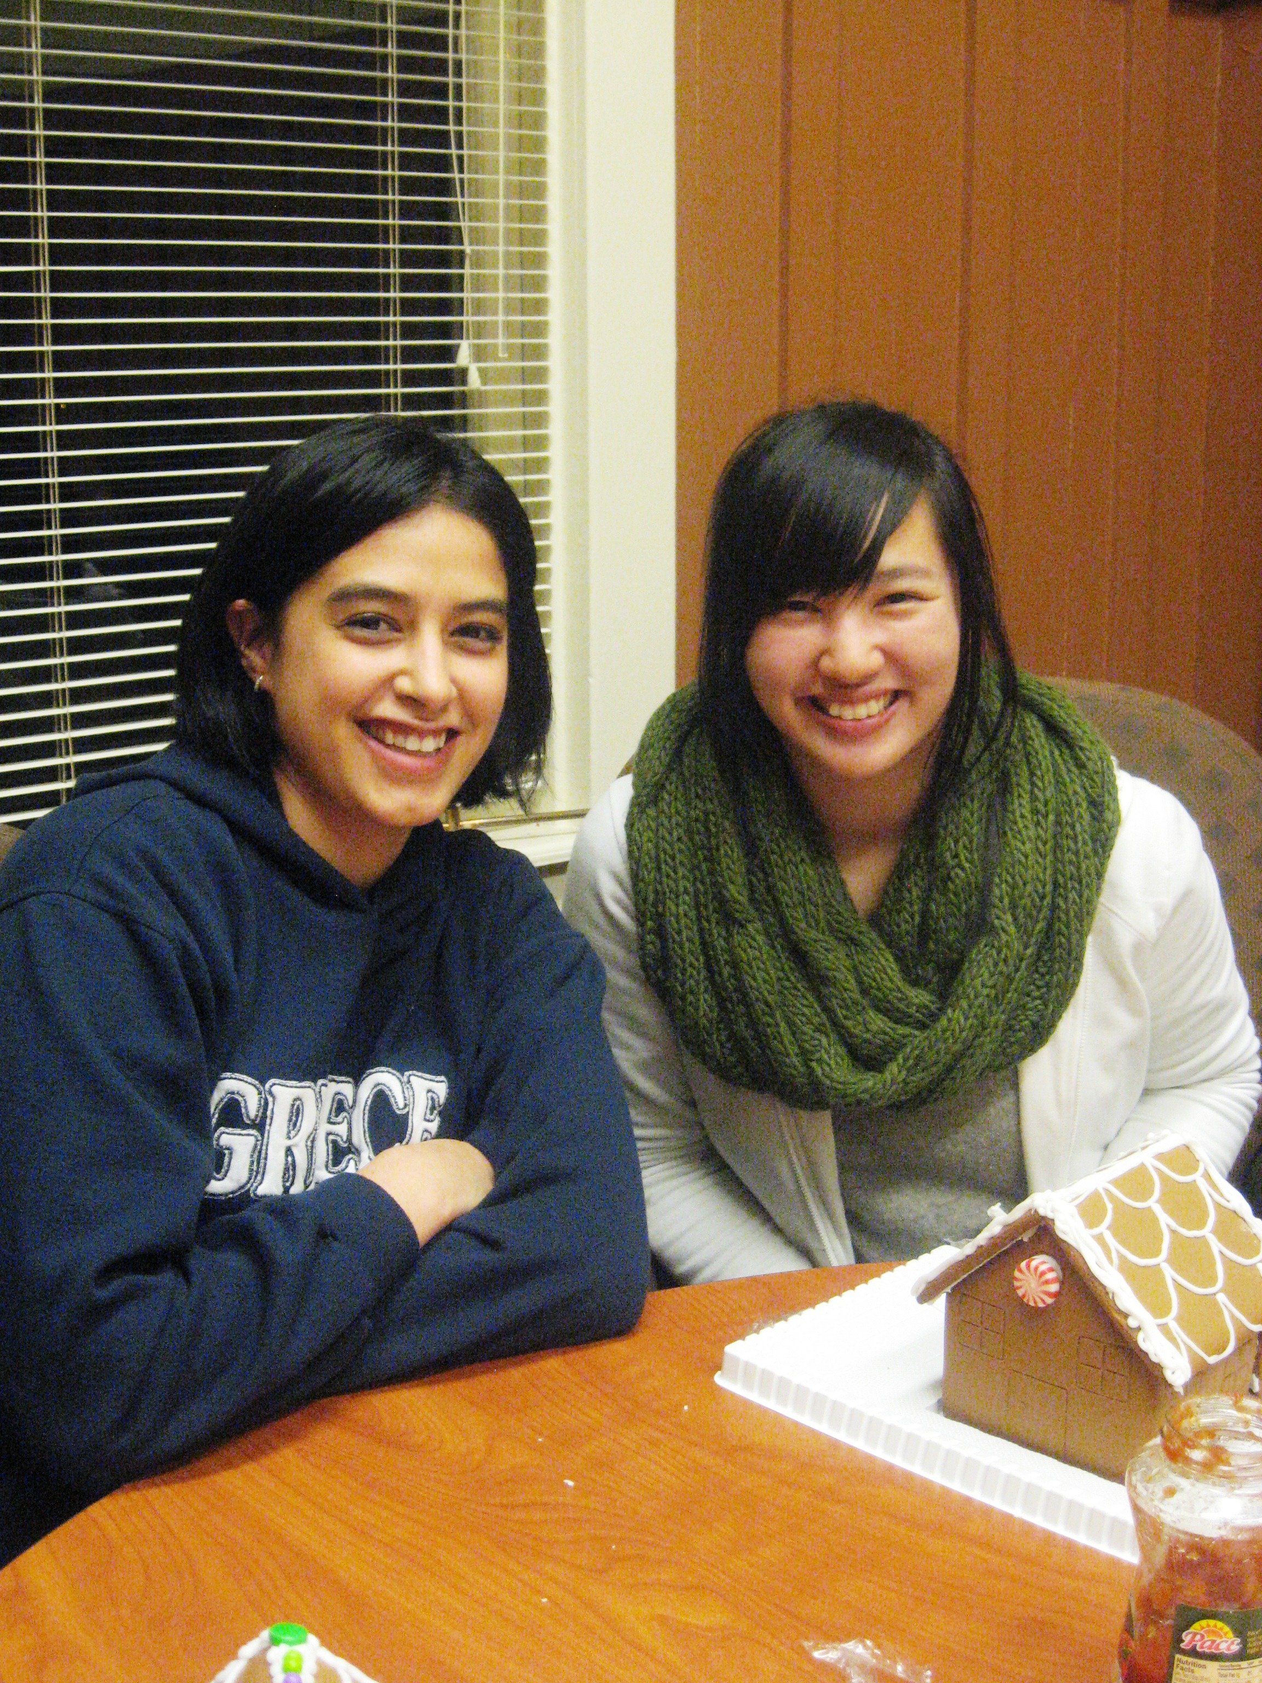
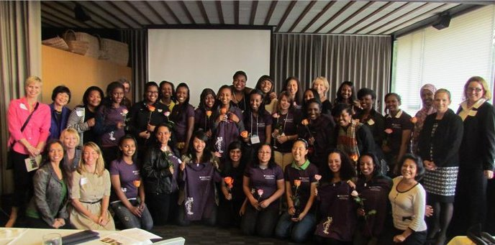
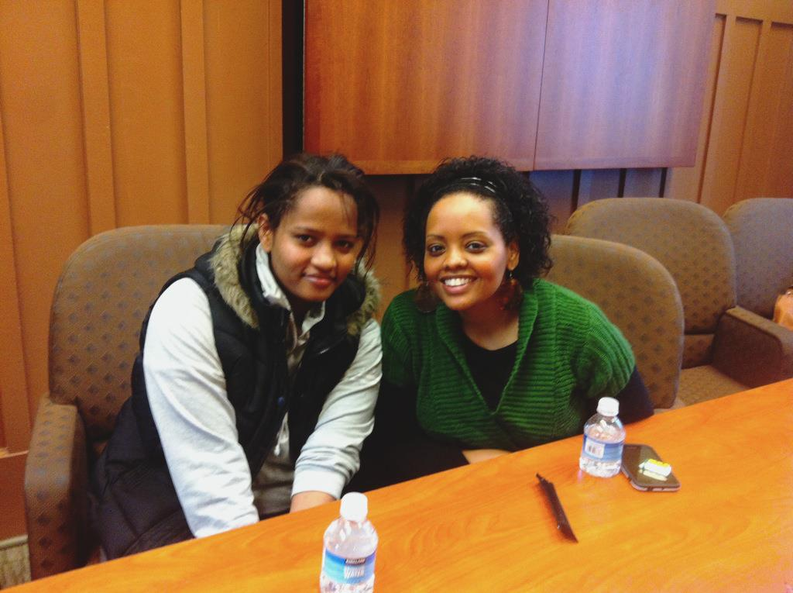
Unlocking Your Potential
MENTOR APPLICATION PACKET
2016-2017

“A lot of people have gone further than they thought they could
because someone else thought they could “-Unknown

WHAT IS MAKING CONNECTIONS?
Making Connections is a college readiness program that serves high school women from socio-economically disadvantaged backgrounds in the Seattle area. The Making Connections program encourages these young women to pursue higher education, assists them with the college application process, and exposes them to careers in the STEM (Science, Technology, Engineering, and Math) and other fields. By participating in Making Connections students realize their capabilities to pursue higher education and a career in the STEM fields. The program supports these young women through individual academic advising, tutoring, and mentoring. Mentors are an important component of Making Connections because they offer guidance, support, and motivation to these young women in achieving their highest aspirations.

Making Connections seeks individuals who will:
- dedicate 4-6 hours a month toward building a relationship with their mentee
- offer support, advice, and guidance to their mentee while they explore higher education, apply for college, and gain knowledge about the STEM fields,
- support and motivate their mentee towards success in achieving their aspirations.
- attend a mandatory mentor orientation and training
- attend mentor-mentee socials with your mentee as well as other Making Connections workshops and activities
- provide monthly updates to program staff

BEGIN MAKING A DIFFERENCE!

PLEASE FILL OUT THE ENCLOSED APPLICATION AND RETURN TO MAKING CONNECTIONS AS SOON AS POSSIBLE.
Mentor Application Form
2016-17

Name: ____________________________________________________________________________
(First) (Middle) (Last)

Local Address: _____________________________________________________________________

City: __________________ Zip: ___________ Phone: ( ) ______ - _________

E-mail:_____________________________________________________________________________

Occupation: ______________________________________________________________________

Education: (Please list completed degrees and/or current program of study.)

____________________________________________________________________________________
Gender: _____________ Ethnicity (optional): ______________________________

Veteran: Yes / No_____

- Please list any interest in or experience you have working with high school students:

1

2. Many of our students come from socio-economically disadvantaged and/or ethnic minority backgrounds. Please list any experience you have working with these populations:

- Currently, do you have any obligations that would hinder your full participation in this program? If so, please explain.

2
4. Please write a short essay, to be read by your future mentee, introducing yourself. Include: why you want to be a mentor for the Making Connections program, your talents, hobbies, and/or interests, and what qualities, skills, and/or resources you feel you could offer a high school student.

5. Throughout the year, students attend hands-on workshops on various topics pertaining to math, science, and technology. Would you be interested in volunteer opportunities during the events?
Yes No (Circle one)

I agree to attend the mentor orientation and training, participate in 4 – 6 hours per month of communication with my mentee(s), attend as many activities as I can with my mentee(s), and support Making Connections events.

Signature: ________________________________________ Date: ________________

Please return the completed form and/or direct questions to:

Meseret Alemu
STEM Enrichment Coordinator
Making Connections, UW Women's Center
wcmcp@uw.edu
Phone: (206) 685-1090 Fax: (206) 685-4490
Box 351380
Seattle, WA 98195-1380

3

