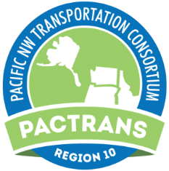

**NO COST EXTENSION**

NO COST EXTENSION will be handled on a case by case basis and can only be requested once. The extension is limited to six months and shall be made by the Project PI no later than 60 days before the project end date by an email to their Institution’s PacTrans Director and a copy to [pactrans@uw.edu](mailto:pactrans@uw.edu) with the following information:

1. Name of Institution Requesting No Cost Extension and Budget Number (if applicable)
2. Original Project Period: (Start and End Date)
3. Requested Project Period for this no cost extension: (Start and New End Date)
4. Project Title:
5. Name of PI:
6. Justification/explanation for the no cost extension

The Institution’s PacTrans Director or representative will notify the PI with a copy to [pactrans@uw.edu](mailto:pactrans@uw.edu) of decision on the request.

Multi institution, Education and Outreach projects will have only one NCE for the entire project and the lead PI will submit the request to PacTrans following this guideline.