REPORT/PROJECT TITLE
REPORT/PROJECT SUBTITLE

FINAL PROJECT REPORT

by

Principal Investigator Name(s)
University Name(s)

Sponsorship
(List PacTrans and matching external sponsors, e.g. WSDOT)
for
Pacific Northwest Transportation Consortium (PacTrans)
USDOT University Transportation Center for Federal Region 10
University of Washington
More Hall 112, Box 352700
Seattle, WA 98195-2700

In cooperation with U.S. Department of Transportation,
Office of the Assistant Secretary for Research and Technology (OST-R)

Disclaimer
The contents of this report reflect the views of the authors, who are responsible for the facts and the accuracy of the information presented herein. This document is disseminated under the sponsorship of the U.S. Department of Transportation’s University Transportation Centers Program, in the interest of information exchange. The Pacific Northwest Transportation Consortium, the U.S. Government and matching sponsor assume no liability for the contents or use thereof.

Technical Report Documentation Page
1. Report No. | 2. Government Accession No. | 3. Recipient’s Catalog No.
4. Title and Subtitle |  | 5. Report Date
 |  | 6. Performing Organization Code
7. Author(s) and Affiliations |  | 8. Performing Organization Report No.
9. Performing Organization Name and Address |  | 10. Work Unit No. (TRAIS)
PacTrans
Pacific Northwest Transportation Consortium
University Transportation Center for Federal Region 10
University of Washington More Hall 112 Seattle, WA 98195-2700
 |  | 11. Contract or Grant No.
12. Sponsoring Organization Name and Address |  | 13. Type of Report and Period Covered
United States Department of Transportation
Research and Innovative Technology Administration
1200 New Jersey Avenue, SE
Washington, DC 20590
 |  | 14. Sponsoring Agency Code
15. Supplementary Notes
Report uploaded to: www.pactrans.org
16. Abstract
17. Key Words |  |  | 18. Distribution Statement
Refer to and utilize keywords found in the Transportation Research Thesaurus http://trt.trb.org/trt.asp?
19. Security Classification (of this report) | 20. Security Classification (of this page) |  | 21. No. of Pages | 22. Price
Unclassified. | Unclassified. |  |  | N/A
Form DOT F 1700.7 (8-72) Reproduction of completed page authorized.

SI* (Modern Metric) Conversion Factors
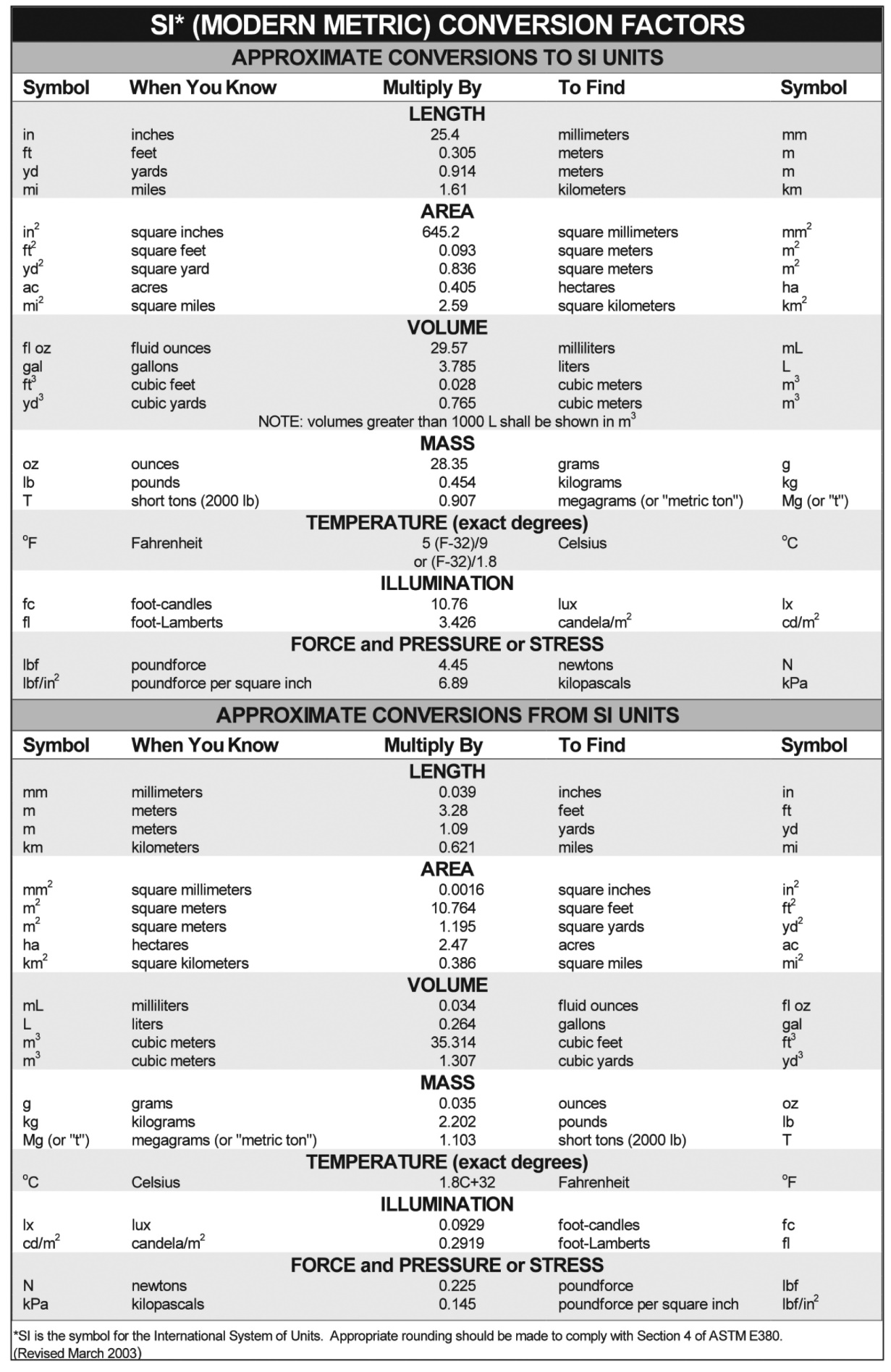
Table of Contents
Disclaimer i
Technical Report Documentation Page ii
SI* (Modern Metric) Conversion Factors iii
List of Figures v
List of Tables vi
List of Abbreviations (optional) vii
Acknowledgments (optional) viii
Executive Summary 1
CHAPTER 1. General Guidelines 2
1.1. Organization of Report 2
1.2. Page Layout and Fonts 2
1.3. Page Numbering 3
1.4. References 3
CHAPTER 2. Formatting Examples 4
2.1. Example of Figure 4
2.2. Example of Table 4
2.3. Examples of References 4
2.3.1. Example #1 5
2.3.2. Example #2 5
2.3.3. List of Reference Examples 5
Appendix A 6

List of Figures
Figure 2.1 PacTrans logo 4

List of Tables
Table 2.1 PacTrans University Names and Abbreviations 4

List of Abbreviations (optional)
PacTrans: Pacific Northwest Transportation Consortium
WSDOT: Washington State Department of Transportation

Acknowledgments (optional)
This text is left aligned with a standard indent and double spacing. You might use this space to thank researchers or folks who helped with the project in some capacity.

Executive Summary
An executive summary, or management summary, is a short document or section of a document, produced for business purposes, that summarizes a longer report or proposal or a group of related reports in such a way that readers can rapidly become acquainted with a large body of material without having to read it all (Wikipedia, 2018).

General Guidelines
Please use the reporting guidelines provided in this template. Using this template as your initial document will ensure that you meet the format required by the U.S. Access Board for producing a Section 508-compliant report (United States Access Board, 2019), as required by the terms of the PacTrans grant from the U.S. Department of Transportation. Simply save the template as your document and start writing, replace the words in the instructions with your own. Using this template also ensures that you have all the required elements of the report including the cover page, disclaimer, technical report documentation page, and metrics conversion table. A report that is not Section 508 compliant and does not contain all required elements will not be accepted for internal review; it will be returned to the principle investigator until those conditions are met. We strongly urge you to remain consistent throughout your report. Failure to submit a consistent, well-written report will result in the return of your report for revisions and may negatively affect your future project selection.

Organization of Report
Reports must include the following content in the order below:
- PacTrans Report Cover Page (required, fixed format)
- Disclaimer (required)
- Technical Report Document (required)
- Metric Conversion (required)
- List of Figures (required if figures are contained within the document)
- List of Tables (required if tables are contained within the document)
- List of Abbreviations (optional)
- Acknowledgements (optional)
- Executive Summary (required)
- Body of Report (Introduction, Literature Review, Data and Methods, Findings, Conclusions, etc., as appropriate)
- References (required)
- Appendices

Page Layout and Fonts
For heading, body, and caption fonts, use the prescribed settings in Styles, as follows:
- Chapter Heading: 12pt, Calibri, all caps, bold (e.g., CHAPTER 1. INTRODUCTION)
- First Subheading: 12pt, Calibri, bold (e.g., 1.1. Background)
- Second Subheading: 12pt, Calibri, bold italic (e.g., 1.1.1. More Background)
- Normal: Use for body text—11pt, Calibri, left justified with 1.08 line spacing, 8pt space between paragraphs
- Captions: 11pt, Calibri, centered
Use the prescribed styles and heading formats developed above. By clicking on the Home tab near the top of the screen, you will find the styles for this report shown above the word “Styles.” (The chapter and heading numbers will self-generate by clicking on the style that applies: Chapter Heading, First Subheading [Heading 2], Second Subheading [Heading 3]).
PacTrans requires the use of Word-generated Table of Contents, List of Figures, and List of Tables (do not enter them manually!). Assigning the appropriate heading style to your headings will allow you to create a Word-generated Table of Contents, and assigning the “Caption” style to your figure captions and table titles will allow you to create a Word-generated List of Figures and List of Tables. Word-generated (also referred to as automatically generated) Table of Contents and Lists of Figures or Tables are accessed by clicking on References at the command tabs row near the top of the screen (“Table of Contents” to the left; “Insert List of Figures” farther to the right [“Insert List of Figures” is also used for inserting a list of tables]).
Note that this document contains all required styles and fonts. We recommend that you use this template in producing your report. For more information, refer to the Microsoft Office Support pages on captions and figure/tables lists.

Page Numbering
Center the page number as a footer, starting ½ inch from the bottom of the page. Starting with Executive Summary, use Arabic numerals (e.g., 1, 2, 3, 4, …). All front matter (disclaimer, technical report documentation page, metric conversion chart, , acknowledgments, table of contents, etc., should use lowercase Roman numerals (e.g., i, ii, iii, iv, …).

References
Cite references following the formats of Harvard-Anglia 2008, the ASCE Journal of Materials in Civil Engineering, or the Transportation Research Record. Note that Harvard-Anglia 2008 is one of the formats available under references. We recommend that you refer to Microsoft Office Support on references and citations, including how to manage sources.

Formatting Examples

Example of Figure
Center-align the figure caption below the figure. The figure caption will have the prescribed font and formatting as outlined in Section 1.2 (Captions) by clicking on the built-in style “Caption.” When assigning the figure caption to the figure, use the Insert Caption feature so that the List of Figures can be automatically generated. All figures need alternate text descriptions to make them accessible to people using screen readers, as required by Section 508. Once figures are added to the document, right click on the figure and select format picture, click on the layout and properties icon and choose the alt text option. In the boxes provided, enter the title for the figure and a brief description. For more information refer to Microsoft Office Support.
Figure 2.1 PacTrans logo

Example of Table
Center-align the table caption above the table. The table title will have the prescribed font and formatting as outlined in Section 1.2 (Captions) by clicking on the built-in style “Caption.” When assigning the table title to the table, use the Insert Caption feature so that the List of Tables can be automatically generated. After creating the table, go to table properties and enter the table title and a brief description of the table in the box under the alt text tab. Under Table Tools/Layout, click Repeat Header Rows so that headers appear above columns at the top of each page and so that a screen reader registers the headers properly.
Table 2.1 PacTrans University Names and Abbreviations
University Name | Abbreviation
University of Alaska Fairbanks | UAF
University of Washington | UW
University of Idaho | UI
Oregon State University | OSU
Washington State University | WSU
Gonzaga University | GU
Boise State University | BSU

Examples of References
(You are encouraged to use the References function in Word, selecting the Harvard-Anglia 2008 format [click at References on the command tabs row at the top of the screen, then click on the down-arrow next to “Style” above the “Citations & Bibliography” section]. See Microsoft Office Support for assistance.)

Example #1
Name of Organization or Agency, Year Published. Title of Publication. City: Publisher, number of pages.

Example #2
Author Surname, Author Initials, Year Published. Book Title. Series Number [online]. City: Publisher, Pages Used. DOI or Available at: http://Website URL. Accessed [month day, year].

List of Reference Examples
Department for Communities and Local Government, 2008. Killian Pretty Review. London: Communities and Local Government, 58 pp.
Jones, D.M., 1967. Publishing Manuscripts (4th ed.). New York: McGraw-Hill, 350 pp.
Smith, J.S., 2000. Report writing. Journal of Science, 15(3): 35-45.
United States Access Board, 2019. About the Section 508 Standards. <https://www.access-board.gov/guidelines-and-standards/communications-and-it/about-the-section-508-standards>. Accessed March 08, 2019.
Wikipedia, 2018. Executive summary. <https://en.wikipedia.org/wiki/Executive_summary>. Accessed January 4, 2019.

Appendix A
(Appendices included as needed)
Page numbers should begin with page 1 for each appendix. For example, page numbers for Appendix A should begin with A-1.

