Concepts of the Body in 19th & 20th Century America

Bioethics & Humanities BH 485
3 Credits

Spring Quarter 2011 Course of Interest

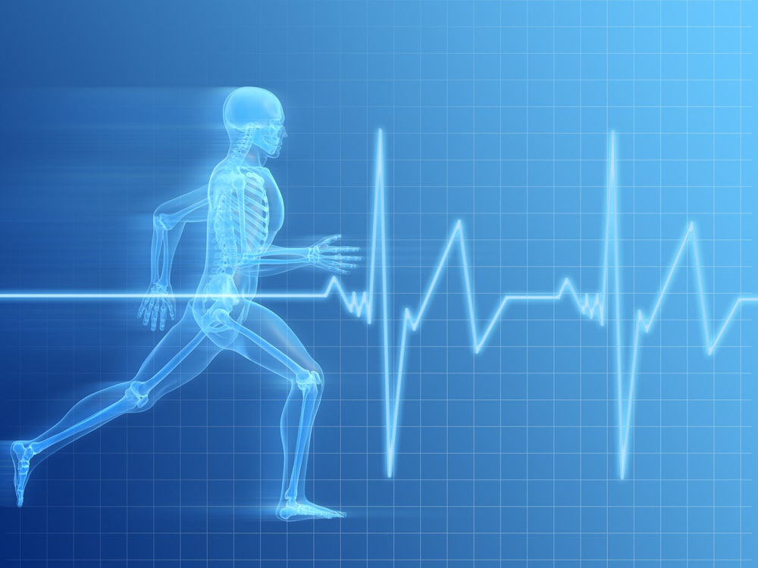

Instructor:
Jack Berryman, Ph.D. Professor, Bioethics & Humanities

Monday & Wednesday
9:30 -10:50 a.m.
Health Sciences, K069

Investigation of ideas relating to corporeal self in nineteenth- and twentieth-century America. Evolution of physical ideals of manliness/femininity, how ideals related to surrounding culture, how different bodily activities developed to realize ideals. Athleticism, physiognomy, beauty contests, body building, decorations, cosmetics, anthropometry, and phrenology.

Contact us:
Bioethics & Humanities
HSB, A204
bhadds@u.washington.edu

