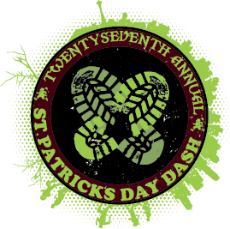

St. Patrick’s Day Dash Volunteer Job Description
Sunday, March 13th 2011
Check In: 7:00AM @ Seattle Center
**Please meet at Volunteer Booth – south of fountain**
Prior to Event: Check in with Alecia Wong at Volunteer Booth
1. You will receive a volunteer shirt, reflective orange vest, donuts, coffee, juice, and instructions
2. Please indicate that you are representing ‘North Helpline’ at check-in
- Dress warmly in clothes you can move in! Also you will be required to wear the T-shirt given to you.
- **PARKING INFORMATION**
  - Most volunteers will NOT stay parked in the volunteer lot. Each volunteer will be assigned a position (i.e → dexter and mercer) on the route once checked in. Once given your position at check-in, you will need to transport to this position and park within the area. Directions will be provided for each volunteer. Those without vehicles will be shuttled to their positions and picked up at the end. YOU MUST HAVE YOUR PARKING PASS.
During the Event:
- Your job is to monitor foot and vehicle traffic – you will direct runners and maintain a safe running route
- Please do not jump in front of vehicles or risk being injured! It is not your job to risk injury if someone really wants to drive through the course
- You will be standing the entire shift, so please wear comfortable shoes!
After the Event:
- Please wait for notification before you leave your post. You will look for a Seattle Police vehicle to pass through with the last walker/runner on the course as a signal to leave your post.
- Please return to volunteer check-in booth to turn in your reflective orange vest
- Approximate end time for this event will be 11AM
***Don’t forget to set your clocks ahead Saturday Night!!!! Day Light Savings!!!***

St. Patrick’s Day Dash
Sunday, March 13th 2011



12736 33rd Ave NE
Seattle WA, 98125
www.northhelpline.org

DRIVING AND PARKING:
Please carpool if you can! Enter Volunteer Parking off of 1st Ave. North between John & Thomas St. Attached is your Parking Pass. Please print it out and put it on your dash board.
Driving directions are below. Walk northeast of the parking lot to Post Dash Area and check in at Volunteer Booth near the International Fountain. Map attached.

DRIVING/PARKING INSTRUCTIONS
I-5 North or South:
- Take Mercer Street Exit
- Right on Fairview
- Left on Valley St.
- Valley St becomes Broad
- Right on Denny
- Right 1st Ave. N.
- Turn Right into the Parking Garage between John and Thomas

ATTACHED IS YOUR PARKING PASS – PLEASE PRINT ENOUGH COPIES FOR YOUR VOLUNTEER DRIVERS, AND GIVE THEM THESE INSTRUCTIONS. IF THEY FORGET THEIR PARKING PASS, OR YOU DON’T HAVE AN OPPORTUNITY TO DISTRIBUT E TO EVERYONE, THE PARKING ATTENDANT (DASH STAFF PERSON) WILL HAVE PARKING PASSES AT THE LOT ENTRANCE.
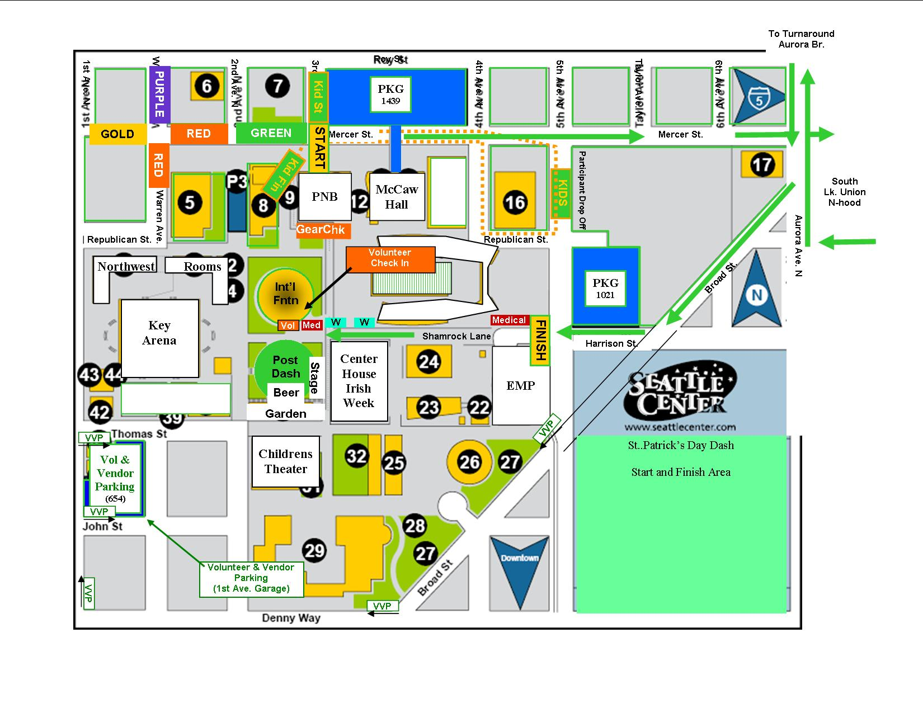

PARKING PASS
St. Patrick’s Day Dash
STAFF & VOLUNTEERS
1st Ave. Garage Only – 3/13/2011
Please Display on Dashboard!

