**World Health Cinema presents:**

***Pray the Devil Back to Hell***

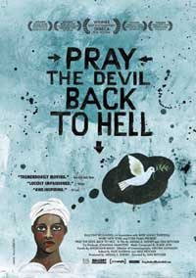

In honor of this year's Nobel Peace Prize going to Ellen Johnson Sirleaf and Leymah Gbowee (along with Tawakkol Karman) we are going to screen "Pray the Devil Back to Hell" (72 minutes). This documentary is about the women in Liberia who led a grassroots movement to bring peace to their country and features the prize winners as well as many other brave Liberian women.

<http://praythedevilbacktohell.com/>

Discussion Leader: TBA

**Friday, December 2nd**

**2:00 to 4:00 p.m.**

**Turner Auditorium (Health Sciences, D-209)**

Sponsor: Global Health Resource Center