STUDY ABROAD

IN

BRAZIL

FALL QUARTER 2012 (Oct 3 thru Dec 7)

Disability in Limited Resource Environments: Brazil

REHAB 496: Special Topics in Rehabilitation (12 credits)

DIS ST 430: Disability Studies (12 credits)
This study abroad course addresses disability within low and middle income countries. Using Northeast Brazil as a cultural, political and socioeconomic context, students will explore a wide range of issues related to disability including human rights laws, prevalence and demographics, measurement, access and barriers to health care and rehabilitation, availability of assistance and support, accessibility of built environments and information technologies, and barriers to education and employment.
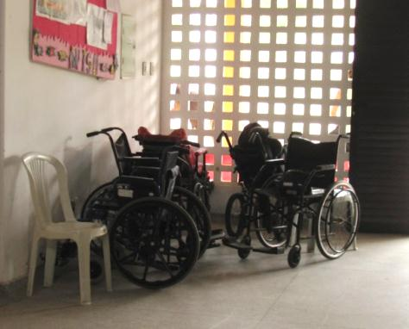
APPLICATIONS DUE APRIL 30th
For more information
Go to the UW Study Abroad Website
http://studyabroad.washington.edu/
and click on UW Programs

Or email program leaders:
Mark Harniss, mharniss@uw.edu
Becky Matter, bmatter@uw.edu

