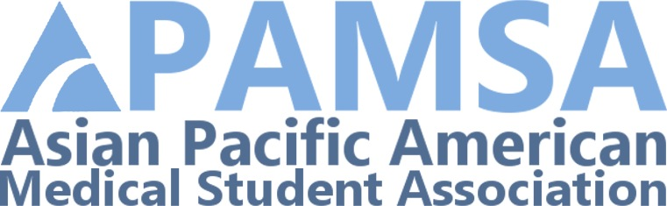

The Asian Pacific American Medical Student Association (APAMSA) will be having its 2nd Annual Pre-Med APAMSA Essay Scholarship Contest to aid interested pre-medical students in attending the **19th Annual National Conference hosted by University of Michigan Medical School from September 29-30, 2012**. This year’s theme will be ***Connect the Dots, Make Your Mark: An Interdisciplinary Approach to Medicine***. For more information, please visit the official conference website: <https://apamsaconference.org/>. It will be regularly updated as we move closer to the conference. For more information about APAMSA, please visit [www.apamsa.org](http://www.apamsa.org). To view last year’s successful winning essays, please check out <http://www.apamsa.org/programs/pre-medical-students/premed-essay-contest-results>.

Each scholarship will amount to **$400** to help defray travel, lodging, and registration costs. Winning students must attend the conference in order to receive funding otherwise they will forfeit their award. The awardees will be recognized in front of roughly 250 medical students and medical professionals during the conference banquet on the evening of **September 29**. The essays will also be posted on the National APAMSA website and published in the monthly APAMSA newsletter.

Please write a thoughtful essay on the following topic:

**What is a current APA issue that needs more advocacy efforts and what would be one way of advocating that issue?**

Creative titles are encouraged.

Essays must be limited to 600 words. Submissions must be emailed to [premed@apamsa.org](mailto:premed@apamsa.org) by 11:59 PM on Sunday, **September 9, 2012**. Winning students will be notified shortly and must show proof of conference registration in order to not forfeit their award. Please direct any questions you may have to [premed@apamsa.org](mailto:premed@apamsa.org).

Please include your name, school, major/degree concentration, anticipated graduation date, phone number, and email at the top of your essay. This will not count towards your 600 words.

**Why Pre-Meds Should Attend**: Though the entire weekend will be very resourceful for both pre-med and medical students offering a wide variety of speakers covering a diverse range of topics pertinent to Asian Pacific American health, APAMSA will dedicate all of Sunday, September 29, towards pre-med enrichment and advising. Below are some of the many reasons to attend this conference:

1. Network with roughly 250 current medical students from the best medical schools in the country.
2. Learn through workshops on various topics: Disparities & Global Health; Arts, Culture & the Humanities; Law, Ethics & Policy; Business & Technology; Mental Health & Wellness; Mentorship & Service.
3. Meet other pre-medical students at every stage of the application process.
4. Panels with admission deans, pre-med advisors and medical students on how to successfully prepare and apply for medical school.