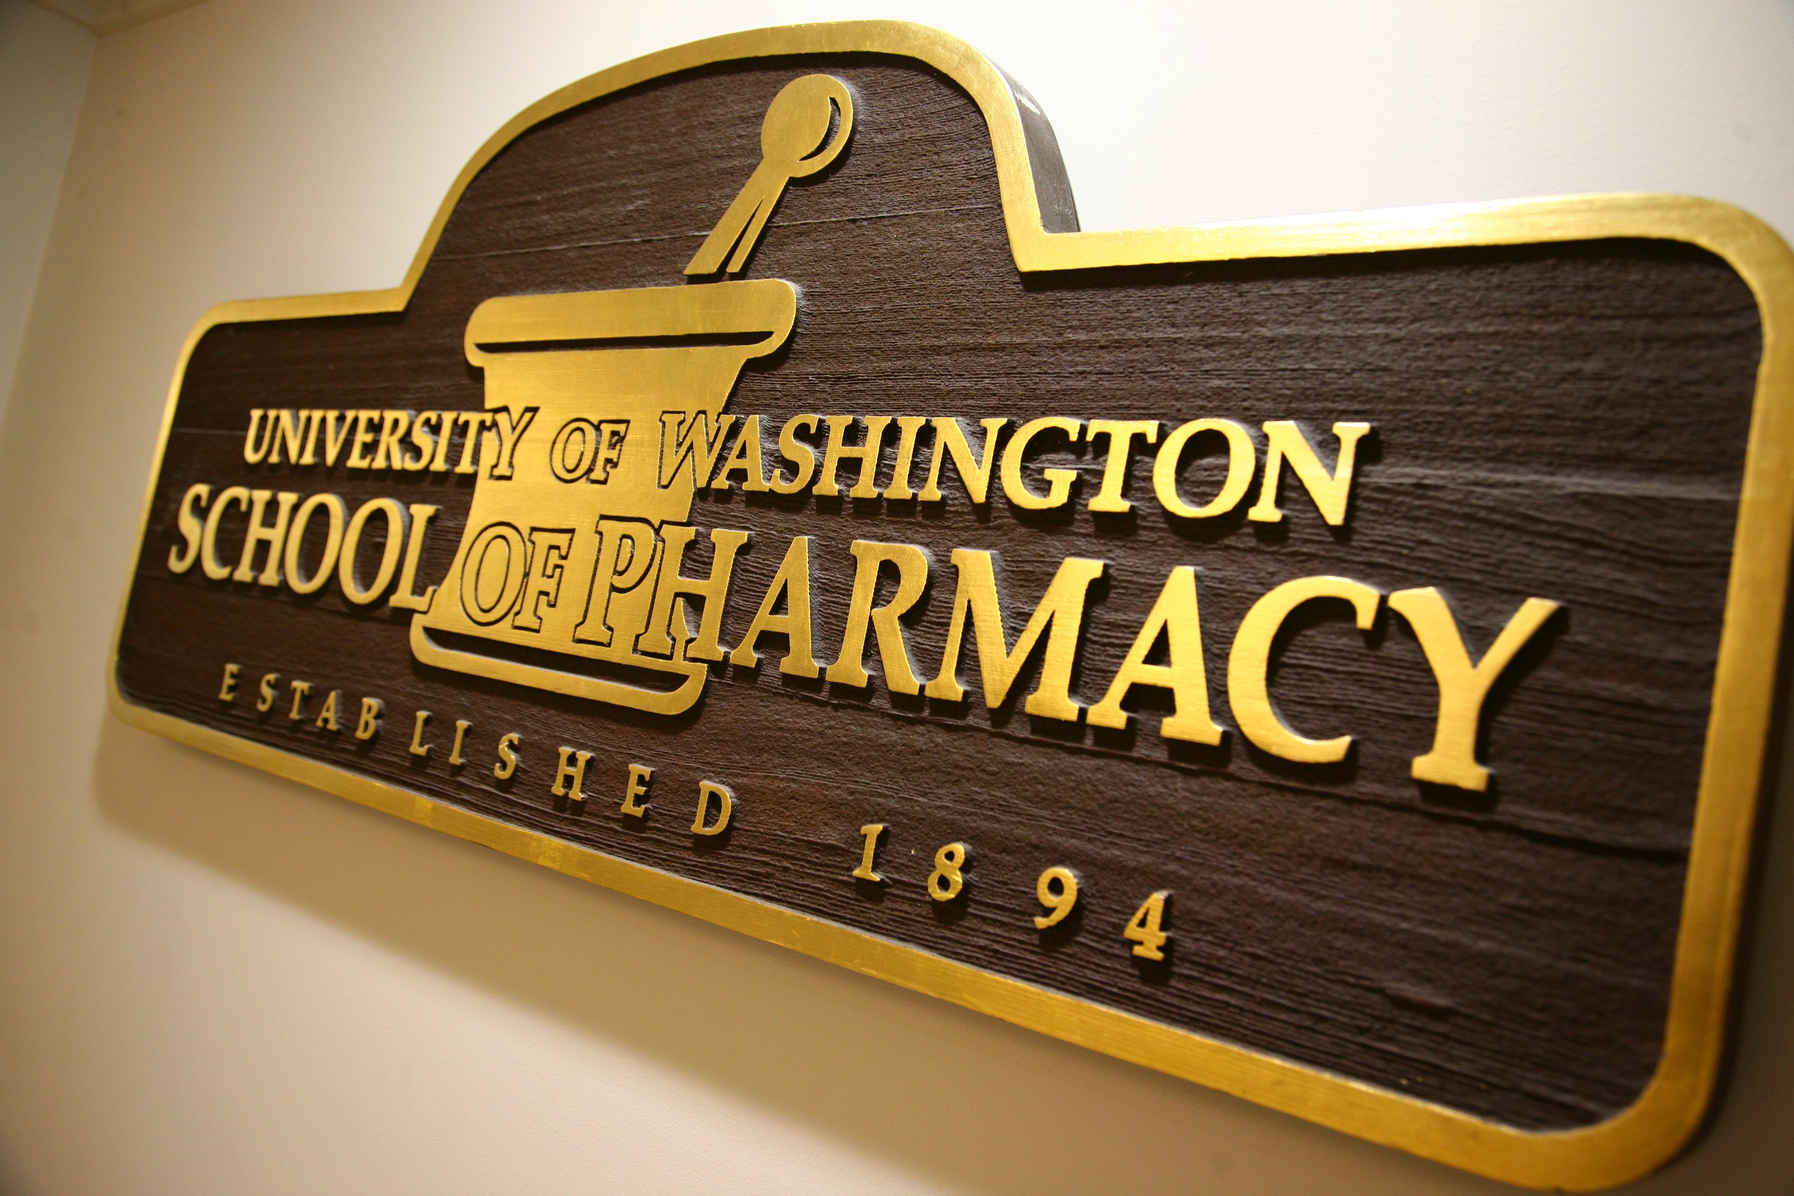

Answer these questions and many, many more in …

**Pharmacy 301**

**“Medications and Health: It’s not all about drugs”**

**Spring Quarter 2013**

The course will feature…

* **TOPICS RELATABLE TO YOU**
* Engaging faculty from the UW School of Pharmacy
* Which medications are the most dangerous?
* Do herbal remedies actually work?
* What’s the big deal with using drugs to help you study?
* How can I decrease stress without medications?
* What’s up with the scary medication side effects on TV commercials?

Do you ever wonder…

#### Pharmacy 301

MWF 11:30-12:20

#### Pharmacy 301

MWF 11:30-12:20

#### Pharmacy 301

MWF 11:30-12:20

#### Pharmacy 301

MWF 11:30-12:20

#### Pharmacy 301

MWF 11:30-12:20

#### Pharmacy 301

MWF 11:30-12:20

#### Pharmacy 301

MWF 11:30-12:20

#### Pharmacy 301

MWF 11:30-12:20

#### Pharmacy 301

MWF 11:30-12:20

#### Pharmacy 301

MWF 11:30-12:20