**Diversity Minor Program**



We would like to encourage you to consider pursuing the **Diversity Minor**! The minor is designed to strengthen students’ understanding of how ***race, class, gender, disability, ethnicity, nationality, sexuality, religion,*** and ***age*** interact to define identities and social relations. The program brings cohesion to a variety of courses selected to increase students’ awareness about issues of power and privilege.

**Courses & Requirements**

The courses that comprise this **25-credit** **minor** come from a wide range of departments within the College of Arts & Sciences, including Communications, CHID, Sociology, English, Anthropology, and more.

Additional information about specific courses that fall within the minor can be found on our [website](http://depts.washington.edu/divminor/). Other classes that are not already on our list may also be considered.

For more information, please visit the [website](http://depts.washington.edu/divminor/), send us an [e-mail](mailto:divminor@uw.edu), “like” us on [facebook](https://www.facebook.com/divminor), or come talk to the Diversity Minor Advisor in Padelford!

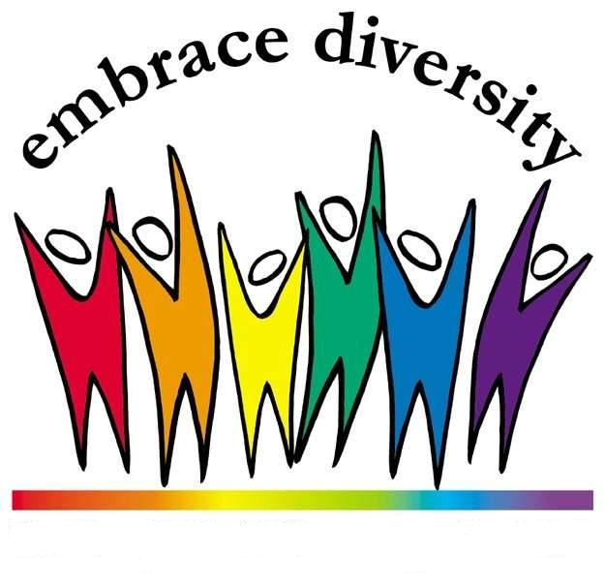

***UW College of Arts & Sciences Diversity Minor Program***

[*http://depts.washington.edu/divminor/*](http://depts.washington.edu/divminor/)

[*divminor@uw.edu*](mailto:divminor@uw.edu)

*Padelford B-507*

*206-616-2352*