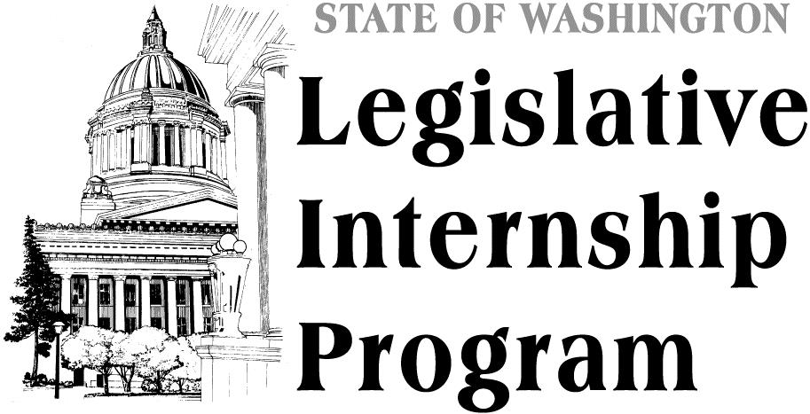

Open to ALL majors. Find out how government really works and get the sort of professional experience that will make you stand out from the crowd.

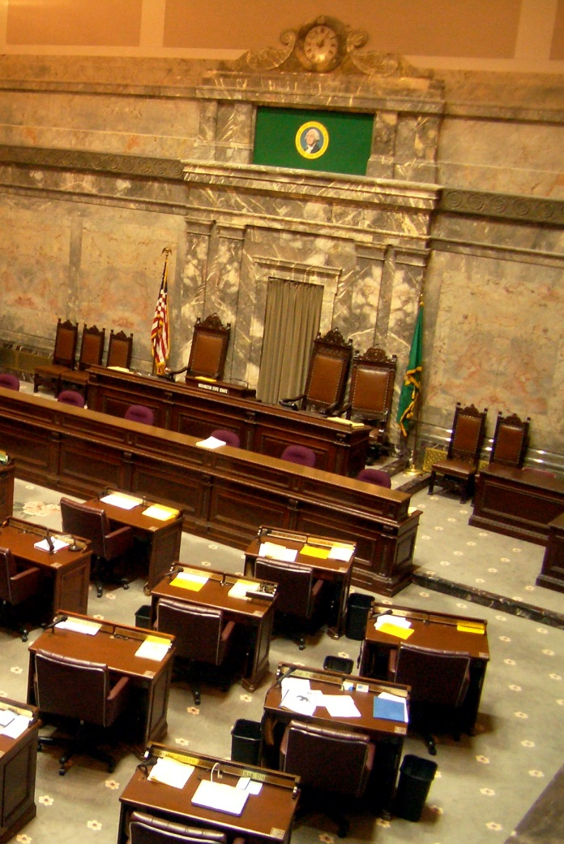
Information Sessions
Gowen Hall, room 1A

Tuesday, May 13th—
11:30am – noon
2:30pm – 3:00pm

Wednesday, May 14th—
9:30am – 10:00am
3:30pm – 4:00pm

