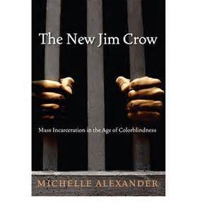

**ASCE and the COE cordially invite you the**

**Common Book Main Event 2015!**

**Panel Discussion** on

**Thursday,** **May 7th** at the **ECC** in the **Unity Ballroom**

*Light dinner served from 6:00-6:45pm, Panel Discussion 7-8:30pm*

***The Panelists include***

**Naomi Murakawa, PhD**

Princeton University, Associate Professor, Center for African American Studies – Political Science

**Joy Williamson-Lott, PhD**

University of Washington, Associate Professor, College of Education – History of Education

**Richard Delgado**, **JD**

University of Alabama School of Law, John J. Sparkman Chair of Law – Critical Race Theory

**Jean Stefancic, MA**

University of Alabama School of Law, Professor and Clement Research Affiliate – Critical Race Theory

**Moderator: Manka Varghese**, **PhD**

University of Washington, Associate Professor, College Of Education