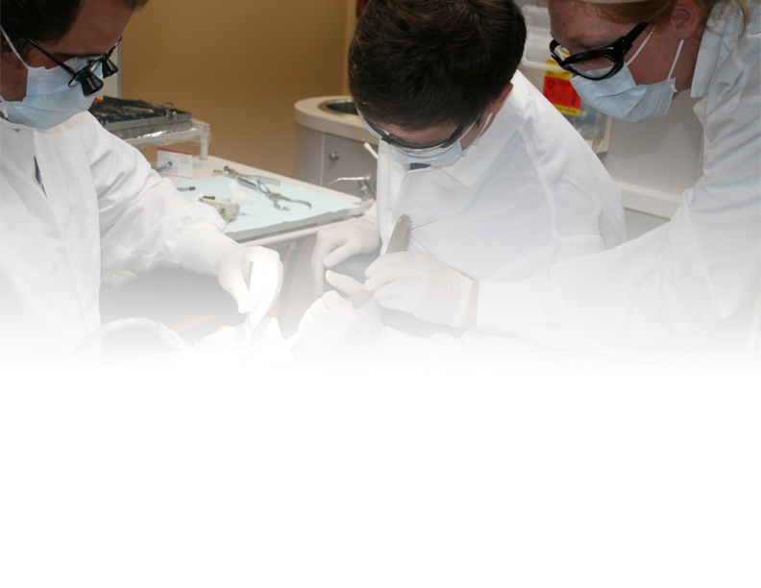

**What: RIDE Open House**

**Why: Learn more about the UWSOD RIDE Track, tour the state-of-the-art EWU facilities, meet RIDE faculty and meet current RIDE students.**

**Where: EWU Spokane Campus**

**Academic Center, room 147 Please RSVP and direct questions to**

**600 N Riverpoint Blvd. Colette at (509) 828-1423**

**Spokane, WA 99202 cloiacono@ewu.edu**

**When: Thursday, October 15, 2015**

**4:30 PM (pizza provided)**

** **



**Are you interested in practicing in rural and underserved communities?**

**If so, then come and learn more about the University of Washington School of Dentistry (UWSOD) Regional Initiatives in Dental Education (RIDE) program at the EWU Riverpoint Campus in Spokane, Washington.**