Standard Operating Procedure
Oxidizers
This is an SOP template and is not complete until: 1) lab specific information is entered into the box below 2) lab specific protocol/procedure is added to the protocol/procedure section and
3) SOP has been signed and dated by the PI and relevant lab personnel.
Print a copy and insert into your Lab-Specific Chemical Hygiene Plan.

Section 1 – Lab-Specific Information
Chemical(s) covered by this SOP: | Osmium Tetroxide (OsO4
Building/Room(s) covered by this SOP: | CHDD; CD186A
Department: | Oto-HNS Virgina Merril Bloedel Hearing Research Center
Principal Investigator Name: | Edwin W Rubel
Principal Investigator Signature: | Click here to enter text.

Important Definitions
- Oxidizing liquid- a liquid which, while by itself, is not necessarily combustible, may generally by yielding oxygen, cause or contribute to the combustion of other material. Hydrogen peroxide, nitric acid, and nitrate solutions are examples of oxidizing liquids commonly found in a laboratory.
- Oxidizing solid- a solid which, while by itself, is not necessarily combustible, may generally by yielding oxygen, cause or contribute to the combustion of other material.

Section 2 – Hazards
Oxidizer should be kept away from heat, clothing, and other combustible materials. Take any precaution to avoid mixing with combustibles and store away from combustibles. Oxidizers can have other associated hazards, such as corrosive or toxic (e.g., nitric acid, sodium nitrite). Make sure that all of the potential hazards are understood before handling any chemical.
Common oxidizers include hydrogen peroxide, nitric acid, nitrate and nitrite compounds, perchloric acid and perchlorate compounds, and Hypochlorite compounds, such as household bleach. Oxidizers have a wide variety of applications including cleaners and disinfectants, agricultural fertilizers, rocket propellant and fuel, and explosives.
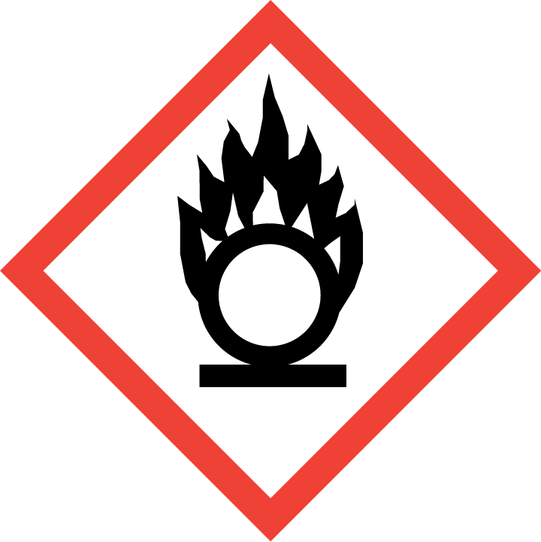
Section 3 – Engineering Controls and Personal Protective Equipment (PPE)
Engineering Controls: Use of oxidizing liquids and solids should be conducted in a properly functioning chemical fume hood whenever possible. The chemical fume hood must be approved for use by EH&S.

Hygiene Measures: Avoid contact with skin, eyes, and clothing. Wash hands before breaks and immediately after handling the product.
Hand Protection: Chemical-resistant gloves must be worn, nitrile gloves are recommended for low volume applications. NOTE: Consult with your preferred glove manufacturer to ensure that the gloves you plan on using are compatible with the specific chemical being used.
Eye Protection: ANSI approved properly fitting safety glasses or chemical splash goggles are required. A face shield may also be appropriate depending on the specific application.
Skin and Body Protection: Laboratory coats must be worn and be appropriately sized for the individual and buttoned to their full length. Personnel must also wear full length pants, or equivalent, and close-toed shoes. Full length pants and close-toed shoes must be worn at all times by all individuals that are occupying the laboratory area. The area of skin between the shoe and ankle must not be exposed.

Respiratory Protection: If oxidizers are being used outside of a chemical fume hood, respiratory protection may be required. If this activity is necessary, contact EH&S at 206.616.3777 so a respiratory protection analysis can be performed.

Section 4 – Special Handling and Storage Requirements
- Do not over purchase; only purchase what can be safely stored in the laboratory.
- Avoid contact with skin, eyes, and inhalation. Avoid inhalation of vapor or mist. Avoid formation of dust.
- Keep away from combustible materials. Keep away from sources of ignition - No smoking.
- Keep containers tightly closed. Store in a cool, dry, and well-ventilated area away from incompatible substances such as flammable and combustible liquids.
- Keep cool and protected from sunlight.
- Opened containers of oxidizing liquids must be carefully resealed and kept upright to prevent leakage.
- Carefully follow manufacturer’s instructions if oxidizing liquid needs to be vented during storage.
- Avoid using ignition sources (flame burners or any open flame source, hot plates, electrical equipment with frayed or cracked wiring, etc.) and/or creating static electricity in areas where oxidizing chemicals are being used.

Section 5 – Spill and Accident Procedures
Chemical Spill Dial 911
Immediately evacuate area and ensure others are aware of the spill. If there is an imminent threat of a fire, pull the nearest fire alarm station to evacuate the building and dial 911. If personnel have become exposed and need medical assistance, dial 911. If the spill is minor and does not pose a threat to personnel, contact EH&S at 206.543.0467 during normal business hours (Monday – Friday, 8 AM – 5 PM) for spill cleanup assistance (dial 911 if spill occurs after hours and assistance is needed).
Section 6 – Waste Disposal Procedures
When possible, do not mix oxidizer waste streams with flammable or combustible waste. Store hazardous waste in closed containers that are properly labeled, and in a designated area away from incompatible chemicals. Complete a Chemical Waste Collection Request Form to arrange for disposal by EH&S; detailed instructions are provided at the following link: http://www.ehs.washington.edu/epowaste/chemwaste.shtm.
Section 7 – Protocol (Additional lab protocol may be added here)
Osmium tetroxide: Secondary fixation following glutaraldehyde fixation for electron microscopy.
Spill and accident procedures: Within the hood: absorb spill with paper towels. Place towels in open waste bag to allow fumes to evaporate. Close bag, label, call EH&S for pickup. Outside the hood: Clear lab of personnel, place absorbent on spill, close lab door, call EH&S Hazmat or Fire Dept.

NOTE: Any deviation from this SOP requires approval from PI.

Section 8 – Documentation of Training (signature of all users is required)
Prior to conducting any work with oxidizers, the Principal Investigator must ensure that all laboratory personnel receive training on the content of this SOP.
I have read and understand the content of this SOP:
Name | Signature | Date
Click here to enter text. |  | Click here to enter a date.
Click here to enter text. |  | Click here to enter a date.
Click here to enter text. |  | Click here to enter a date.
Click here to enter text. |  | Click here to enter a date.
Click here to enter text. |  | Click here to enter a date.
Click here to enter text. |  | Click here to enter a date.
Click here to enter text. |  | Click here to enter a date.
Click here to enter text. |  | Click here to enter a date.
Click here to enter text. |  | Click here to enter a date.
Click here to enter text. |  | Click here to enter a date.

