LABORATORY-SPECIFIC INFORMATION

This Laboratory Safety Manual serves as your Chemical Hygiene Plan (CHP), it belongs to:
Laboratory Name: | Rubel Lab
Chemical Hygiene Officer*: | Robin Gibson
Department: | Otolaryngology
Phone: | 206-221-6438
Date: | October 27, 2020

This Laboratory Safety Manual serves as your Chemical Hygiene Plan (CHP), it belongs to:
Laboratory Name: | Stone Lab
Chemical Hygiene Officer*: | Robin Gibson
Department: | Otolaryngology
Phone: | 206-221-6438
Date: | October 27, 2020

* The Chemical Hygiene Officer is the Principal Investigator, Faculty Member, or Supervisor who is responsible for the Chemical Hygiene Plan in the unit or laboratory.

This CHP covers the following laboratory spaces:

Building(s): CHDD
Room #: CD186A, CD186HJK, CD186N, CD186L, CD186D, CD055, CD056, CD056A, CD056B, CD056D, CD056E, CD068, CD175
If Parts of Room(s), Description of Area:

CD 186A-Histology
CD 186N-Microtomy
CD186D-Molecular Biology
CD186 H,J,K-Tissue Culture
CD175 Digital Microscopy
CD 055 Animal Procedure
CD 056E: Fish Cave, CD 056B: VOR, CD 056D: Mouse ABR
CD 068 Electrophysiology
Names of PI(s) that share the space(s):
Dr. Edwin W Rubel
Dr. Jennifer Stone

This CHP, consisting of the UW Laboratory Safety Manual and our laboratory-specific information, was reviewed and updated

On: By:

March 8, 2016 | Robin Gibson
August 30, 2016 | Robin Gibson
October 18, 2016 | Robin Gibson
May 23, 2017 | Robin Gibson
May 25, 2017 | Robin Gibson
April 03, 2018 | Robin Gibson
June 05, 2018 | Robin Gibson
August 28, 2019 | Robin Gibson
October 27, 2020 | Robin Gibson

The items listed below identify the laboratory-specific information that is attached (or filed in its noted location) and that applies to this laboratory:

Laboratory-specific information cover sheet (i.e., these pages)
Laboratory floor plan(s) CD186A CD186D, CD186HJK, CD055
General laboratory safety rules, applicable throughout the laboratory
Designations of individuals performing particular tasks (e.g., checking first aid supplies, maintaining chemical inventories, etc.)
Authorizations for individuals to use specific hazardous/controlled substances
Any special instructions for receiving and storing hazardous materials
Contents of chemical spill kit(s)
Any special instructions for labeling containers
Training records, or location if filed separately from this Plan
Standard Operating Procedures (SOPs), or location if filed separately
SOPS ARE IN THIS SECTION OF THE 3-RING BINDER (LSM) LOCATED IN CD186A
MyChem Chemical Inventory Report, or location if filed separately
For access to MSDS/SDSs, go to http://mychem.ehs.washington.edu and login using your UWNetID and password.
To request access to site-specific chemical inventories and the Chemical Exchange, send an email to mychem@uw.edu .
Locations of MSDSs, other reference materials, University or departmental
safety rules that apply to us, equipment maintenance manuals, other paper
documents (such as a building evacuation plan or departmental health and safety plan) if filed separately from this CHP, etc.

ADDITIONAL INFORMATION CAN BE FOUND AT
http://depts.washington.edu/rubelab/index.html

Laboratory floor plans

Building: CHDD
Room #: CD186A CD186D, CD186HJK, CD055
CD 186A-Histology
CD186D-Molecular Biology
CD186 H,J,K-Tissue Culture
CD 055 Animal Procedure

CD186A/B Histology Floor Plan

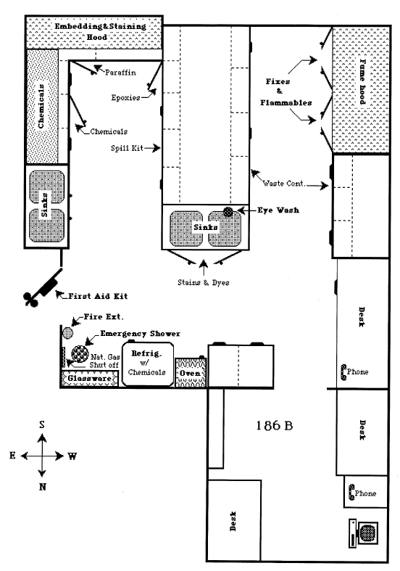
CD186D Molecular Biology Floor Plan

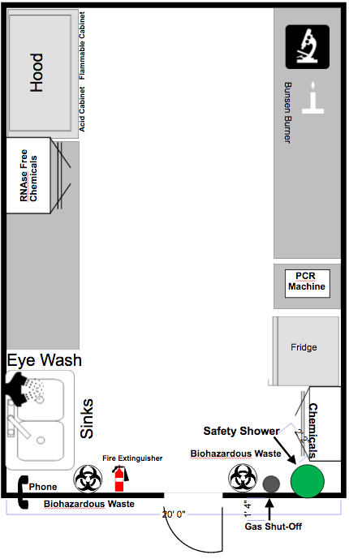

CD186 (H, J, K) Tissue Culture Floor Plan

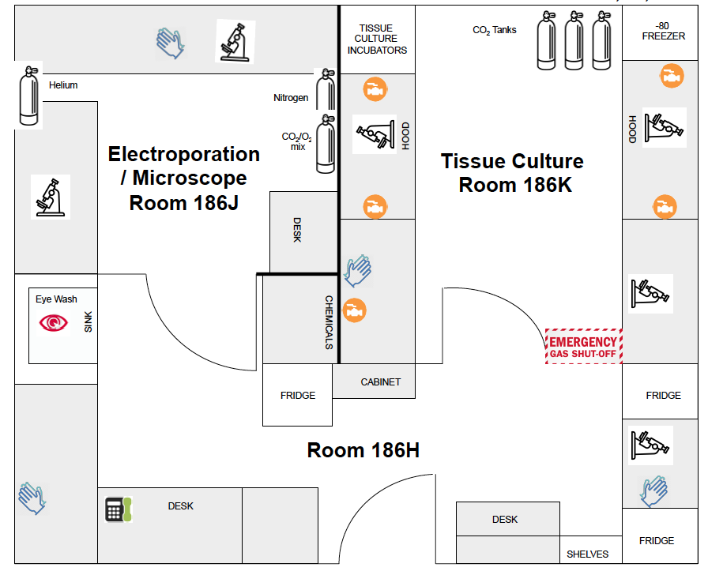

CD055 Animal Procedure Room Floor Plan

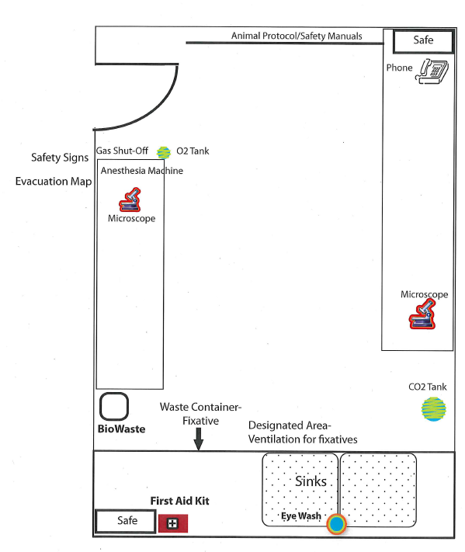

General laboratory safety rules, applicable throughout the Rubelab

Emergency procedures
- It is your responsibility to read safety and fire alarm posters and follow the instructions during an emergency.
- Know the location of the fire extinguisher, eye wash, and safety shower in your lab and know how to use them.
- Know the location of your Evacuation Assembly Point (EAP). For CHDD, the EAP is outside on the south lawn, near the Montlake Cut.
- Accident Reporting: Report any work-related injury or illness to your supervisor as soon as possible. Then report it to the Environmental Health and Safety Department (EH&S) via the UW Online Accident Reporting System (OARS). Submit the OARS report within 24 hours.
- Also submit an OARS report for near misses, hazardous conditions, and accidents or injuries involving students, UW volunteers working on or off campus, or members of the public visiting campus.
- Anyone with a UW NetID can access OARS.
The affected UW employee, his or her supervisor, or a University representative can submit the report.
Also call EH&S immediately at 206.543.7262 if the incident involves any of the following:
- In-patient hospitalization
- Recombinant/synthetic DNA exposure or spill
- Fatality
Outside of EH&S business hours (8:00-5:00 PM, Monday-Friday), call the UW Police Department (UWPD) at 206.685.UWPD (8973). UWPD will notify an EH&S on-call staff member.

General laboratory safety rules
- Never eat, drink, or smoke while working in the laboratory.
- Read labels and signs carefully.
- Do not use any equipment unless you are trained and approved as a user by Ed Rubel (PI).
- Wear safety glasses or face shields when working with hazardous materials and/or equipment.
- Wear gloves when using any hazardous or toxic agent.
- Do NOT wear gloves in the hallway, elevators, stair well, offices or common areas outside of the laboratory.
- Clothing: When handling dangerous substances, wear gloves, laboratory coats, and safety shield or glasses. Shorts and sandals should not be worn in the lab at any time.
- If you have long hair or loose clothes, make sure it is tied back or confined.
- Disposal – lab members are responsible for knowing how and where to dispose of chemical waste, bio hazardous materials and sharps/plastic/glassware.
- Lab members are required to label all reagents, buffers and waste containers with:
Name:
Date:
Contents: (this includes the percent of each chemical so that including water, it adds up to 100%)
- Equipment Failure - If a piece of equipment fails while being used, report it immediately to your PI or the lab manager.
- If leaving a lab unattended, turn off all ignition sources and lock the doors. (If leaving after 5PM, please check and lock all lab doors.)
- Never pipette anything by mouth.
- Clean up your work area before leaving.
- Wash hands before leaving the lab and before eating.
Chemical safety
- Make sure all chemicals are clearly and currently labeled with the substance name, concentration, date, and name of the individual responsible.
- Never return chemicals to reagent bottles. (Try for the correct amount and dispose of any excess.)
- Comply with fire regulations concerning storage quantities, types of approved containers and cabinets, proper labeling, etc. If uncertain about regulations, contact the lab manager or EH&S.
- Use volatile and flammable compounds only in a fume hood. Procedures that produce aerosols should be performed in a hood to prevent inhalation of hazardous material.
- Never allow a solvent to come in contact with your skin. Always use gloves.
- Never "smell" a solvent!! Read the label on the solvent bottle to identify its contents.
- Dispose of waste and broken glassware in proper containers.
- Sharps and Broken Glassware boxes must be labeled with PI Name and Room number (e.g. “Rubel/CD186”).
- Clean up spills immediately.
- Do not store or consume food in laboratories.
Additional Safety Guidelines
- Keep your lab space clean and organized.
- Maintain unobstructed access to all exits, fire extinguishers, electrical panels, emergency showers, and eye washes.
- Be careful when lifting heavy objects.
- Clean your lab bench and equipment, and lock the door before you leave the laboratory, especially if you are the last one leaving and it is close to 5PM.

Designations of individuals performing particular tasks (e.g., checking first aid supplies, maintaining chemical inventories, etc.)

Rubelab Main Brain Page

What | Description | Who
RESPONSIBILITES SHARED BY EVERYONE
Lab Safety |  | Everyone
Lab Dish Washing | Wash your glassware and put it away.  Please see Robin Gibson for training before using the dishwasher downstairs. | Everyone
Animal Surgery Room | Leave clean and stocked. | Everyone
Sharps Waste | Red Biohazardous Sharps Containers: seal when no more than 2/3 full, label with autoclave tape, PI and Room #--do not cover vents. Leave next to autoclave. Notify Van or Jialin. | Everyone
Biohazardous Waste | When Red Biohazardous Waste bags are no more than 2/3 full they must be double bagged and transported to autoclave room for decontamination following the posted instructions. The waste is then placed in a black garbage bag and put in the garbage dumpster. Be sure to label the bag with room number and PI name. | Everyone
Non-Biohazardous Lab Glass and Plastic | Cardboard boxes must be labeled with PI name and Room number. When boxes are less than full, the boxes must be taped shut using packing tape and LABORATORY GLASS TAPE. They may then be placed in the hall for custodial pick-up (as long as they are not too heavy) or taken directly to the dumpster. | Everyone
Styrofoam Box Recycling | Styrofoam Boxes are bagged and labeled following the SOP that is posted in CD 186L (darkroom) and on the Rubelab webpage. UW recycling is notified for pick-up. | Everyone
Ordering Supplies | General supplies are ordered on a shared budget matrix by everyone. Please see detailed ordering instructions in “Welcome to the Rubelab”. | Everyone
LAB DUTY SPECIFIC MAIN BRAINS
Microscopy | Training, consultation and maintenance. | Jennifer Stone
Autoclave | Please see Van, Jialin or Stephanie for training before using the autoclave. Maintenance duty includes running monthly biospore safety test. | Van Redila, Jialin Shang
Lab Coats | Send soiled coats to Medicleanse | Robin Gibson
Sharps Waste | Red Biohazardous Sharps Waste Container Disposal: Autoclave and transport to T-276 in the T-Wing. | Van Redila, Jialin Shang
EQUIPMENT SPECIFIC MAIN BRAINS
Confocal Microscope | Training, consultation and maintenance. | Jennifer Stone
Cryostat, CD 186N | Training, consultation and maintenance. | Ling Tong
Sledge, CD 186N | Training, consultation and maintenance. | Ling Tong
Microtome, CD 186N | Training, consultation and maintenance. | Jialin Shang
Vibratome | Training, consultation and maintenance. | Jennifer Stone
Sterilization Oven | Located in dark room. | Ling Tong
PCR machine | Located in molecular biology | Ling Tong
Nano Drop | Located in basement (Tempel lab) | Tot Nguyen/Robin Gibson
Centrifuge | Located in basement (Tempel lab) | Tot Nguyen/Robin Gibson
i-Cycler (Bio Rad) | Located in basement (Tempel lab) | Robin Gibson
Gas Tanks | Oxygen and CO2 tanks, ordering and changing, consulting. | Jialin Shang, Van Redila
ROOM SPECIFIC MAIN BRAINS
Tissue Culture, CD186H |  | Jialin Shang
Histology, CD 186A |  | Ling Tong
Molecular Biology, CD 186D |  | Tot Nguyen/Ling Tong
Animal Surgery, CD 055 |  | Van Redila
In Vitro Suite: CD 056
Fish Cave, CD 056E | No longer in use.
VOR Testing, CD 056B |  | Jim Phillips
Mouse ABR, CD 056D |  | Ed Rubel, Ling Tong
Animal Physiology, CD 068 |  | Van Redila
Tempel Physiology CD 072 |  | Cliff Hume, Jay Rubinstein
Bloedel Maintenance | Building concerns/burned out light bulbs. | Llyne Foy, Robin Gibson
Freezers
Refrigerators

LAB MANAGER DUTES
EH&S | Maintain Chemical Hygiene Plan, attend and follow-up with inspections | Robin Gibson
Website | Maintain and update website | Robin Gibson
IACUC | Attend inspections. | Robin Gibson
Animal Protocol | Submit Significant Changes; complete renewals | Robin Gibson
Eye Wash Checks | Flush monthly and log the date. | Robin Gibson
Lab Safety Training | Maintain and document lab-training records. | Robin Gibson
Ed’s Calendar |  | Robin Gibson
Lab Meeting Announcements | Weekly announcement sent out on Tuesday whether or not we are having lab meeting on Wednesday. | Robin Gibson

Authorizations for individuals to use specific hazardous/controlled substances

- Individuals working with hazardous substances have read the Occupational Health recommendations.

Hazardous Substance | Name | Date | Authorization
BrdU
Isoflurane | Van Redila | 10/12/16
Amsacrine, cisplatin, vinorelbine | Patricia Wu | 10/12/16
TTX (tetrodotoxin) via disk implantation

DT (diphtheria toxin) via disk implantation | Ling Tong | 10/12/16
Cholera toxin B subunit

Carvedilol, fluspirilene, fluoxetine, fluvoxamine, paroxetine, phenoxybenzamine, raloxifene, ractopamine, tamoxifen

Proparacaine eye drops

Kanamycin, amikacin, neomycin, tobramycin, gentamicin | Van Redila  Patricia Wu | 10/12/16
For listed injectable agents pharmaceutical forms of the drug must be used.  (including SR buprenorphine, atropine, Beuthanasia, ketamine, xylazine, neomycin, kanamycin, gentamycin, butorphanol, buprenorphine, carprofen, heparin, vinorelbine, pentamidine, amikacin, streptomycin, tobramycin, and other injectable drugs) | Ling Tong  Van Redila | 10/12/16
Paraformaldehyde (fixing agents) | Ling Tong | 10/12/16
DMSO (dimethyl sulfoxide), used as diluent for certain agents. | Van Redila  Patricia Wu | 10/12/16
Ethanol aka ETOH, Dimethylacetamide aka DMA, PROTO X (and PROTO 1, 2 etc.), drugs identified with Cell Death inhibitors screen (bax channel blocker, pifithrin (PFT)-alpha, UCF-101, FUT-175, Z-LLF-CHO, Leupeptin. 3-MA and D-methinonine), cepharanthin(e), drofenine, hexamethlyene amiloride, methiothepin, tacrine, drugs identified with Timtec library screen (ST001973, ST052198, ST014647, ST070285, metergoline ester), | Van Redila | 2/2/2016
CO2 gas | Van Redila  Ling Tong | 10/12/16

Authorizations for individuals to use specific controlled substances

Rubel Lab Personnel with Access to Controlled Substance Drug Stocks
Lab Member | Title | Authorized
Edwin Rubel | Principal Investigator | ✔
Jennifer Stone | Professor | ✔
Robin Gibson | Research Scientist/Lab Manager | ✔
Van Redila | Research Scientist | ✔
Jialin Shang | Research Scientist | ✔
Ling Tong | Research Scientist | ✔
Patricia Wu | Research Scientist | ✔

