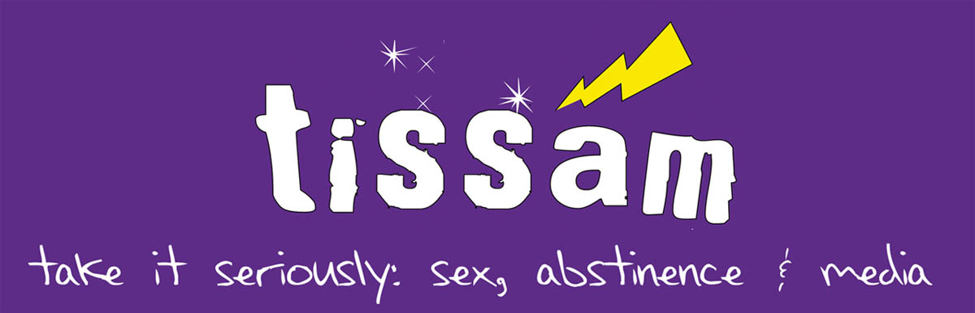
TISSAM Curriculum Package Order Information

To receive your TISSAM Curriculum Package, we encourage you to place your order now.

The TISSAM Curriculum Package contains:
- Teacher’s Manual
- Master copy of the Presenter’s Manual
- Sample master copies of handouts
- TISSAM DVD

The TISSAM DVD includes:
- The 6 core TISSAM lessons, each on a PowerPoint presentation with embedded video
- Master copies of all handouts and exercises
- Copy of the Presenter’s Manual

Note we are able to make this special curriculum offer available only to Washington State residents. All others please contact Teen Futures Media Network toll-free at 1-888-833-6638.
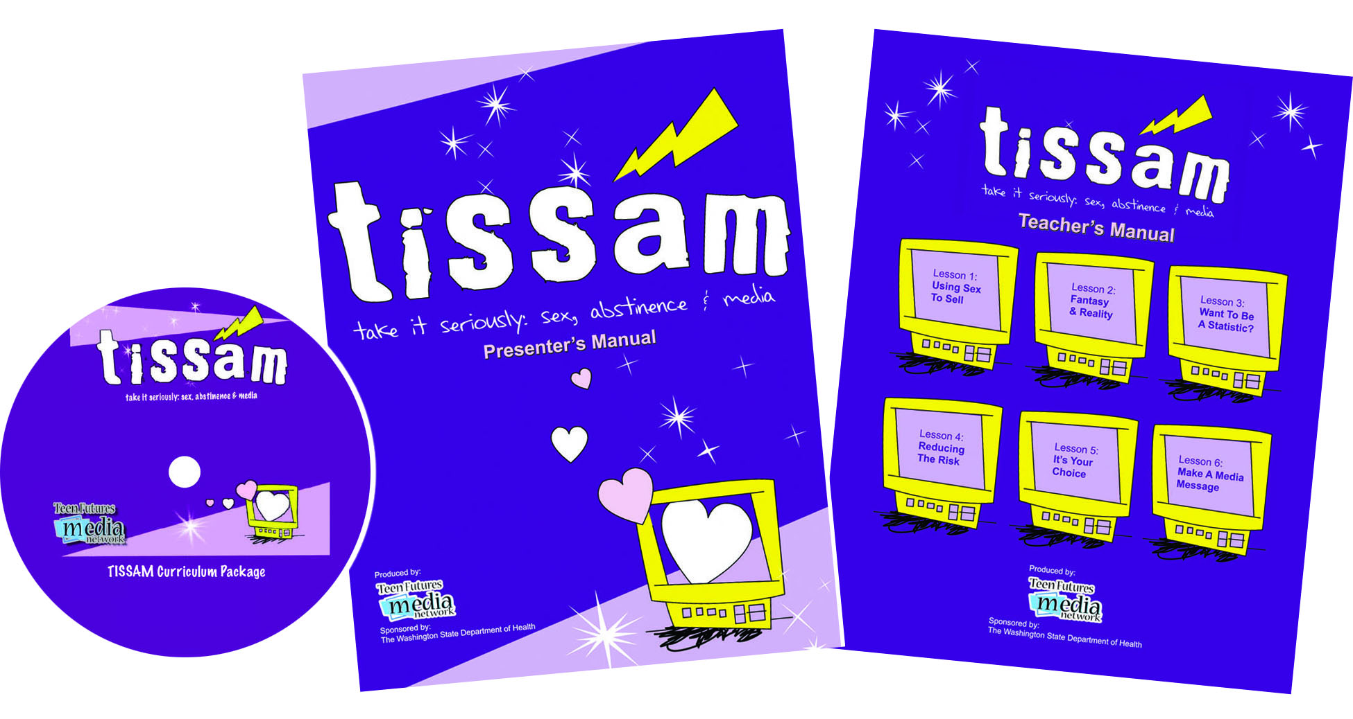

TISSAM Curriculum Package Order Form
Please send me the following:

Price Per | Title | Quantity | Total
$75.00/pkg. | TISSAM Curriculum Package
 | Subtotal
 | Add $12 for shipping and handling
Add 9.5% (.095) WA State sales tax
(WA State residents only)
 | Total Order (U.S. currency)
FAX your Order: 1-206-543-8480 Call Toll-Free: 1-888-833-6638

Organization/School: ___________________________________________________________ Phone: ( )_______________

Your Name: _______________________________________ E-Mail: ________________________________________________

Billing Address: _____________________________________________ City: ___________________________ Zip: __________

Shipping Address: ___________________________________________ City: _____________________________ Zip: ________

Payment Information (circle one)

Payment enclosed Pre-pay check (U.S. Funds) payable to: University of Washington

Invoice Me - Purchase Order # ______________ PO orders must be signed and accompanied by an
institutional purchase order.
We do not accept credit cards for payment.
Mail your completed order form to:
Teen Futures Media Network
University of Washington
Experimental Education Unit
Box 357925
Seattle, WA 98195

