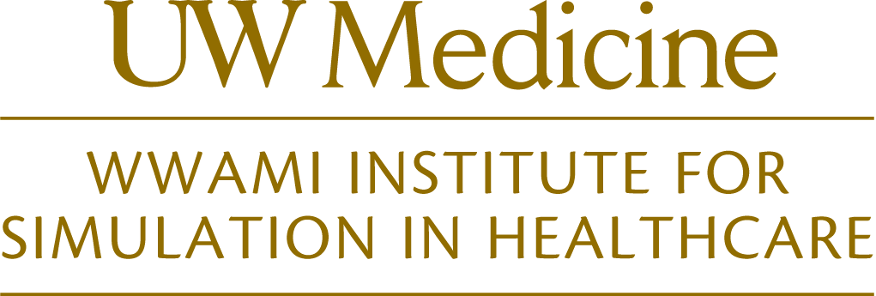

REQUEST FOR WISH PROGRAMS
RESOURCE GRANT
APPLICATIONS

2017 Cycle

WISH PROCESS:
The WWAMI Institute for Simulation in Healthcare (WISH) has developed a formal intake and grant process for all WISH education/training programs. Beginning in 2017, all new programs are required to complete a program application in order to be considered for WISH resourcing (space, technical support, simulation equipment, etc.). Applications for WISH resources, will be accepted on a rolling basis with a bi-annual award cycle*. All accepted programs will henceforth be reviewed annually for compliance.
- Applications will be reviewed by the WISH Application Review Committee, which will include clinical content, education, and simulation technology representatives.

ELIGIBILITY:
Only UW Medicine entities are eligible to submit grant proposals to utilize WISH resources.

APPLICATION:
Applications are available online via the WISH website (http://wish.washington.edu). Completed applications are accepted on a rolling-basis with a bi-annual review deadline (see calendar below). Completed applications must be submitted by the bi-annual due date in order to be considered in that round of review.
Accepted applicants will be notified and approved for scheduling via WISH-HMC and WISH-UWMC processes.
Recurrences of existing programs (defined as courses that have been held/scheduled in WISH to-date) will not be formally reviewed in the 2017 pilot season of applications, but will need to submit a completed application portfolio by 10/1/17, in order to be considered for 2018-2019 academic year resourcing.

REVIEW CRITERIA:
All applications will be reviewed and prioritized based on alignment with UW Medicine strategic safety priorities. Priority will be given to courses demonstrating educational need, multi-disciplinary/interprofessional collaboration opportunities.

DUE DATES
Applications are accepted year-round, however cutoffs for bi-annual award review are as follows:
- 5/1/2017 (Round 1)
- 10/1/2017 (Round 2)

Application portfolios for existing programs are due no later than:
- 10/1/2017

APPLICATION PROCESS
Event | Date
Informational Session | 11/21/16
Online Application Portal Opens | 2/1/17
Deadline for Application Submission (Round 1) | 5/1/2017
Review of Submitted Applications | May 2017
Notification to Applicants | 6/1/2017
Deadline for Application Submission (Round 2) | 10/1/2017
Review of Submitted Applications | Oct/Nov 2017
Notification to Applicants | 12/1/2017

CONTACT
Any questions concerning application requirements should be directed to:
Name | Megan Sherman
Address | Box 356410
Phone | 206-598-1542
FAX | 206-598-0809
Email | shermm@uw.edu

COMPLETING THE APPLICATION
Applications can be submitted via pdf form to (shermm@uw.edu). WISH is available to assist with the process and any questions that may arise.
Applications include the following information:
- General Information
- Goals & Objectives, Teaching Methods & Assessment
- Research (as applicable)
- Course information and WISH Assistance (UWMC and HMC specific sections)

FAQ
Who needs to complete an application?
All qualified applicants with NEW course/program requests in WISH must complete an application for review prior to scheduling confirmation.
If I currently run a course in WISH, will I need to apply for that course?
All EXISTING courses/programs must have a completed application packet on file by 10/1/17. Existing courses will be reviewed for compliance with new standards. If portions of the application are incomplete (e.g., equipment list, needs analysis, assessment metrics, etc.), courses may be prevented from future scheduling until WISH receives completed materials.
Once an application is submitted, then what happens?
Applications will be reviewed by members of the WISH Application Review Committee. Each application will, at minimum, be reviewed by a grant review study section to include clinical, education, and sim technology representatives. If the grant review team requires clarification or additional information, they will reach out to the faculty members at that time.
Once reviewed, faculty will receive a determination regarding WISH resourcing. Approved courses will be able to schedule for the remainder of the following academic year.

