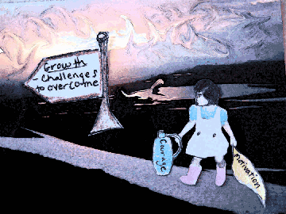
(Original photo and manipulation by Sandy)

Beyond the Rugged Mountain
By Sandy
I have climbed up many hills as the first generation college student that I am today. I have tried to turn my barriers into my personal inspiration. I have transformed the sharp cuts and wounds of childhood isolation from attending a predominantly white school, into scars of strong will and perseverance. I have learned to weave out the academic discouragements that haunted my peers. To me, these are my stages of climbing.
I am the last child in my family; the one to witness the casualties of having less. I am the one to witness my siblings struggling to keep up with education, poverty, and respect for parents who could not help in the college process. I fear having to live the same life that still imprisons my siblings. I want more have than that caged life. I want to show everyone that I can stop the cycle and prove that perseverance can overcome these challenges.
To be a first generation college student in my family to me means more than working for a career. To me, college is my destination in which I am not only free to learn about my passion in physical and biological sciences, but to also discover my family history. College is the domain of resources to help me connect with mother's ancestry, to help me cement the relationship lost between her and my siblings. I want to revive her forgotten history. I want to learn of the world she grew up in. I want to help her understand the Cambodian genocide that exists in her nightmares. I want to heal the misery of her family's destruction and experience at the concentration camps from the 1970's.
The hills I have climbed reach above the tall Douglas fir trees. It overlooks the brush of thorns that once punctured me. It overlooks the thorns of family and societal expectations that encourage women to find careers in humanities. These thorns are also the thorns that stripped my mother and other elite women from the education in Cambodia that could have allowed her independence from abusive husbands. Now that I have learned to have tough skin, I am inspired to help others find that resistance and esteem.
From the jagged hills I have climbed, I have learned how to prepare for climbing my internal mountain. Reaching its peak is my accomplishment of inspiring others, finding my career, improving my family's living conditions, and recovering the past of my mother and ancestry. With some my preliminary climbing equipment I am only on the terrain, reaching its base. My ambition and optimism is beyond the sufficient nutrients of energy drinks and bars. I will need more.
I am a first generation college student. I have the opportunity to work for many improvements. I have the opportunity make my mother proud and inspire younger generations to live their dreams and be dauntless. I have learned to give myself an opportunity to reach beyond high school through my hard work. With my mental strength I know that someday I will be able to see beyond –beyond from the peak of a mountain to the thousands of pristine lakes reflecting my accomplishments.
In those lakes I will see the forgotten faces of my ancestors, my career, and those who have learned to have a strong will. I will also see the face of my mother smiling without worries and trauma. I will see the hope I have shed for my family.

