Kelsie, Wichita State University, Trio Talent Search, Research

Graffiti
Don’t you love looking at a beautifully drawn piece of art work? I do but you know what a gets me even
More…
Graffiti
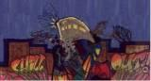
You’ve probably heard of the Chinese art of paper folding. Well, graffiti to me is the art of expressing you’re self. You may not love seeing it in the hallway at school or on the wall of the work place, but either way it’s still a sweet art.

Graffiti started in the 60’s and 70’s when people began a rivalry with others through writing of their signatures. But you know young people weren’t the only ones doing it. Big gangs would do it to mark their territory and to become famous. Then young people would continue it by writing their own names or nicknames on walls and many other places. People would also use it as a form of communication. It became more visible when spray paint was invented and tagging became more and more popular.
Through the time tags became more of an artistic expression. Then a new form of graffiti was born when people started to outline their names and the writing became bigger and bigger. This form was called “Piece.”
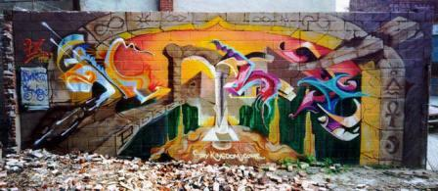
In 1973 The New York Times held a competition to see who had the best graffiti. They even admitted tag awards. Security became more aggressive on subways when Lee Quinones came in. Writers started to paint the walls instead of subways, Lee Quinones also known as Lee started to turn his neighborhood into a famous graffiti gallery. He turned the place of grim near Brooklyn Bridge into an art gallery of graffiti.

During all this, the writing of millions cost MTA hundreds of millions of dollars. They where trying to remove the graffiti but it just wouldn’t go away. Just removing 1 meter would be about $750 and a car would be about $78000.

So as you know graffiti is an art and we should respect it like you would Picasso or Van Gogh. Next time you see it just think about what you think that person was thinking at the time he painted it (he/she probably has a reason).

Pictures and information from: jam2dis.com
Written by: Kelsie

