Harlem Hours

Harlem in one-way or another
May be to some a place
Where a lot of people would like to be
Who? Me
We
I mean us… the smell of the fuel coming from the bus
Is surrounding your brain
Below you, you hear the whistle of the train
On 125th street you hear the beat
The sound
The heat
The pound of people playing their drums
And on the corner you might even see a dirty old bum
But yet as you stand there thinking why would anyone want to be here?
You look up and you see in big bold lit up letters APOLLO THEATER
Where your favorite rapper or singer
May have started like juelz Santana
You know who im talking about
The one who always wear a different color bandana
Yeah! As you walk around you figure you need some new clothes
You might even buy a new CD
To bop to hop to cop to might even drop to
You’ve been shopn and copn new things all day
It’s getting dark… so you say
Waiting on the train and you start to strain
As you see this little light smaller then a bug bite.
Then the light gets bigger it’s the train you relax
It’s full of people so slowly one foot in front of another you get on
Finally it’s your stop
You hop off on 106 and Madison

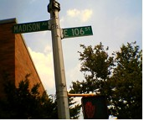

And you make a pit stop to help old lady Paterson.
As you pass the big graffiti wall in the court

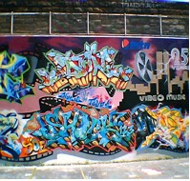

Where all your friends play ball till it hurts
You’re being real patient it seems like a long walk
But it’s right around the corner and down the block
As you reach your building you hear a loud pop
And a light that looks like some one was filming come out at the same time someone has just been shot. So you run to your building you hear screaming and you see running. Your glad you made it home safely
The next day you see your whole entire neighbor hood standing around flowers and candles saying a prayer for Tyree

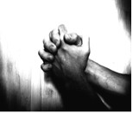

Who just yesterday in his white tee
Smiling, living, breathing, and feeling free
Confusion forces his family to demand why life was taken away
Why couldn’t he last a few more days the question remains?
You have the blacks
Selling crack.
Puerto Ricans hating Dominicans
Why can’t we come together the way I know we can.
Even though we may fuss and fight
Just think
We will come together and unite

By: Domonique

- Graffiti and street sign photograph were taken by Domonique
- Praying Hands image provided by Google.com

