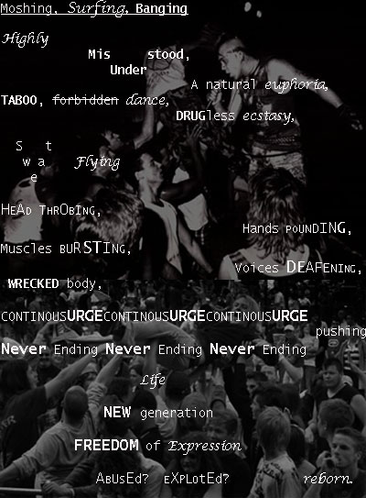

top http://www.bbc.co.uk/shropshire/content/image_galleries/oswestry_music_live_2006_artists_gallery.shtml?17

BOTTOM
http://www.flickr.com/photos/musicalsuicide/445172848/

